**Practical No. 1**

**1. Implementation of Data partitioning through Rang and List partitioning**

**List Partition**

**1) Create table dept_6 with List partition**

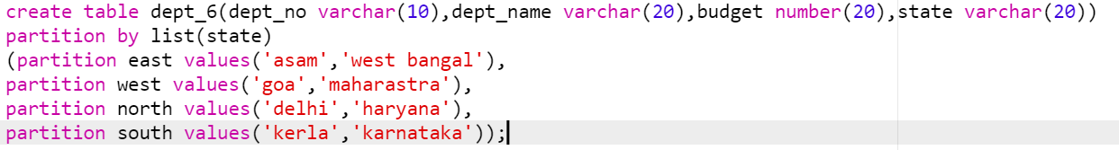

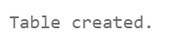

**2) write a query insert values in dept_6 table**

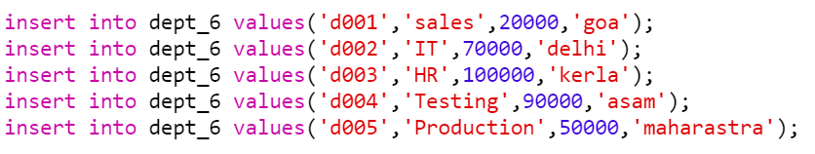

**3) write a query to display element in dept_6 table**

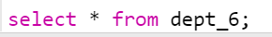

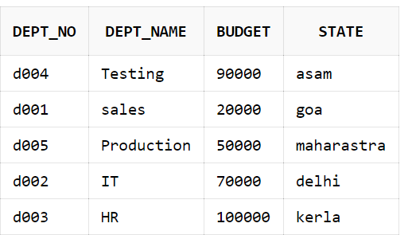

**4) write a query to display contains of table dept_6 along with partition wise**



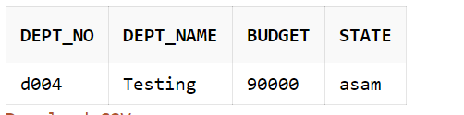



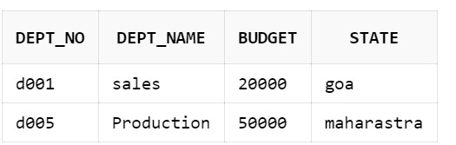



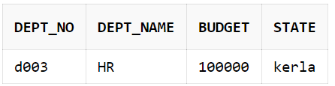



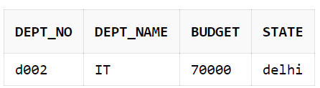

**5) write a query to merge partition**



**6) write a query to display new partition**



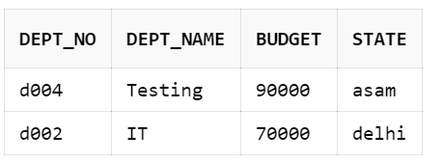

**7) write a query to split a partition**



**8) write a query to display split partition**



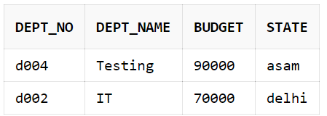

**9) write a query to drop partition**



**Range Partition**

**1) Create sales_6 with Range partition**

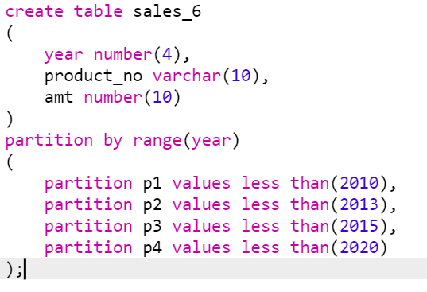

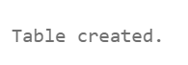

**2) write a query to insert values in sales_6 table**

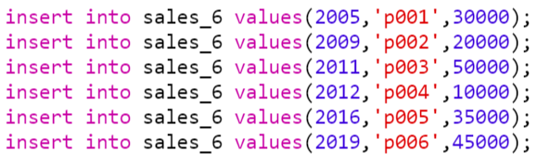

**3) write a query to display element in sales_6 table**

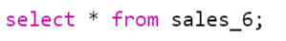

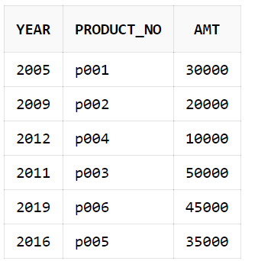

**4) Write a query to view the contains of table sales_6 along with partition wise**



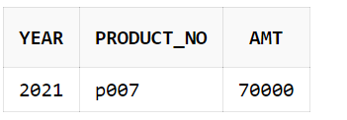

**5) write a query to add new partition in sales_6 table**



**6) write a query to insert value in new partition**



**7) Write a query to merge a partition.**



**8) write a query to display element in new partition**

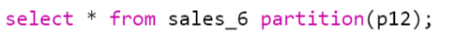

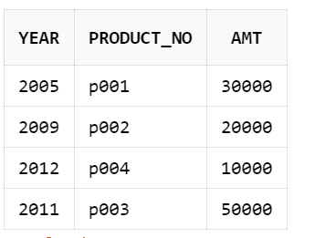

**9) write a query to split partition in sales_6 table**





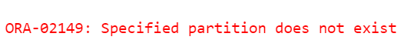

**10) write a query to rename partition**



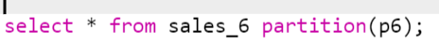

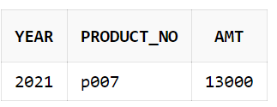

**11) write a query to drop partition**



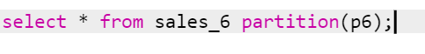

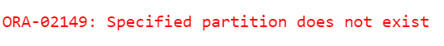

**Practical No. 2**

**1. Implementation of Analytical queries**

**1) create table employee_6**

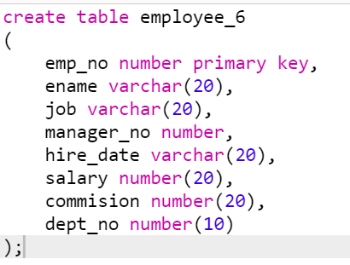

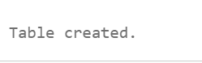

**2) Insert record in employee_6**

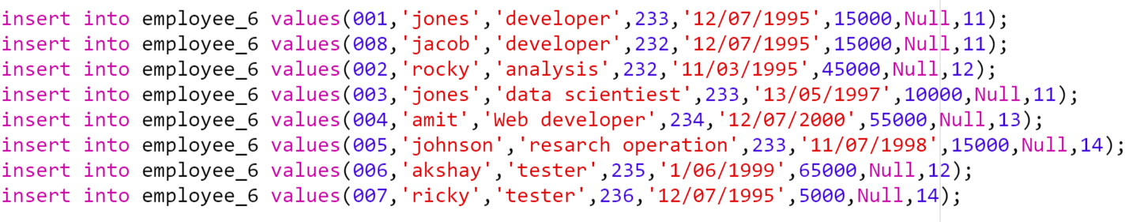

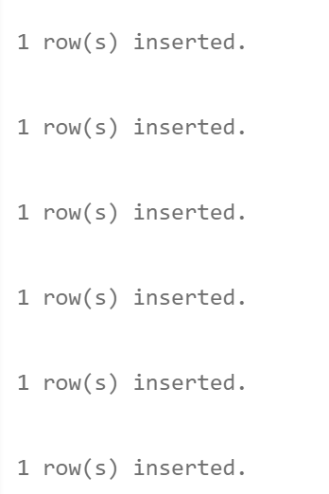

**3) write a query to display element in employee_6**

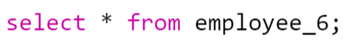

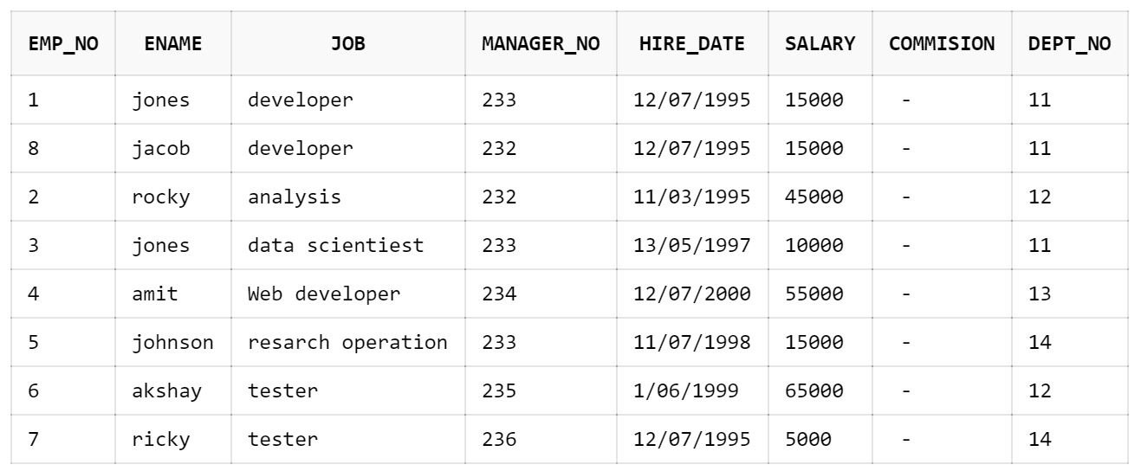

**4) write a to display employee_6 using Rank order by salary**



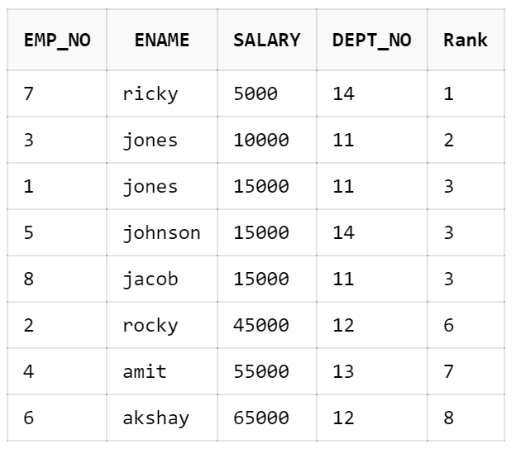

**5) write a to display employee_6 using Rank order by salary and partition by dept_no**



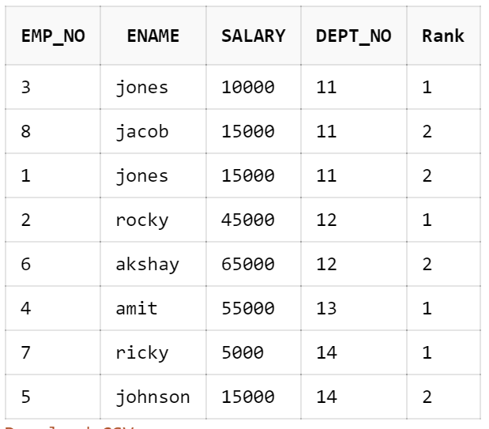

**6) write a to display employee_6 using Rank order by salary desc and partition by dept_no**



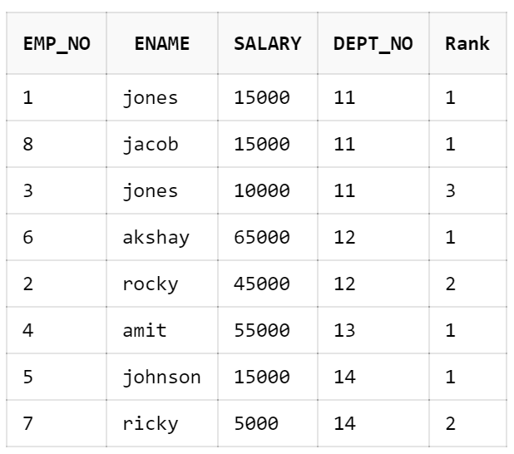

**7) write a to display employee_6 using Dense_Rank order by salary desc and partition by dept_no**



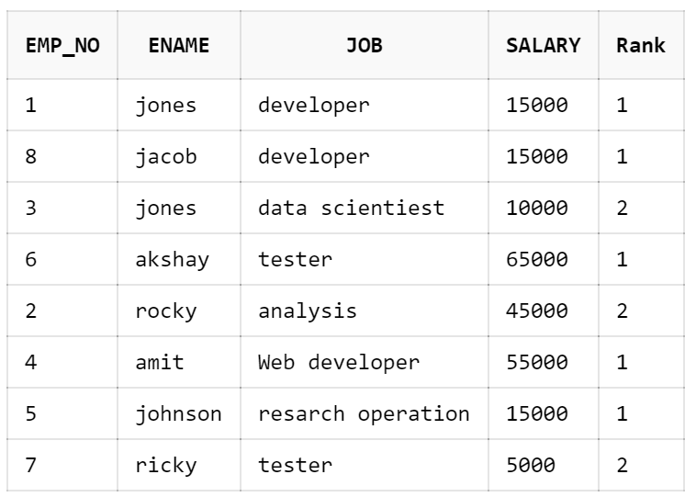

**8) Display the highest and the lowest salary of the employee within their department order by dept_no and salary. Min and max first value and last value.**



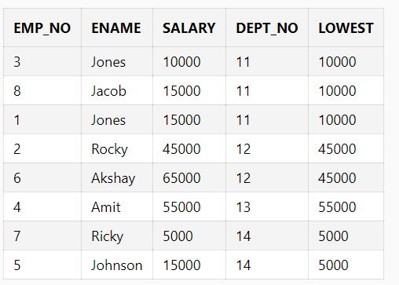



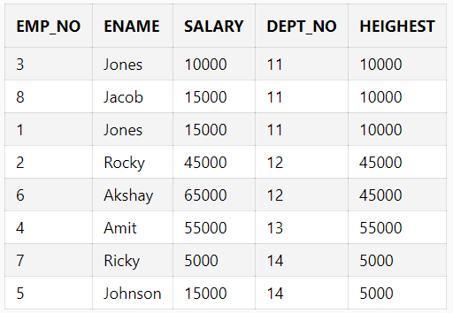

**9) Write a query to display a row number.**



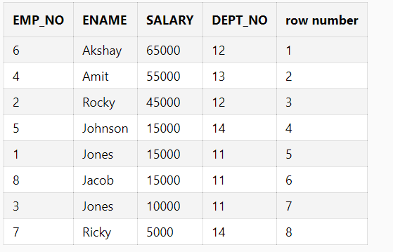

**10) Without Partition**



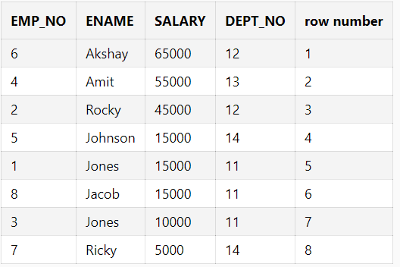

**11) Print the average salary of department.**



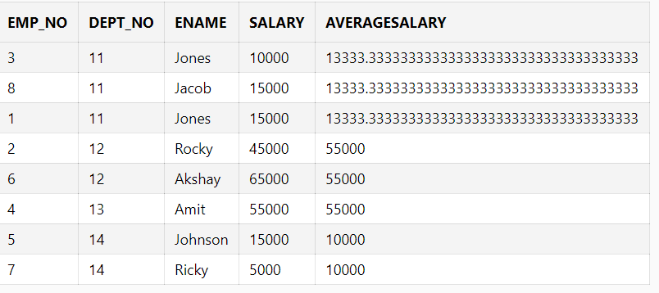

**12) Find out the sum of the salary, dept_no and job wise**

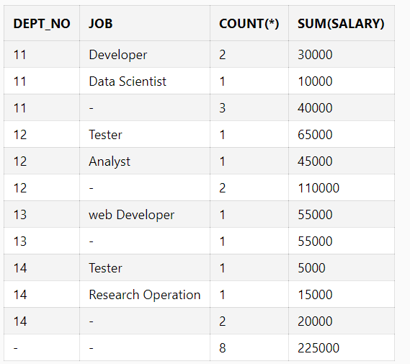

**13) Group by function Cube.**



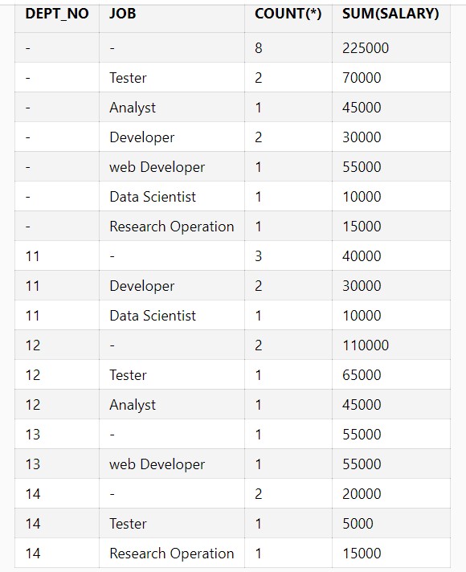

**Practical No. 3**

**1. Implementation of ORDBMS(Object)**

**1) Create type stud_obj_6 as object(Fname ,Mname,Lname).**



**2) create table student_6**

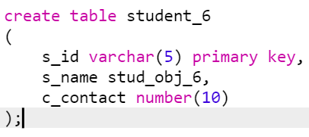

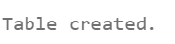

**3) insert records in student_6 table**

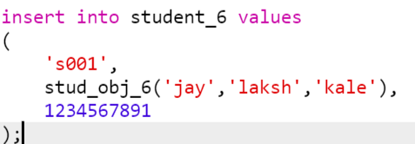

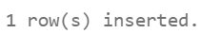

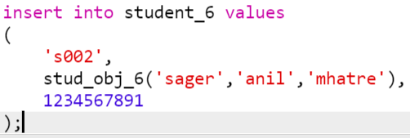

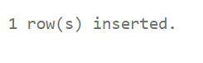

**4) Display record in student_6 table**



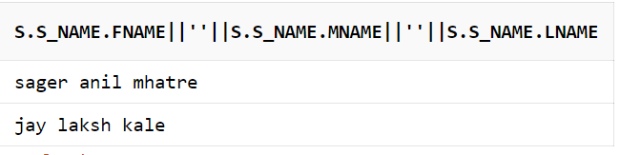

**Practical No.04**

**Implementation of ETL Transformation with Pentaho.**

**Step 1.** Open Data Integration folder (C:\data-integration)

**Step 2.** Double click on spoon(Windows Batch file)

**Step 3.** Click on cancel

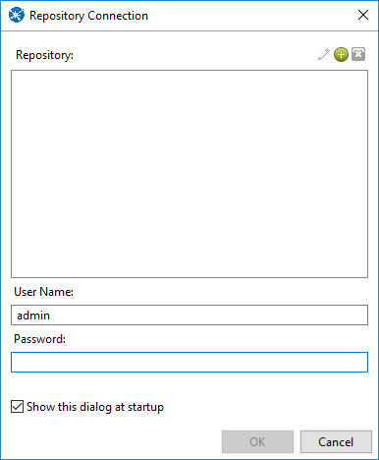

1. **Transforming Source Table and storing to Output Table in SQL Step1: Go to Pentaho**

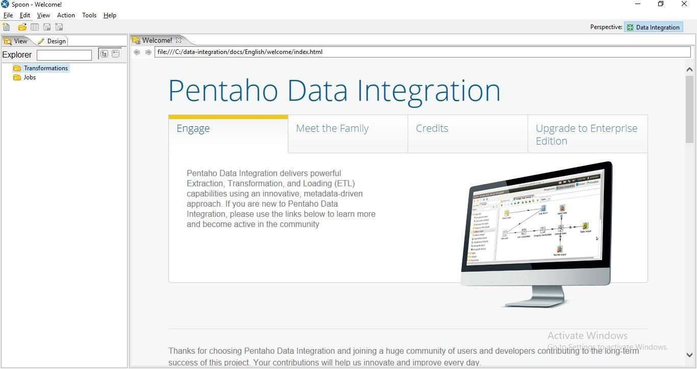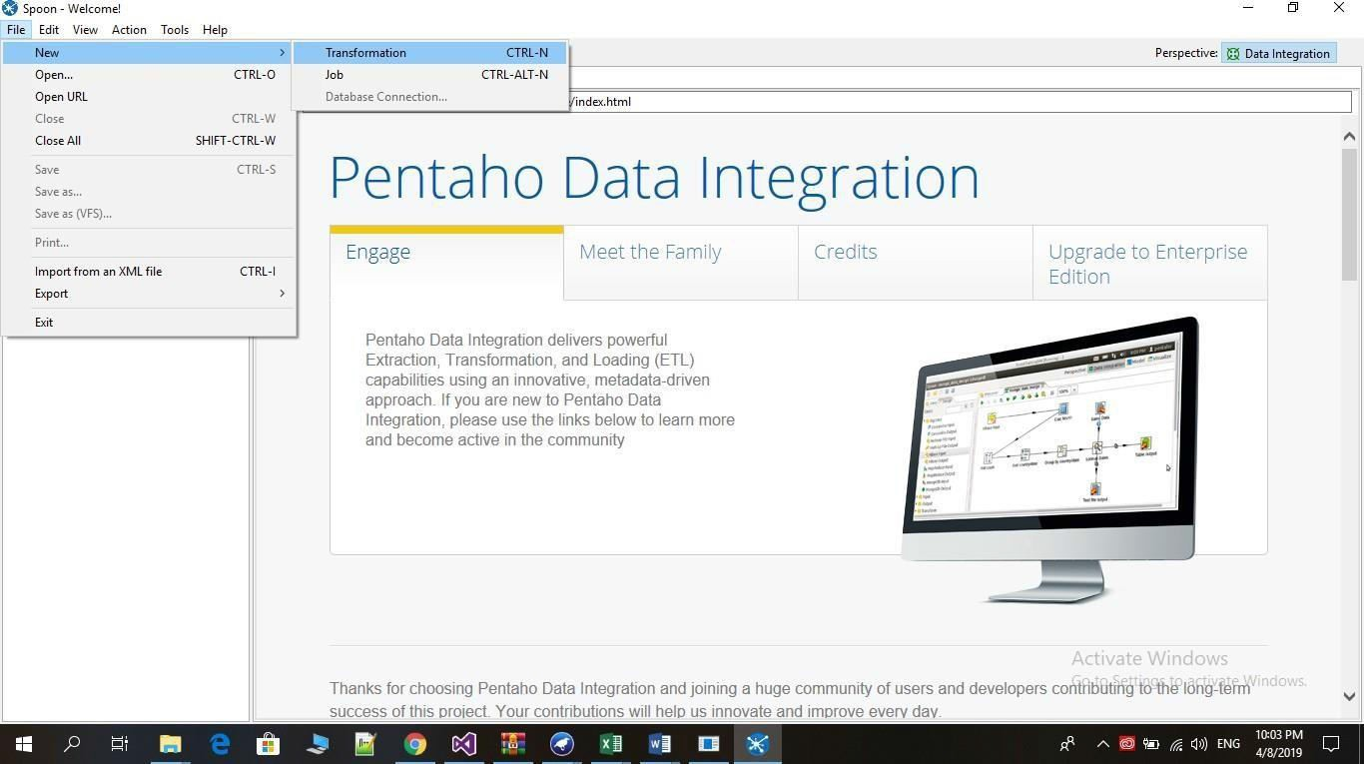

Step2: Go to file->New->Transformation.

Step 3: Click on Input

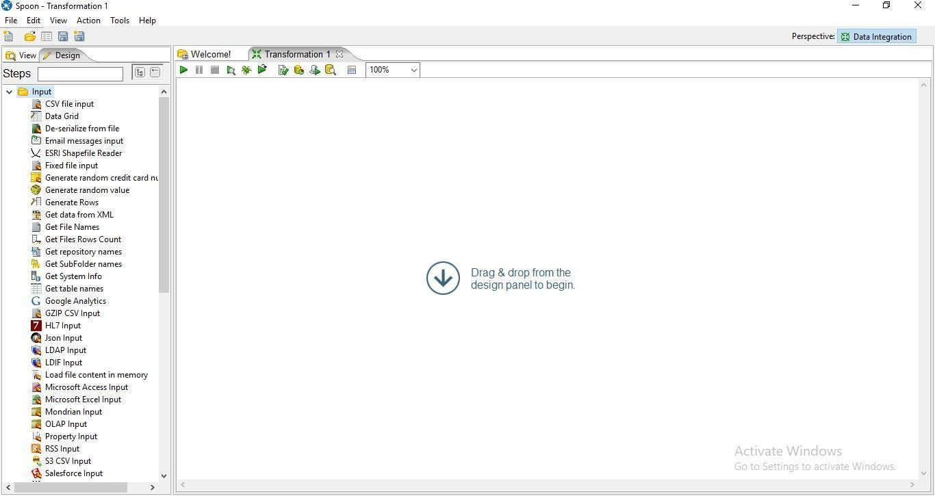

Step 4: Drag Table Input on the panel

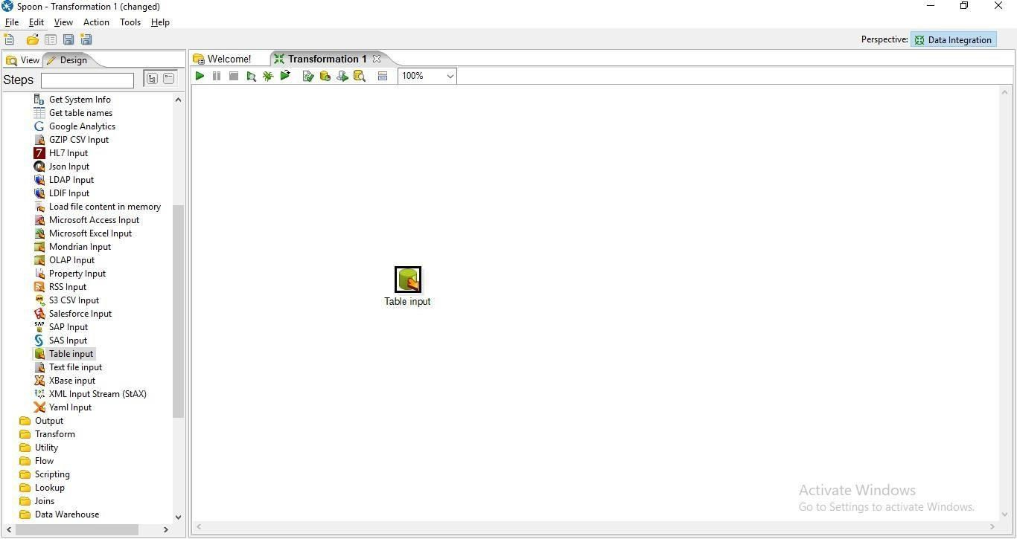

Step 5: Double Click on Table Input and the following tab will appear.

## Click On New

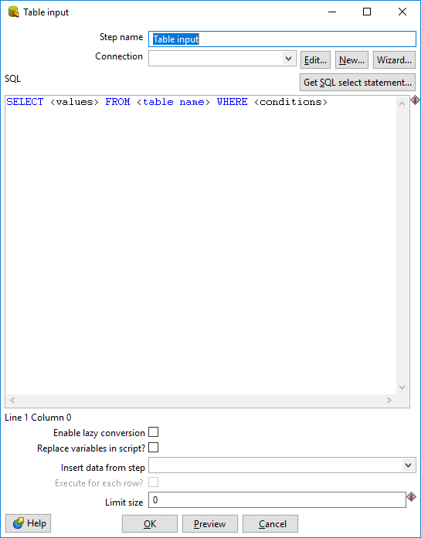

* 1. **Select Oracle in Connection Type and enter Connection Name, Database Name, User Name and Password and click on Test.**

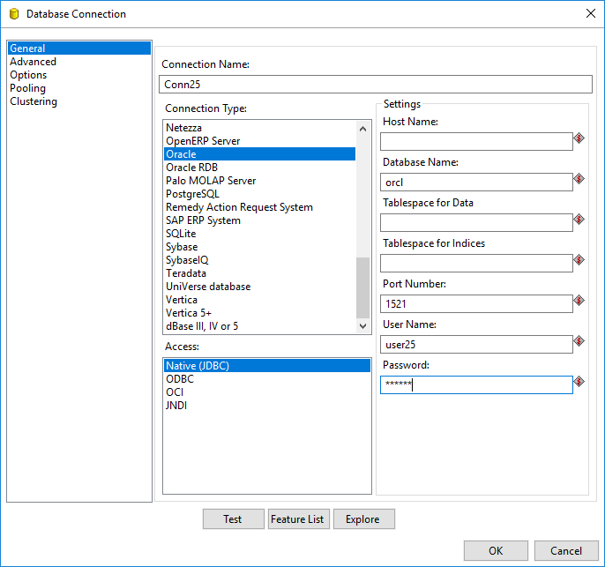

Connection Successful

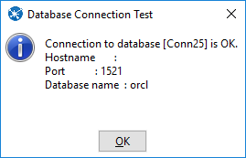

## Click on get SQL select statement

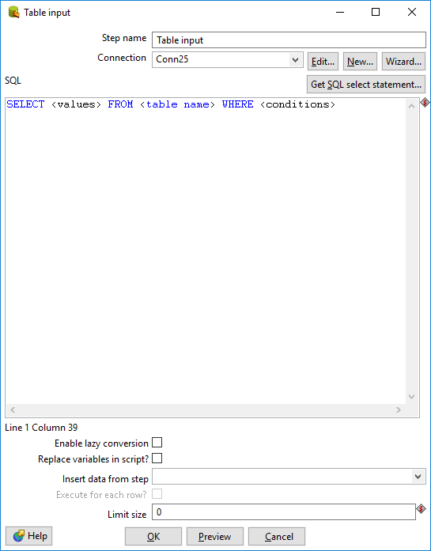

* 1. **Click on database -> table and select the table name.**

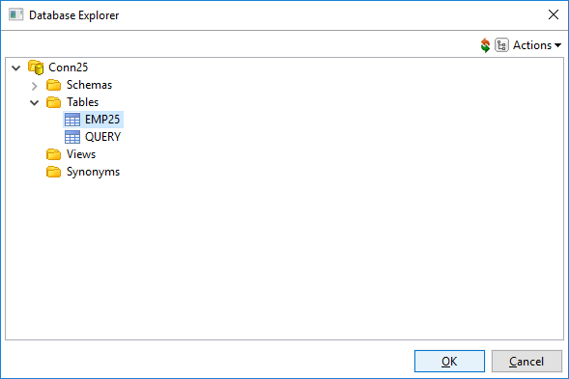

* 1. **Click on Preview**

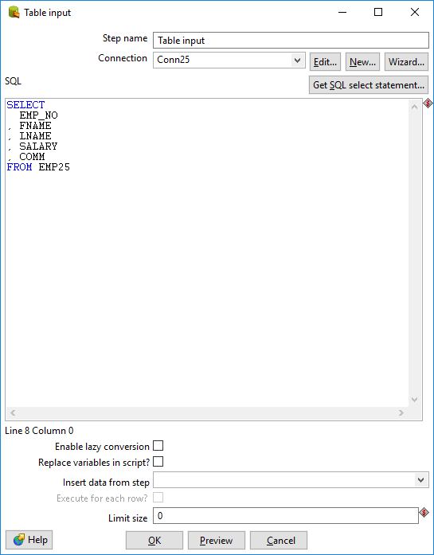

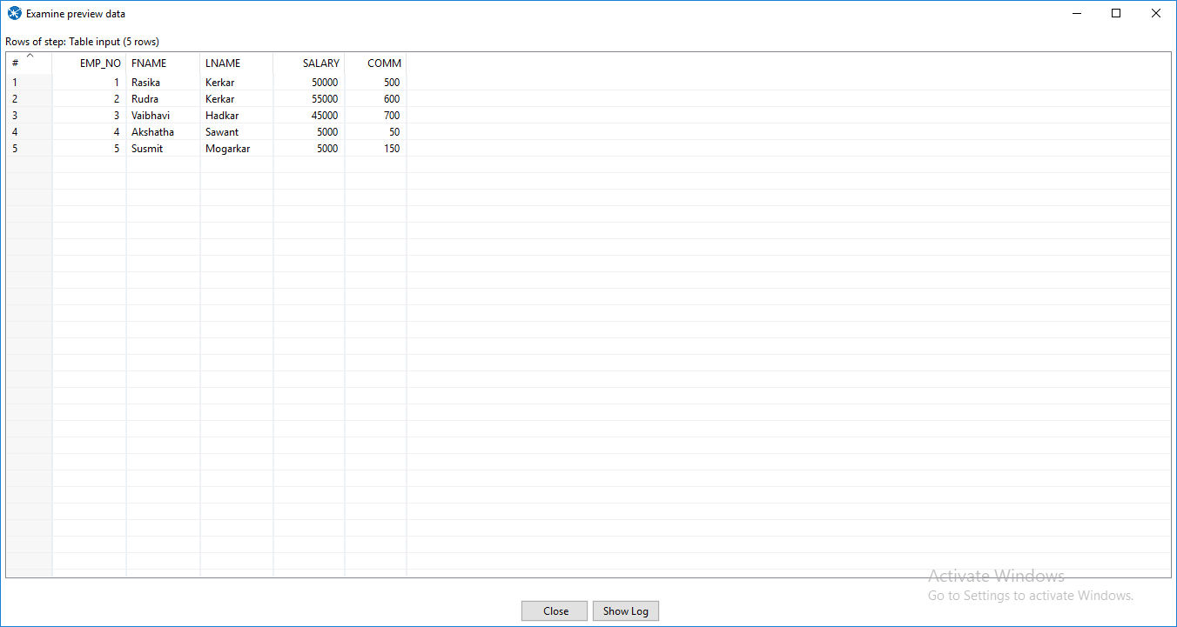

Step 6: Click on Output and drag table Output.

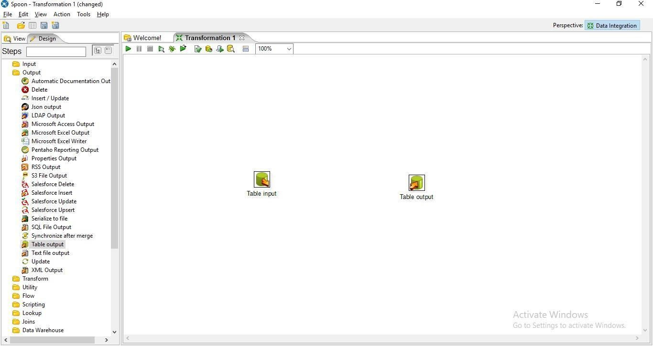

Step 7: Hold the mouse Pointer on table input and select and drag the Output connector to the Table output.

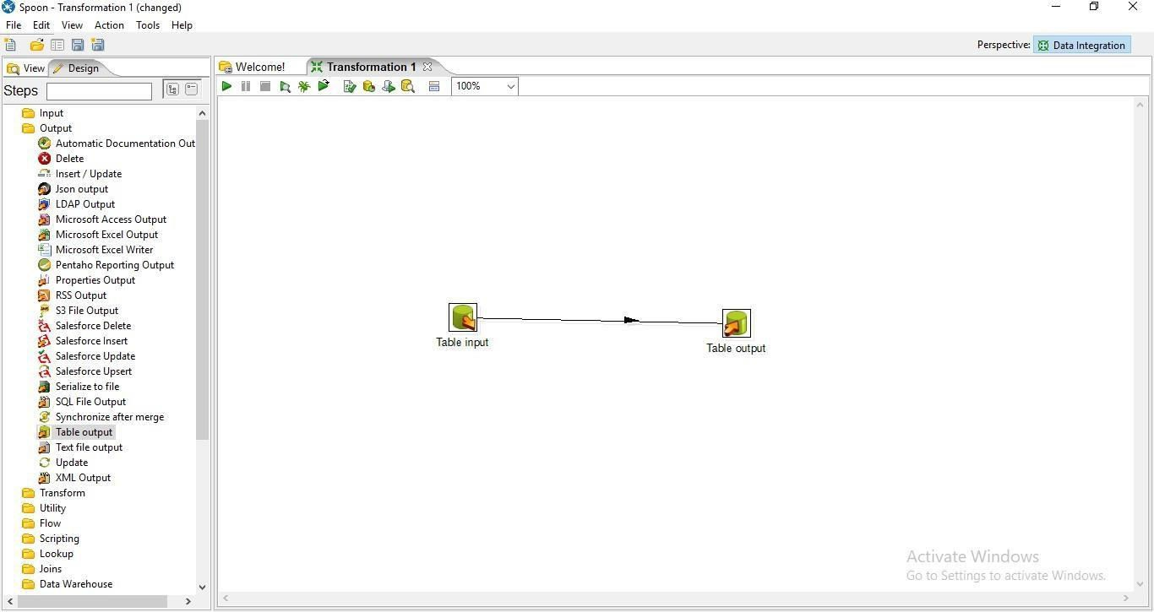

Step 8: Double Click on target table

a. Enter the Target table name and check the truncate table and Specify database fields Check Box

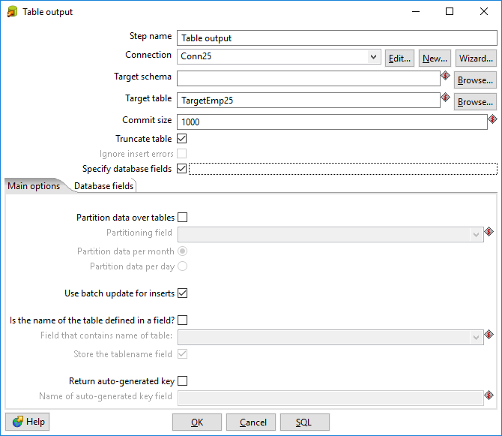

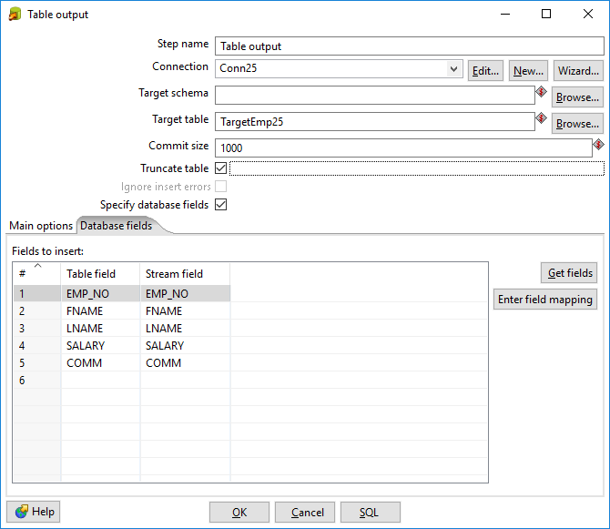

c. Click on SQL and click on Execute.

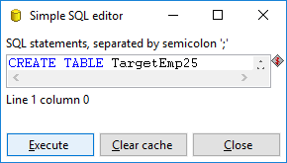

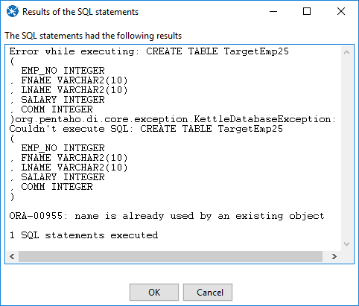

Step 9: Click on Run Transformation and Click on Launch

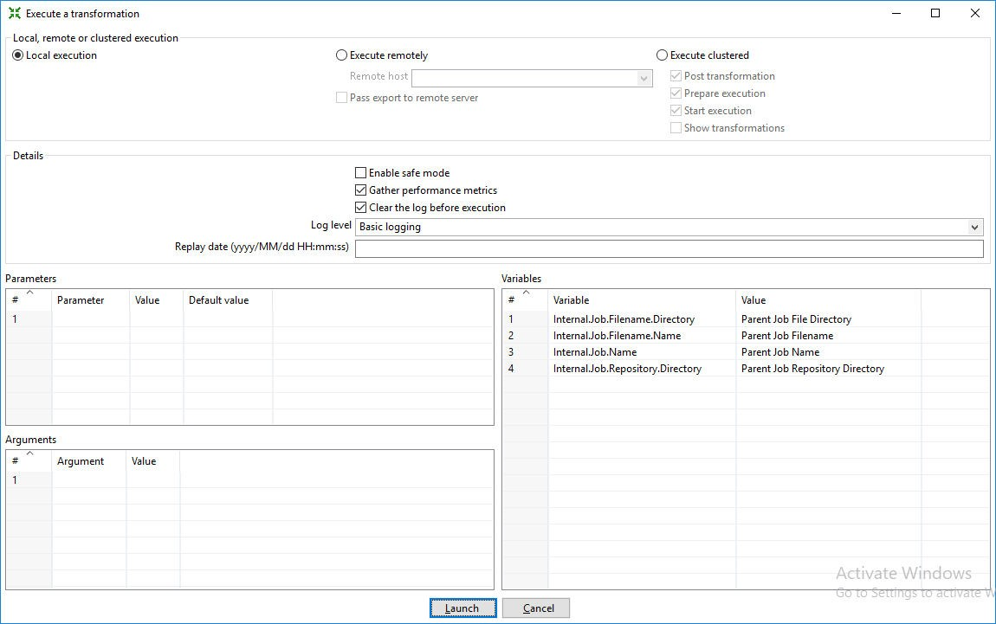

Step 10: Click on Debug Transformation(Spider) and Click on Quick Launch

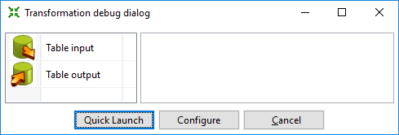

Output:

The Green ticks on the table input and table output shows successful transformation.

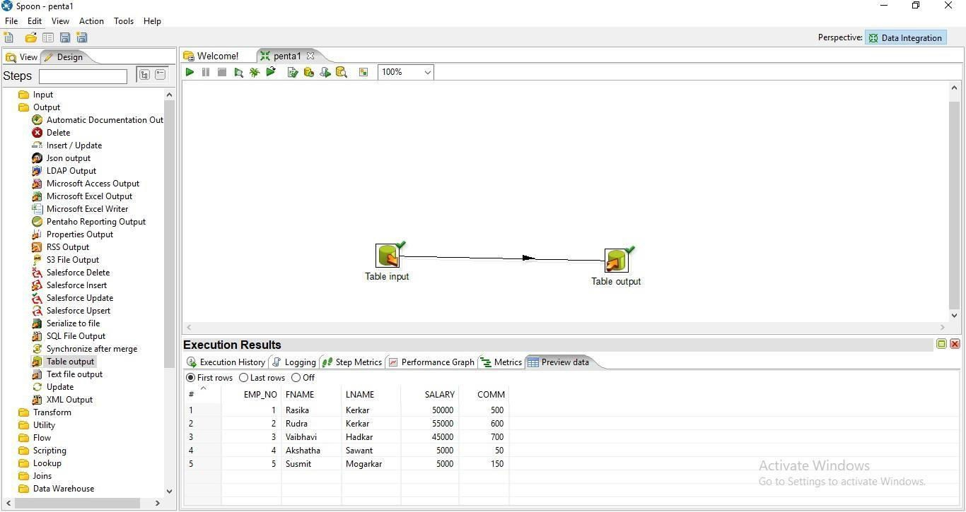

## Sorting Operation and adding Sequence to Output Table. Step 1: Perform the first 5 steps same as practical 1.

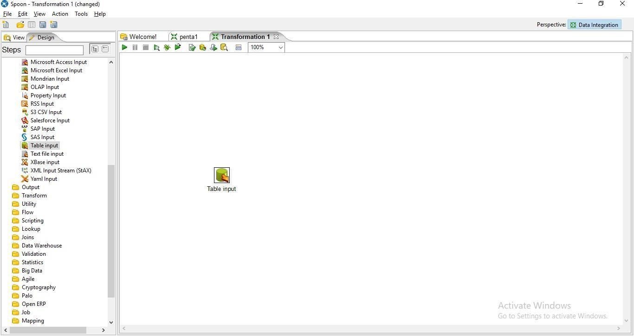

Step 2: Click on Transform in the left

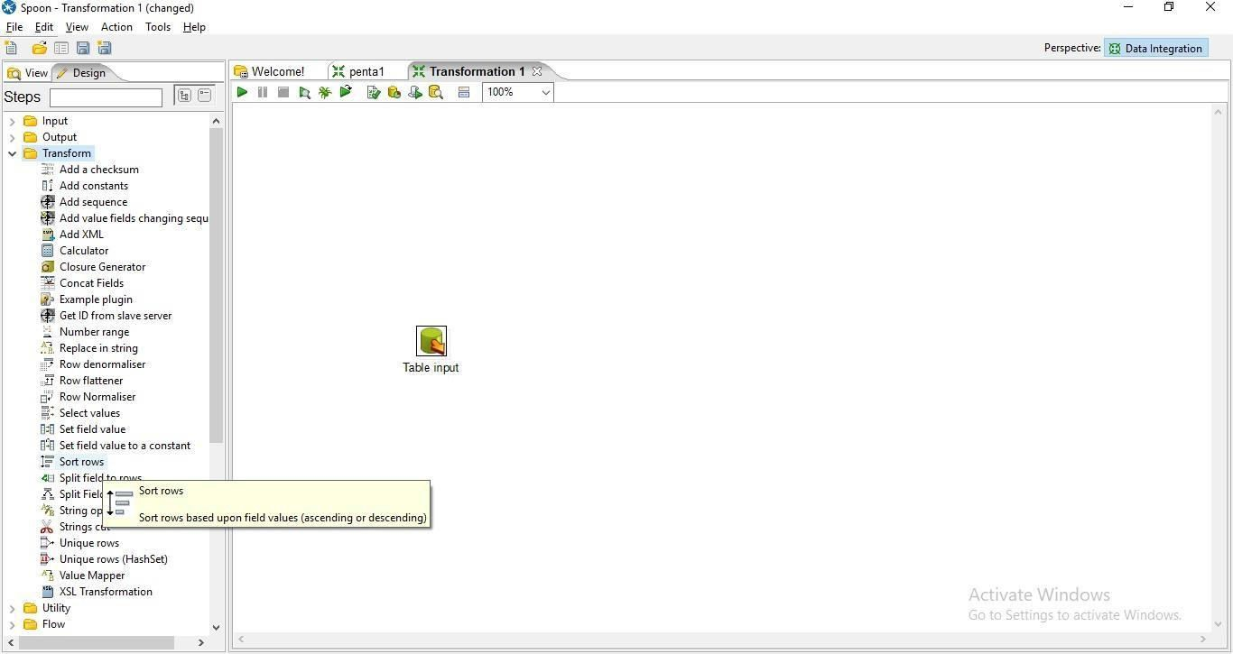

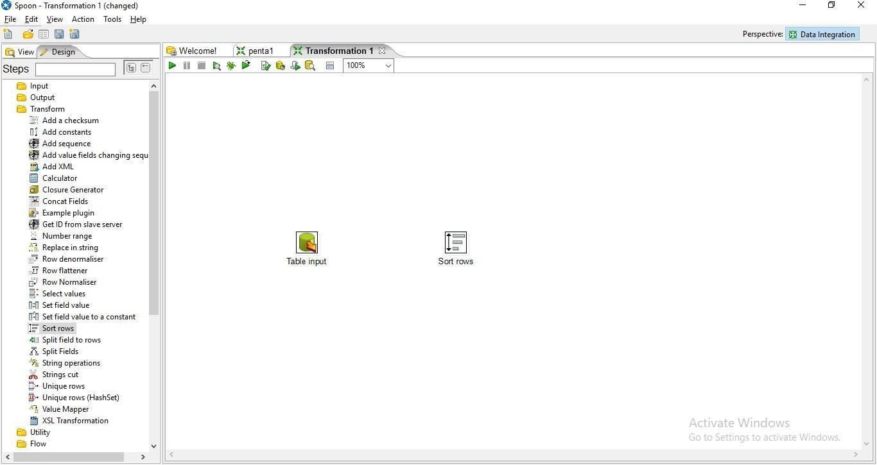

Step 4: Hold the mouse pointer on the Table Input and then drag the output connector to the sort rows.

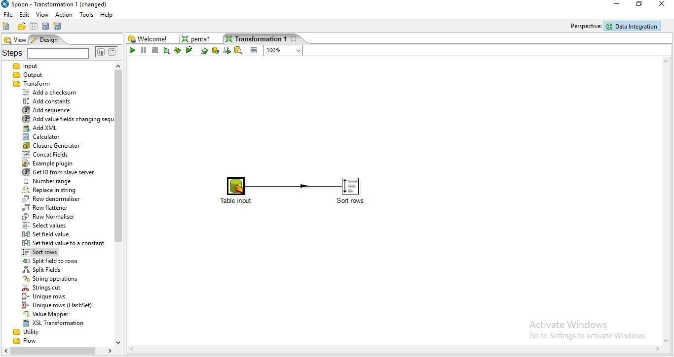

## click on get fields

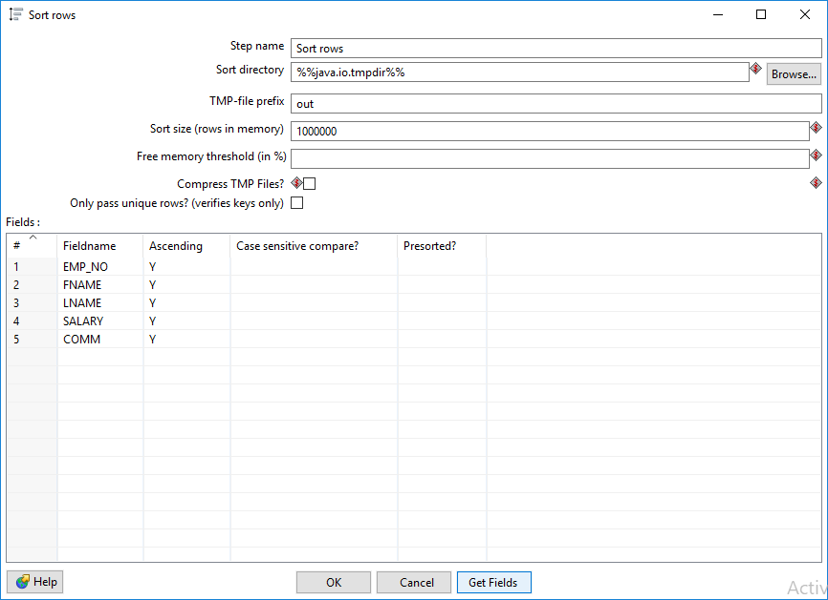

1. **Edit the fields and press ok**

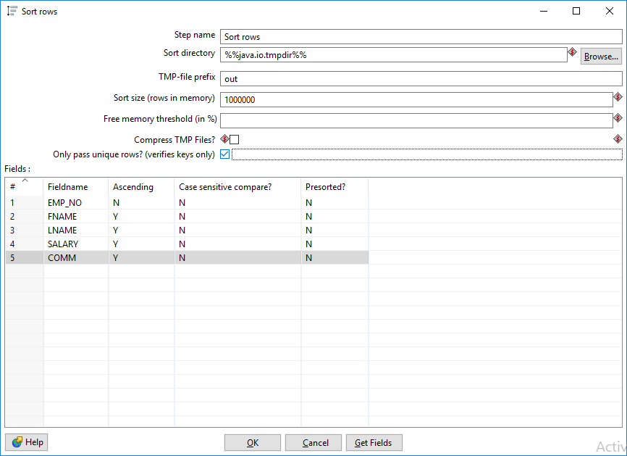

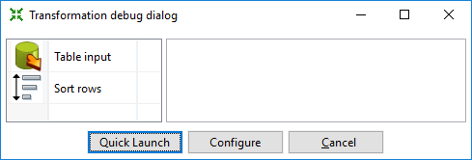

Successful connections(Green Ticks)

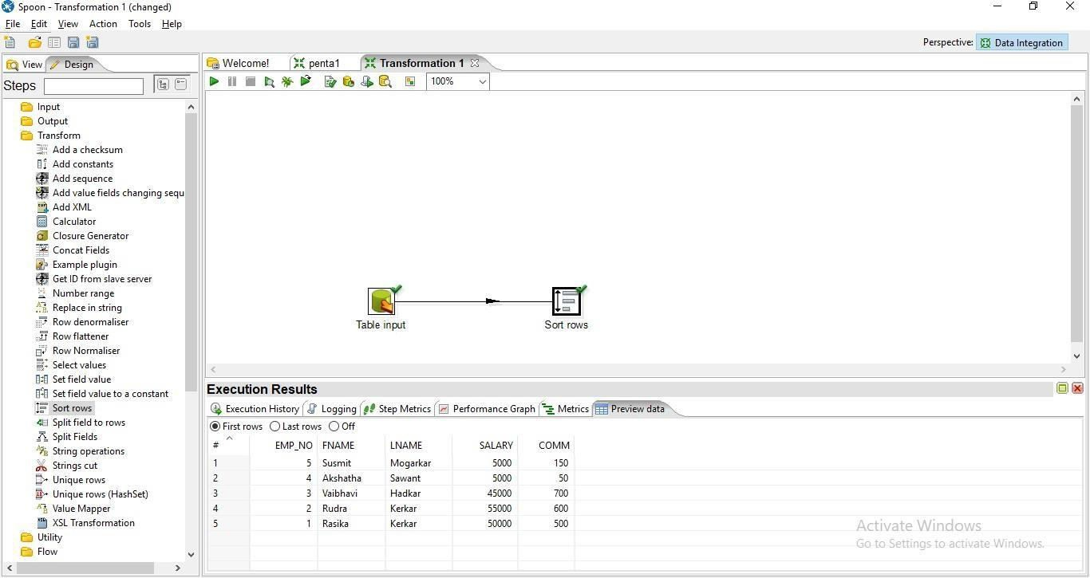

Sorted Data

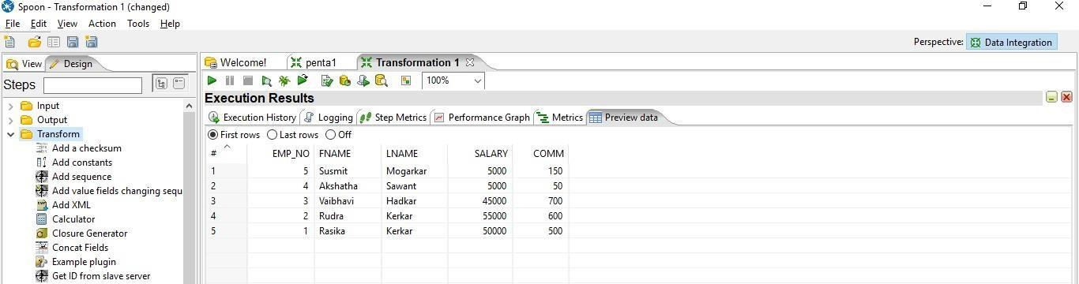

the table output.

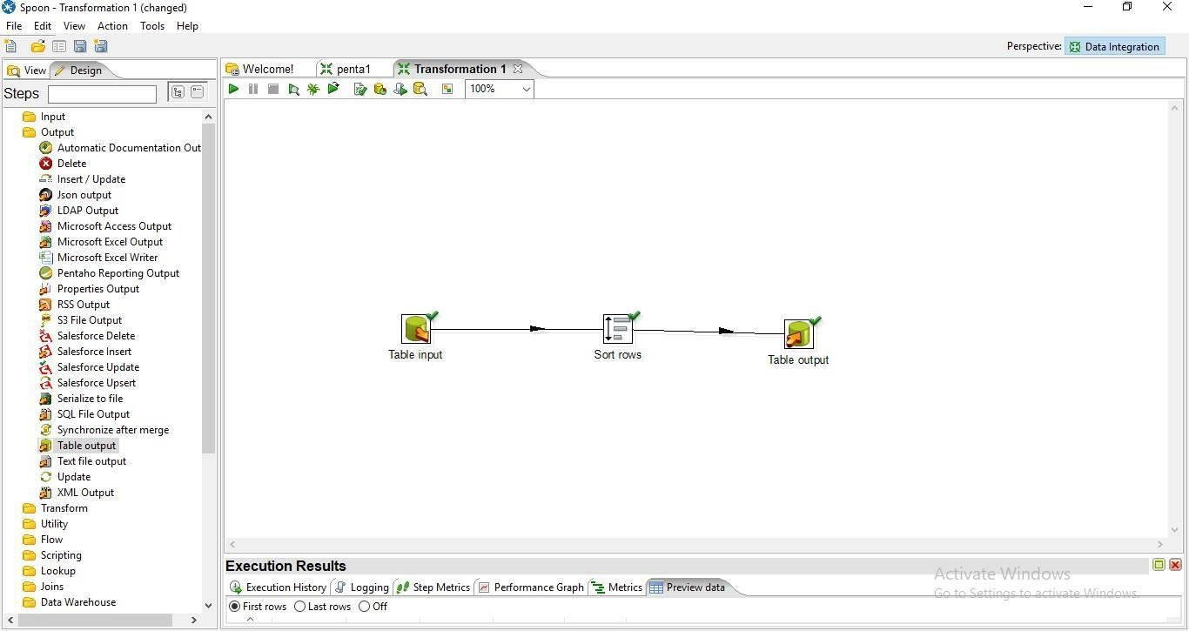

Step 8:now perform step no 8 to steo 10 from practical 1. Final Output:

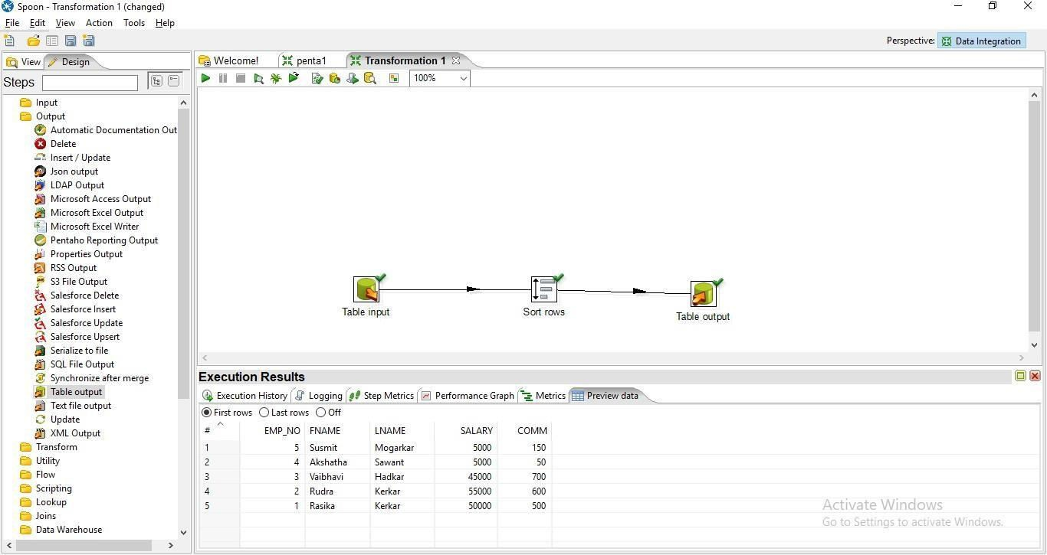

EMP_NO FNAME LNAME SALARY COMM

---------- ---------- ---------- ---------- ----------

|  |  |  |  |  |
| --- | --- | --- | --- | --- |
| 5 | Susmit | Mogarkar | 5000 | 150 |
| 4 | Akshatha | Sawant | 5000 | 50 |
| 3 | Vaibhavi | Hadkar | 45000 | 700 |
| 2 | Rudra | Kerkar | 55000 | 600 |
| 1 | Rasika | Kerkar |  |  |

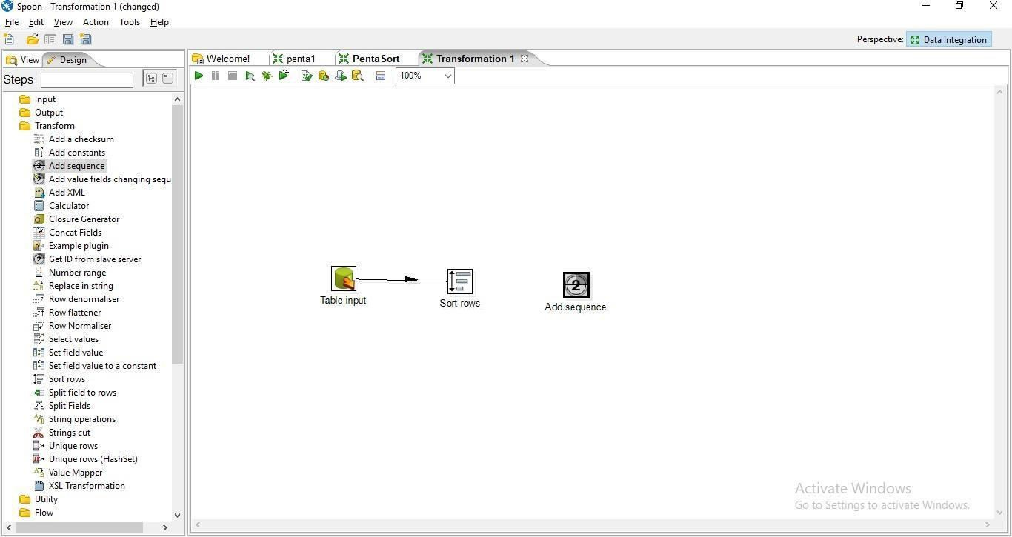

50000 500

Step 10: Hold the mous pointer on the sort rows and drag the output connector to the Add sequence control.

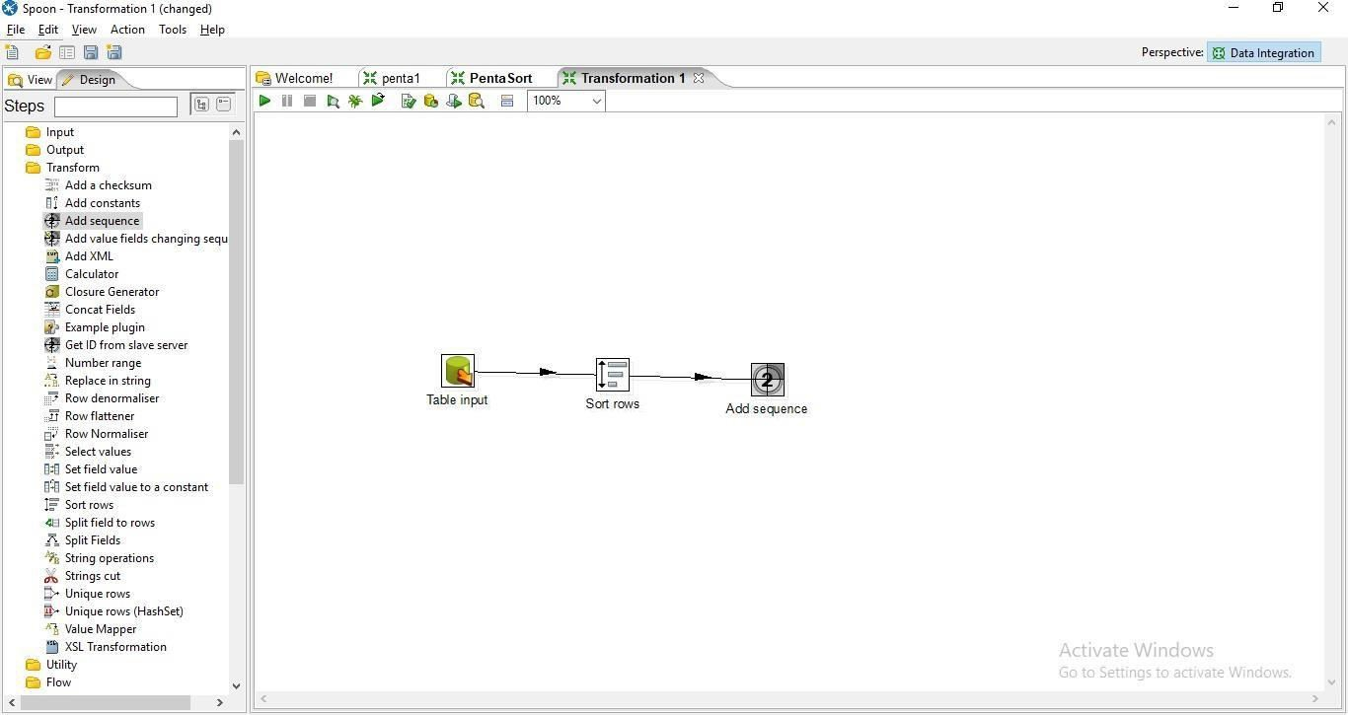

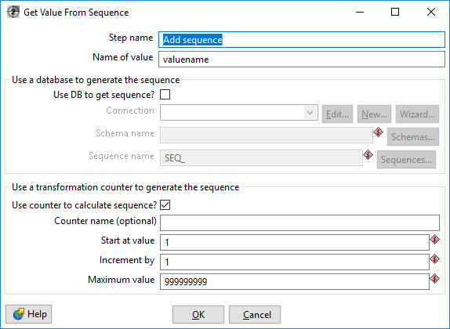

* 1. Enter the values for Start at Values,Increment by and Maximum Values and press ok.

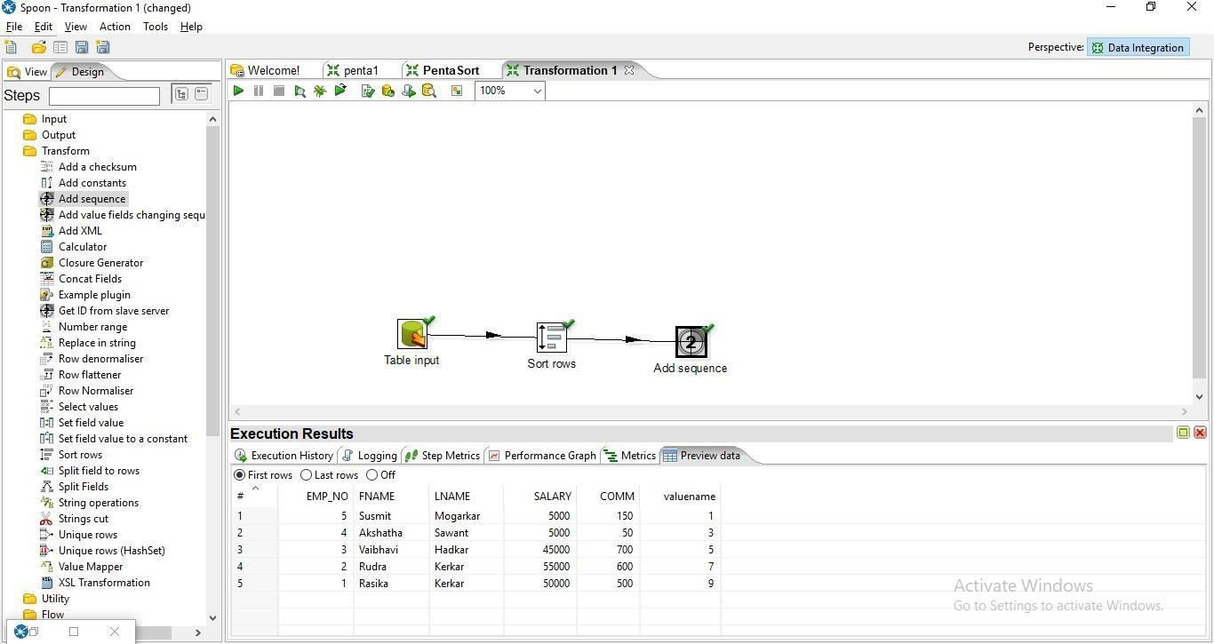

Step 13: Drag and drop the table output on the panel

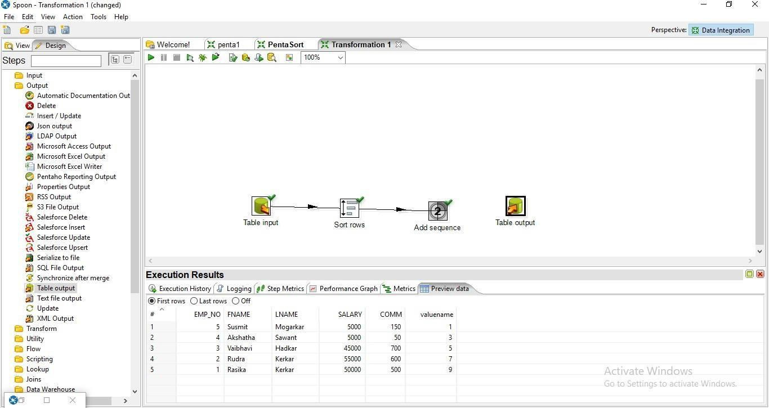

output connector to the table output.

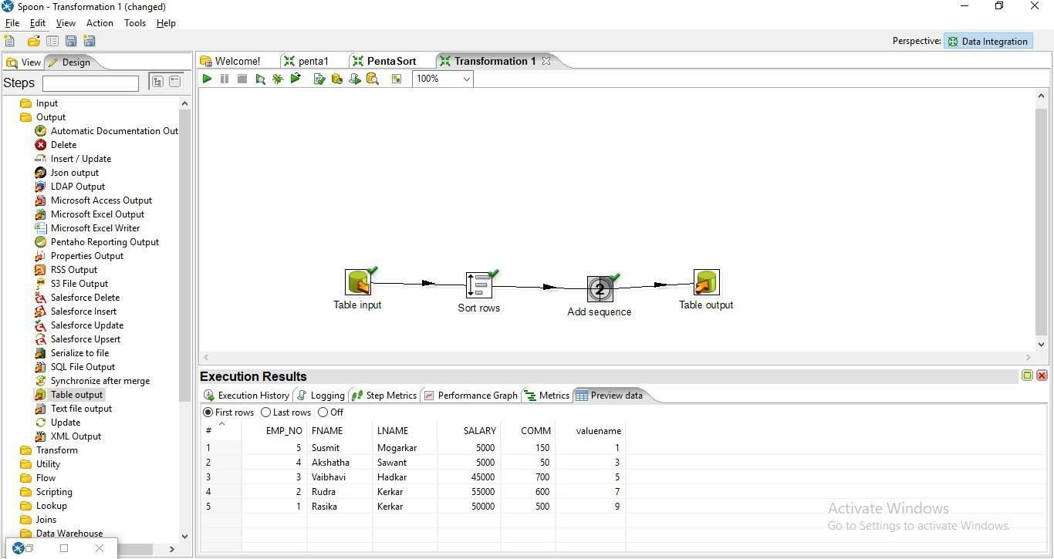

## Click on Database Fields

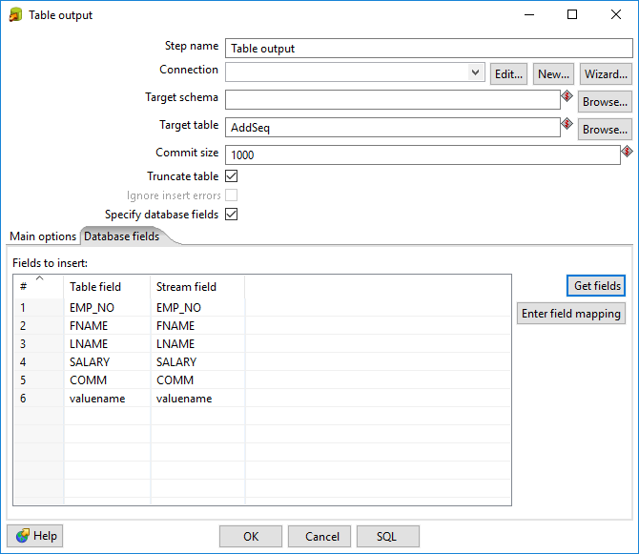

1. **Click on SQL**

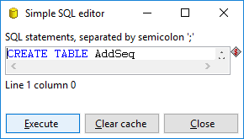

1. **Click on Execute an then press ok**

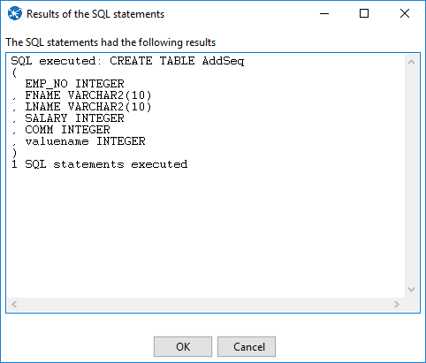

Step 16: Click on debug Transformation and then quick Launch

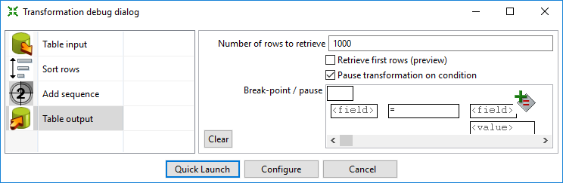

Output

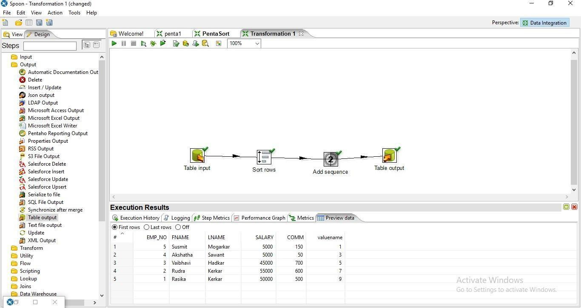

SQL> select * from AddSeq;

EMP_NO FNAME LNAME SALARY COMM VALUENAME

---------- ---------- ---------- ---------- ---------- ----------

|  |  |  |  |  |  |
| --- | --- | --- | --- | --- | --- |
| **5** | **Susmit** | **Mogarkar** | **5000** | **150** | **1** |
| **4** | **Akshatha** | **Sawant** | **5000** | **50** | **3** |
| **3** | **Vaibhavi** | **Hadkar** | **45000** | **700** | **5** |
| **2** | **Rudra** | **Kerkar** | **55000** | **600** | **7** |
| **1** | **Rasika** | **Kerkar** | **50000** | **500** | **9** |

## Calculator Operation

Step 1: Perform first 5 steps same as practical 1.

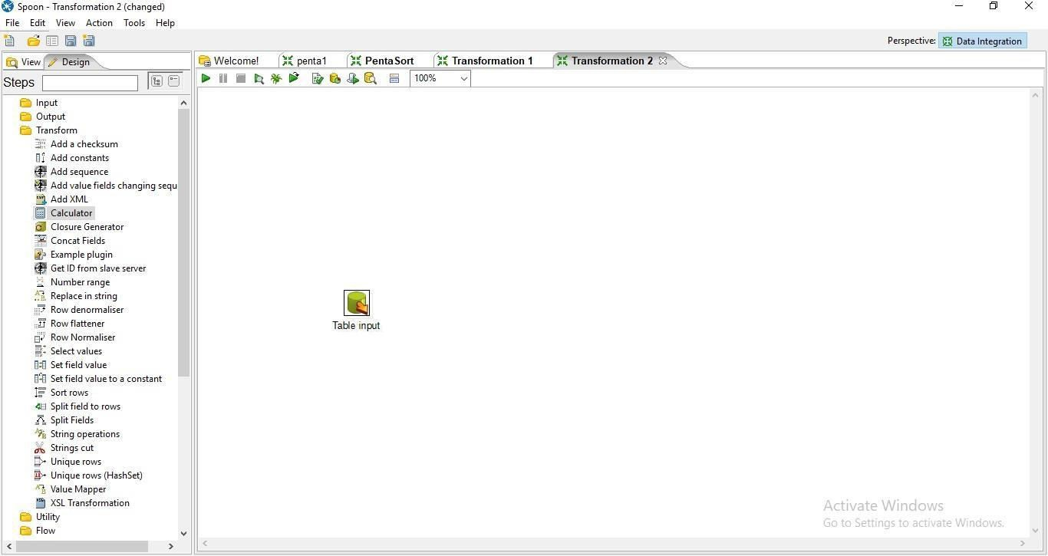

Step 2: Drag and Drop Calculator from transformation on the panel.

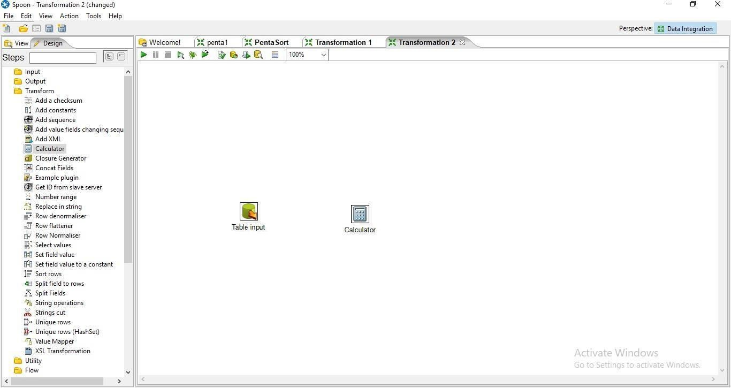

Step 3: Hold the mouse pointer on the Table input and drag the output connector to the calculator control.

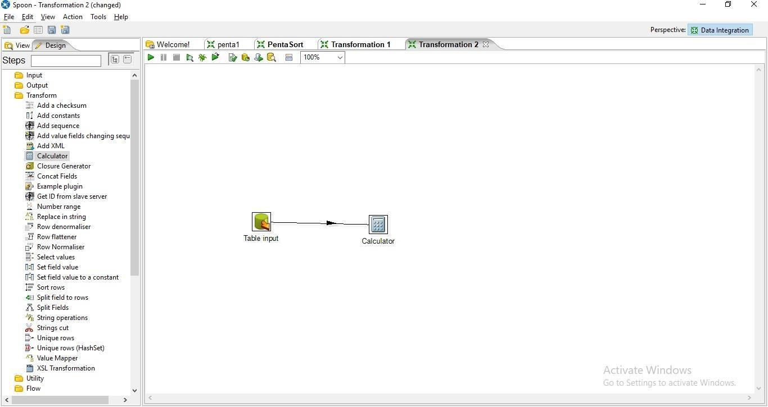

Step 4: Double Click on the Calculator

## specify the new field name

* 1. **select the calculation function.**

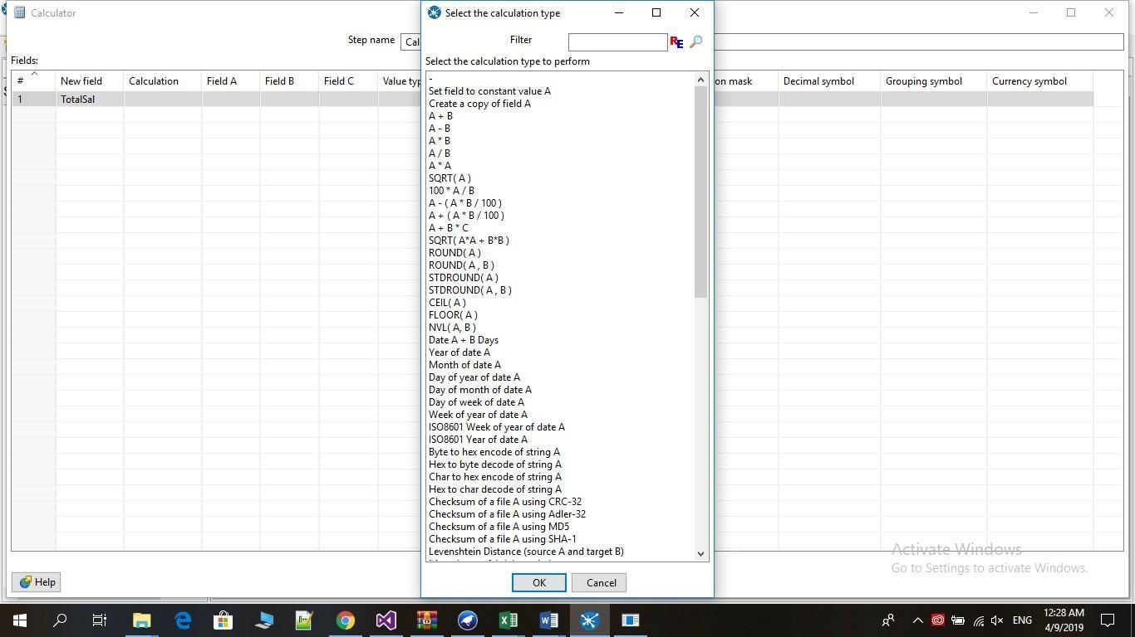

* 1. **Enter Field A, Field B, Value type and Length and press ok.**

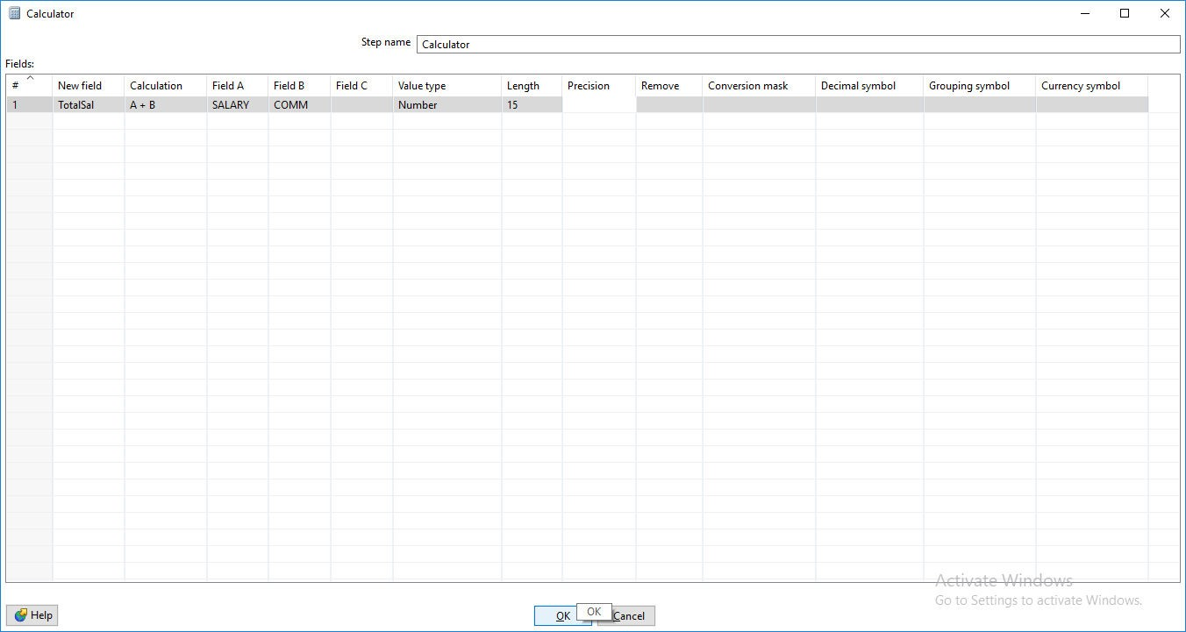

Step 5: Click on Debug transformation and click on Quick Launch.

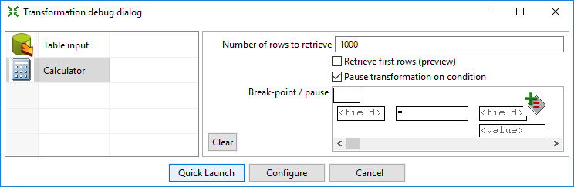

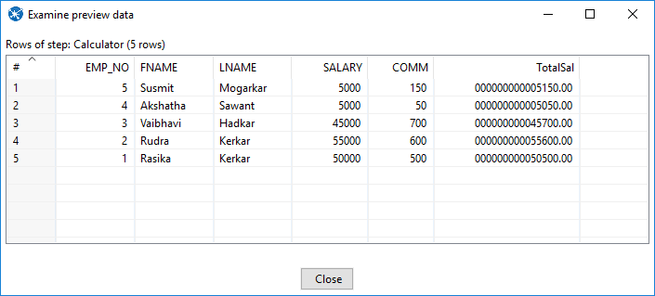

Step 6: Now Perform the steps 6-10 same as practical 1.

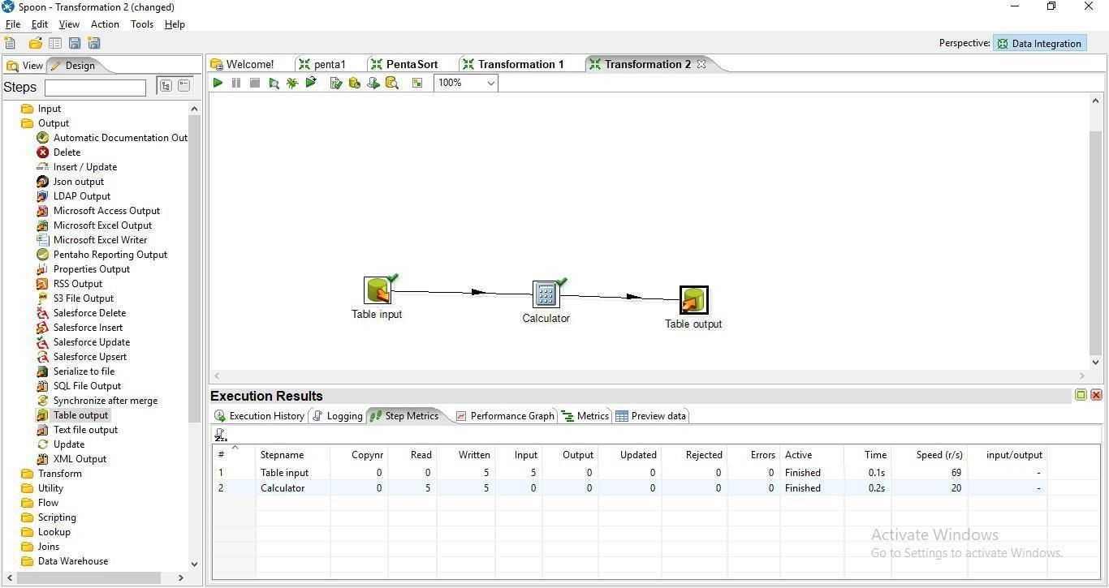

Step 7: Click on Debug Transformation and then click on Quick Launch

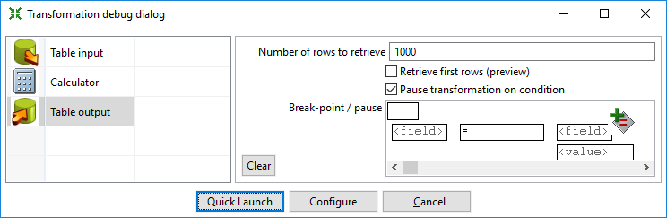

Output:

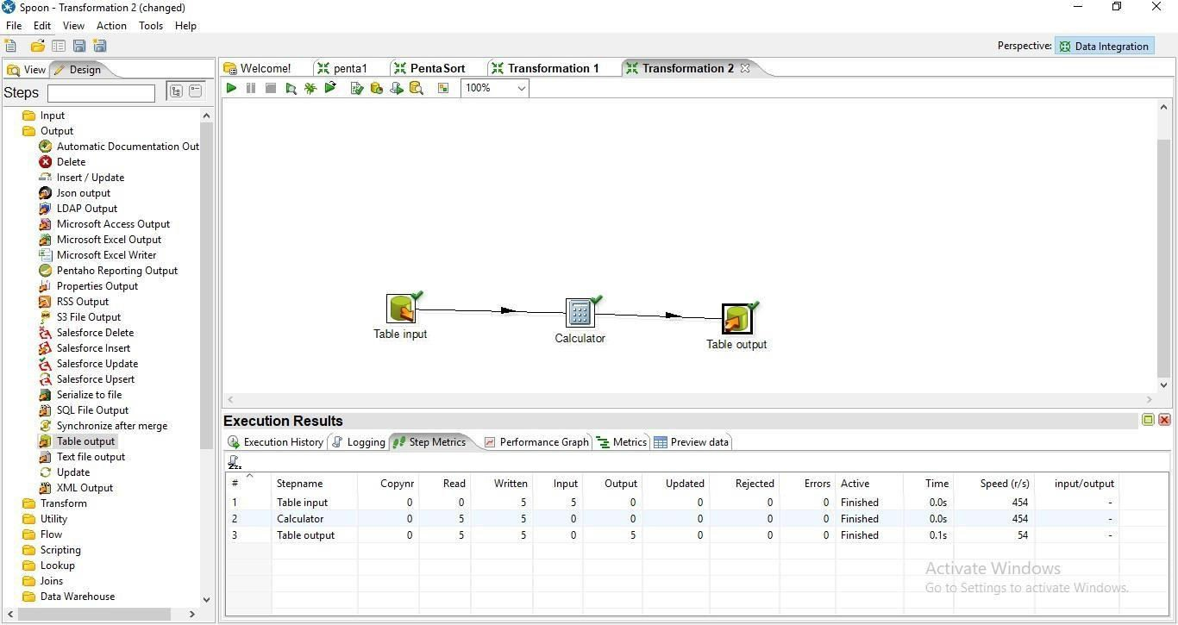

SQL> select * from calcTable;

EMP_NO FNAME LNAME SALARY COMM TOTALSAL

---------- ---------- ---------- ---------- ---------- ----------

|  |  |  |  |  |  |
| --- | --- | --- | --- | --- | --- |
| **1** | **Rasika** | **Kerkar** | **50000** | **500** | **50500** |
| **2** | **Rudra** | **Kerkar** | **55000** | **600** | **55600** |
| **3** | **Vaibhavi** | **Hadkar** | **45000** | **700** | **45700** |
| **4** | **Akshath** | **Sawant** | **5000** | **50** | **5050** |
| **5** | **Susmita** | **Mogarkar** | **5000** | **150** | **5150** |

## Concatenation Operation

Step 1: Perform first 6 steps same as practical 1.

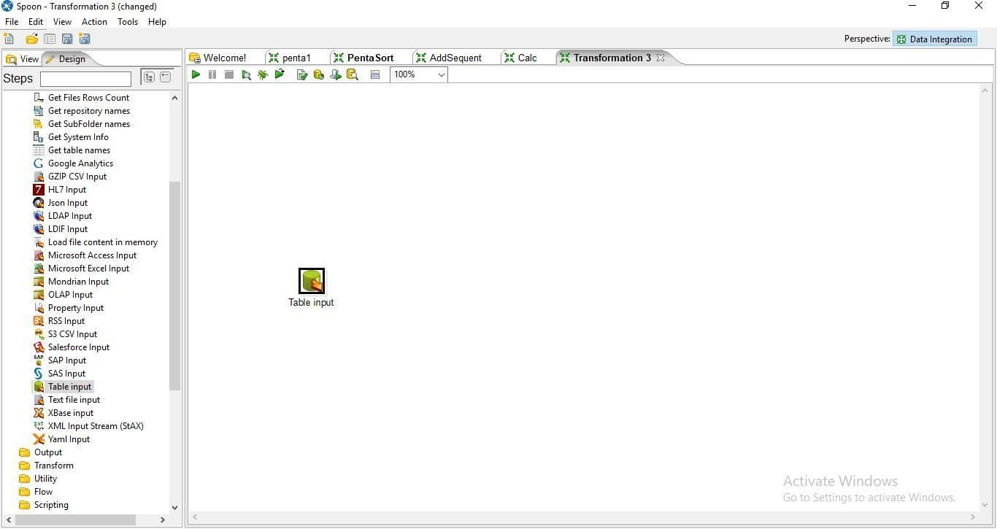

Step 2: Drag and drop Concat Field

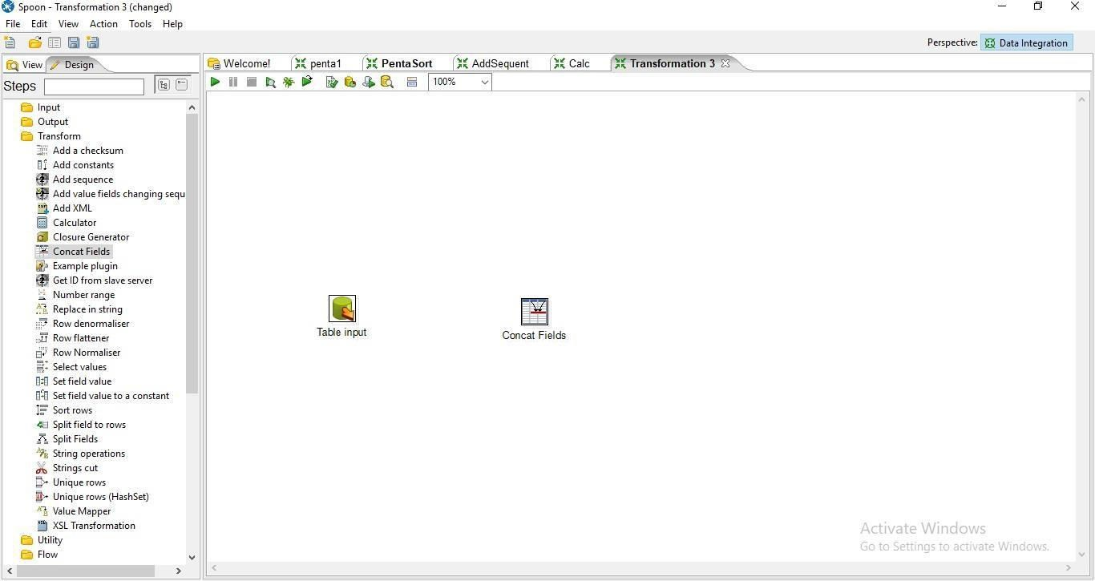

Step 4: Hold mouse pointer on input table and drag the output connector to the Concat field.

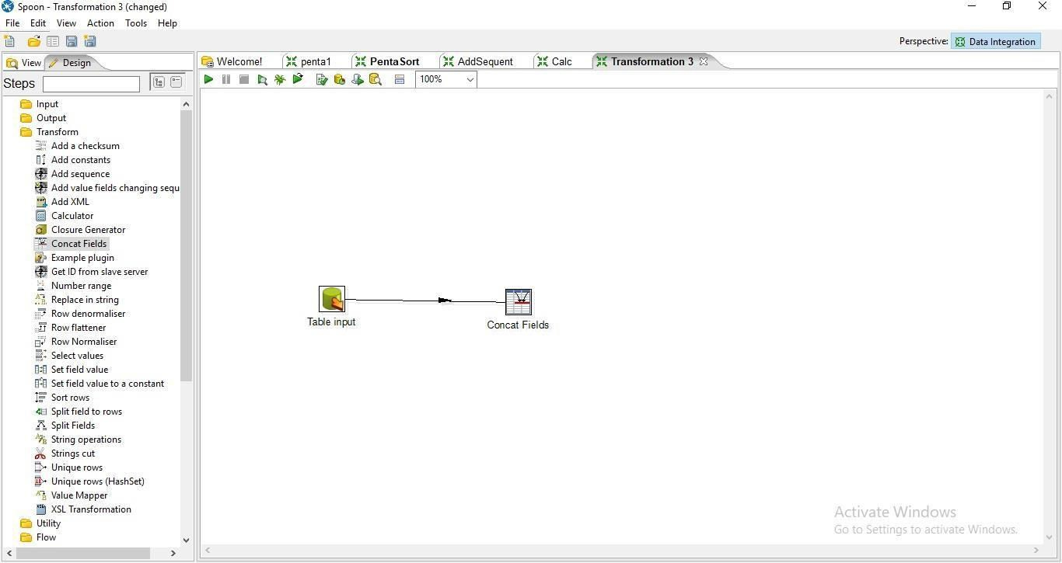

Step 5: Double Click on Cncat Field

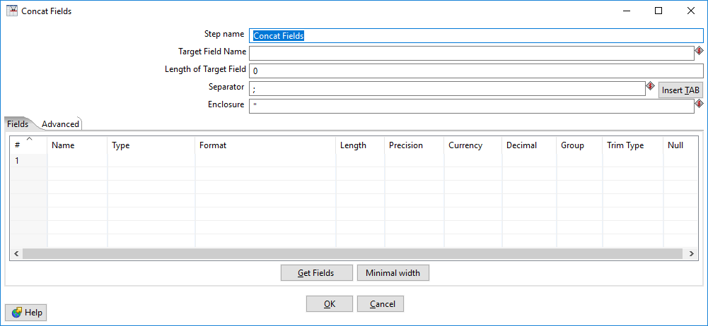

## Enter the values for Target Field Name, Length of the Target Field and the Seperator and press on Get Fields

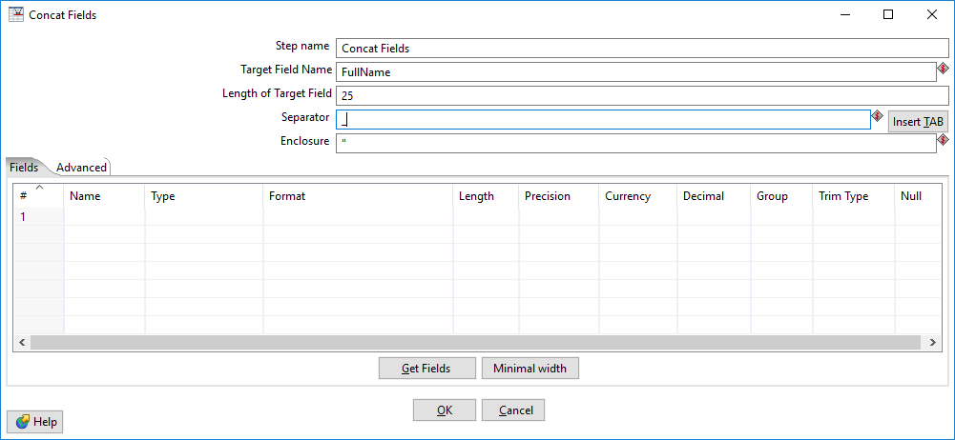

1. **Select the columns that you want to concat**

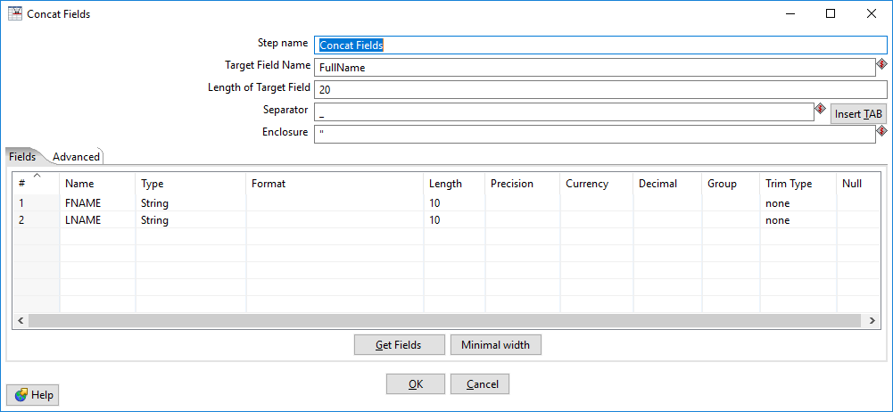

Step 6: Click on Debug transformation and click on Quick Launch.

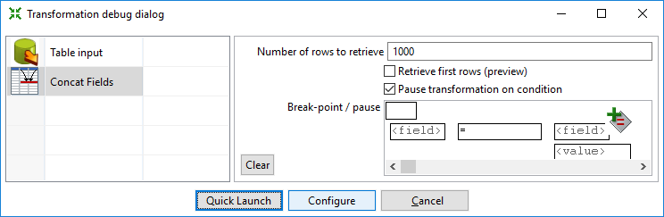

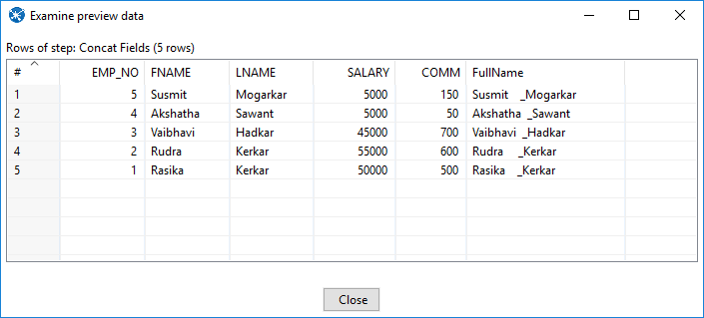

Step 7:Now Perform the steps 6-10 same as practical 1.

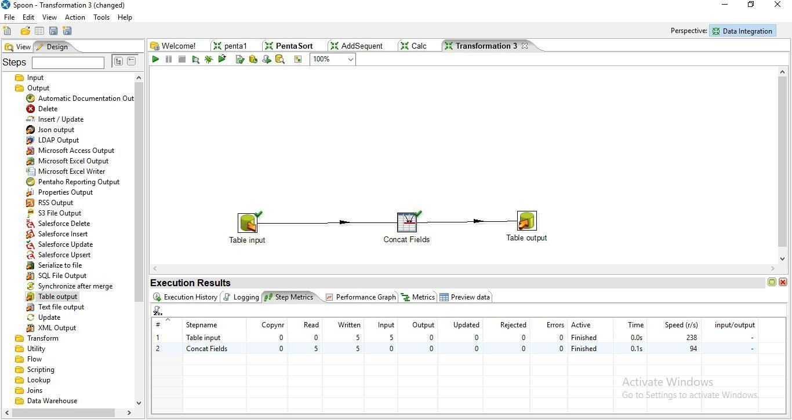

Step 8: Click on debug Transformation and click on Quick Launch

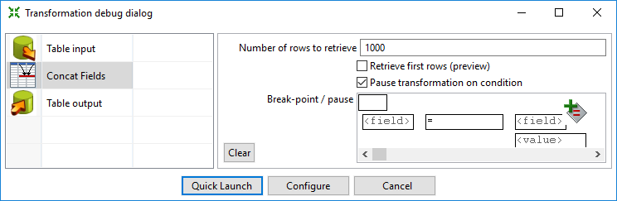

Output:

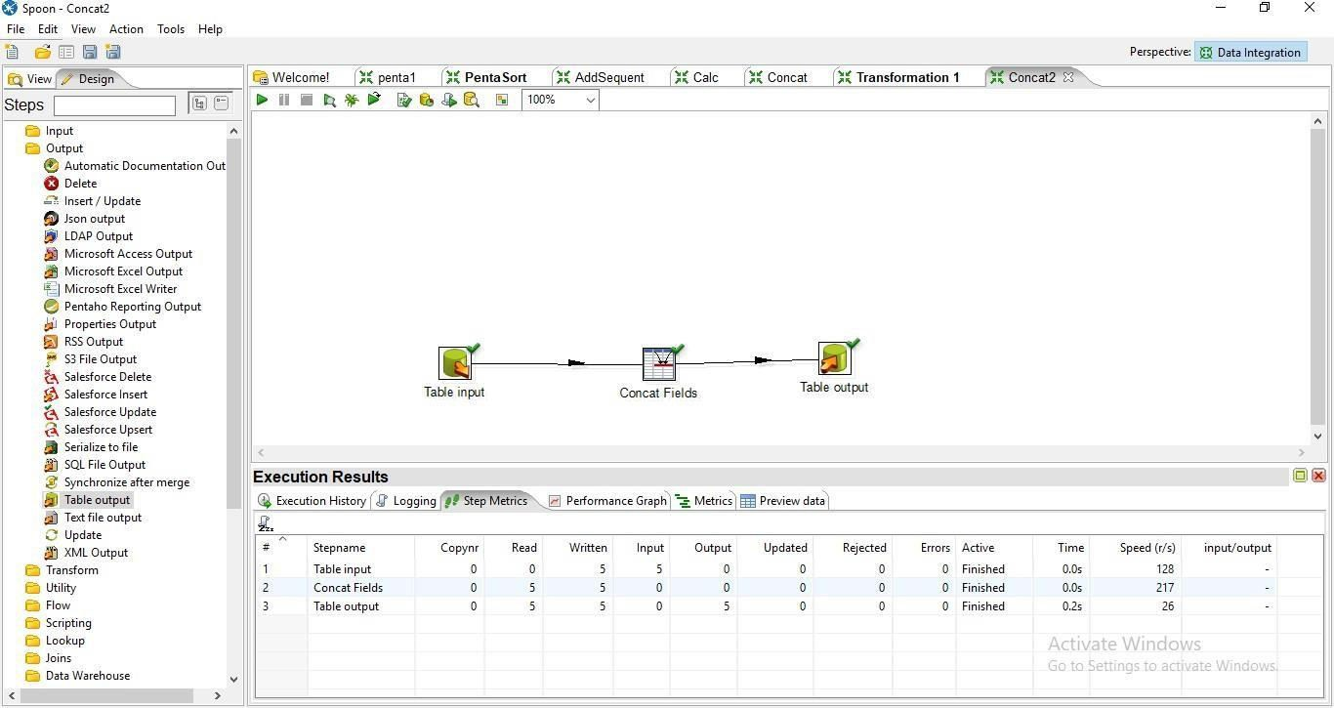



SQL> select * from Concat;

EMP_NO FNAME LNAME SALARY COMM FULLNAME

---------- ---------- ---------- ---------- ---------- -------------------------

## Rasika Kerkar 50000 500 Rasik

**a**

**_Kerkar**

* 1. **Rudra Kerkar 55000 600 Rudra _Kerkar**

|  |  |  |  |  |
| --- | --- | --- | --- | --- |
| **3 Vaibhavi** | **Hadkar** | **45000** | **700** | **Vaibhavi _Hadkar** |
| **4Akshatha** | **Sawant** | **5000** | **50** | **Akshatha _Sawant** |

**5 Susmit Mogarkar 5000 150 Susmit Mogarkar**

1. **Splitting Operation**

Step 1: Perform first 6 steps same as practical 1.

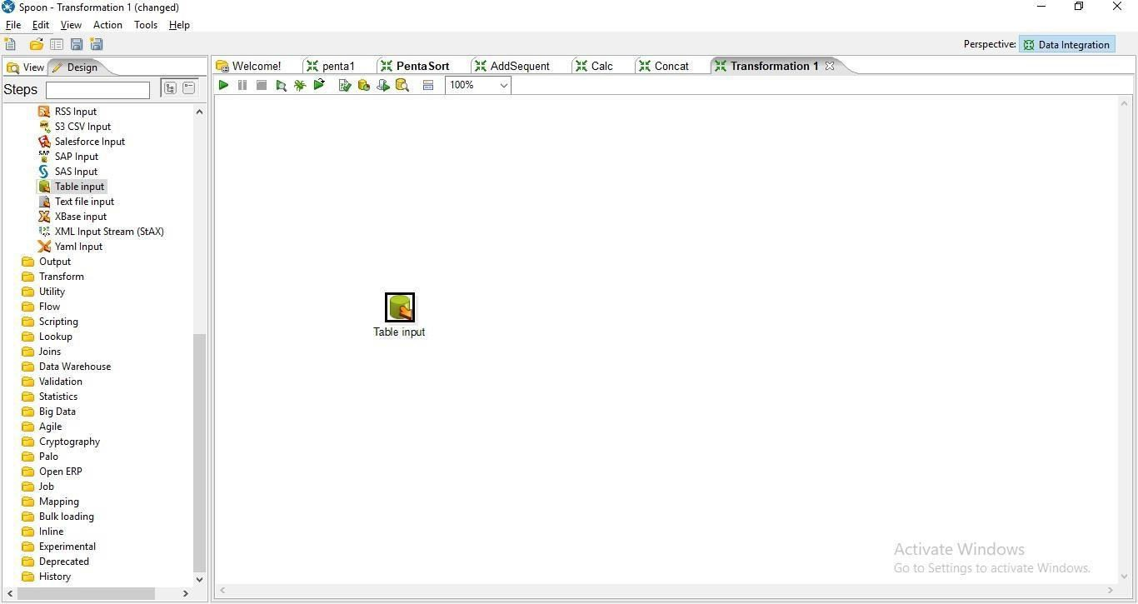

Step 2: Drag and drop Split Field on the Panel

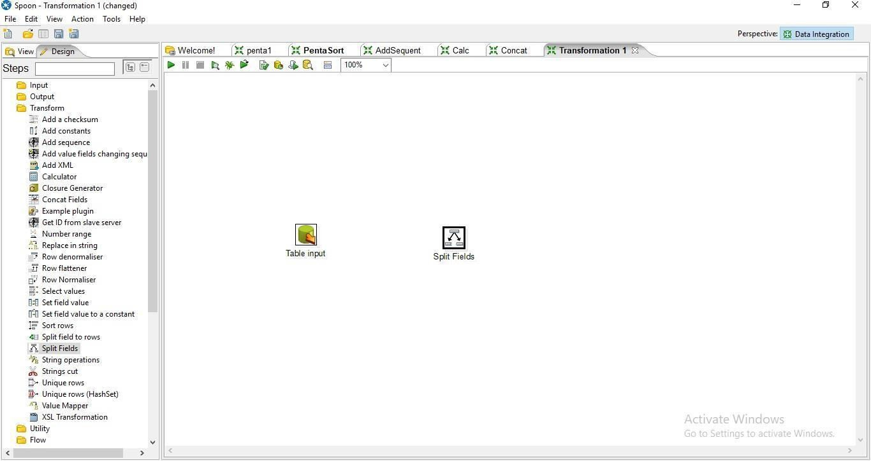

Step 3: Hold the mouse pointer og table input and drag it to the Split Field.

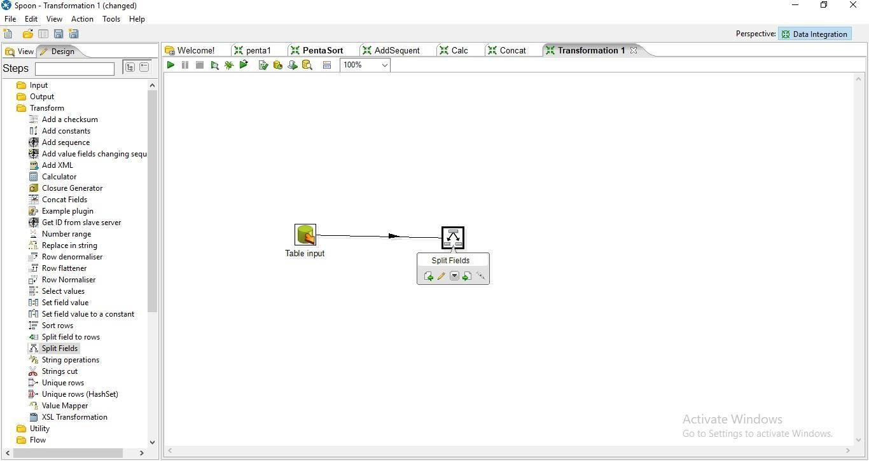

Step 4: Double Click On Split Field.

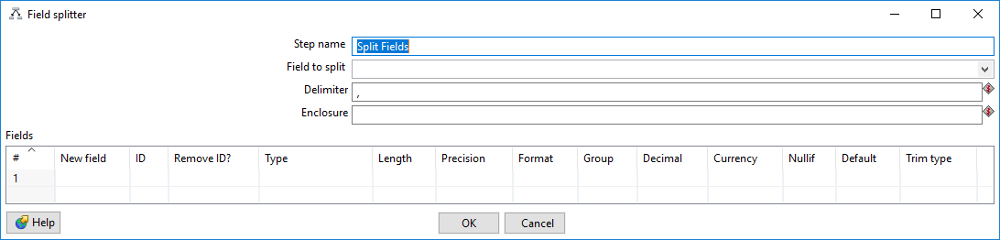

a. Enter the values For Field to Split, Delimiter and the field names and press ok

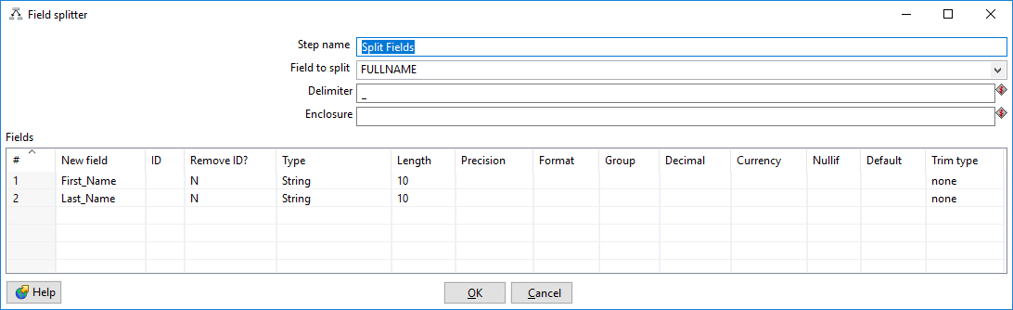

Step 6: Click on Debug transformation and Click on Quick Launch.

Step 7: Perform steps 6-10 same as practical 1.

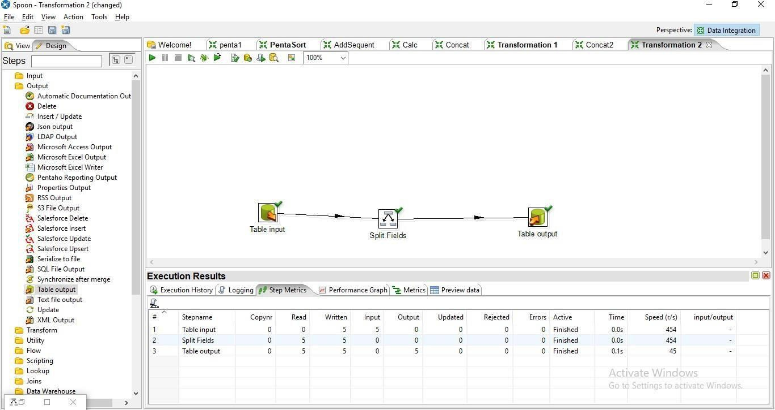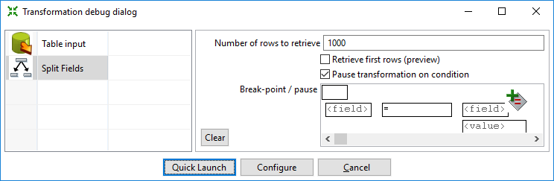

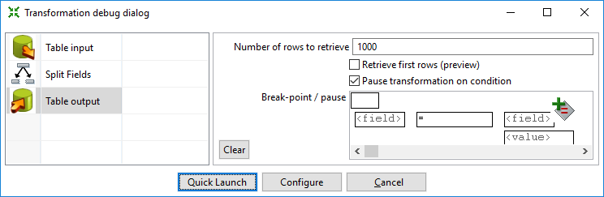

Step 8: Click on Debug transformation and Click on Quick Launch. Output:

SQL> select * from SlpitTable;

EMP_NO FNAME LNAME SALARY COMM FIRST_NAME LAST_NAME

|  |  |  |  |  |
| --- | --- | --- | --- | --- |
| 1 Rasika | Kerkar | 50000 | 500 | Rasika Kerkar |
| 2 Rudra | Kerkar | 55000 | 600 | Rudra Kerkar |
| 3 Vaibhavi | Hadkar | 45000 | 700 | Vaibhavi Hadkar |
| 4 Akshatha | Sawant | 5000 | 50 | Akshatha Sawant |
| 5 Susmit | Mogarkar | 5000 | 150 | Susmit Mogarkar |

**6. Number Range:**

Create Student table in SQL SQL> select * from student ;

## ROLL_N

**O**

**PERCENTA**

**GE**

**---------- ---------- 101 55**

**102 59**

**103 68**

**104 75**

**105 83**

**106 35**

**107 88**

7 rows selected. In Pentaho

Step 1: Perform first 6 steps same as practic

al

1.

### Step2: Drag and drop Number Range transformation and double click on it.

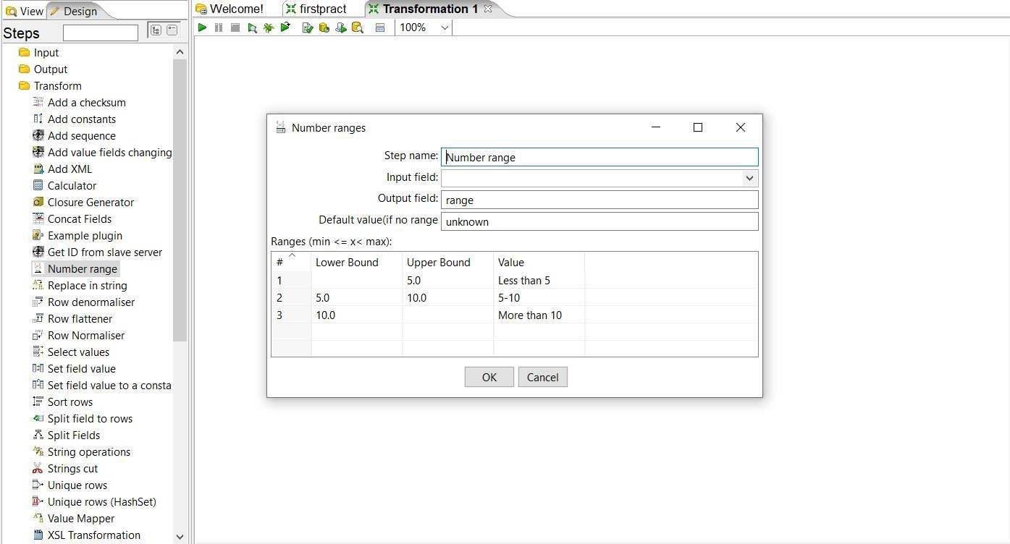

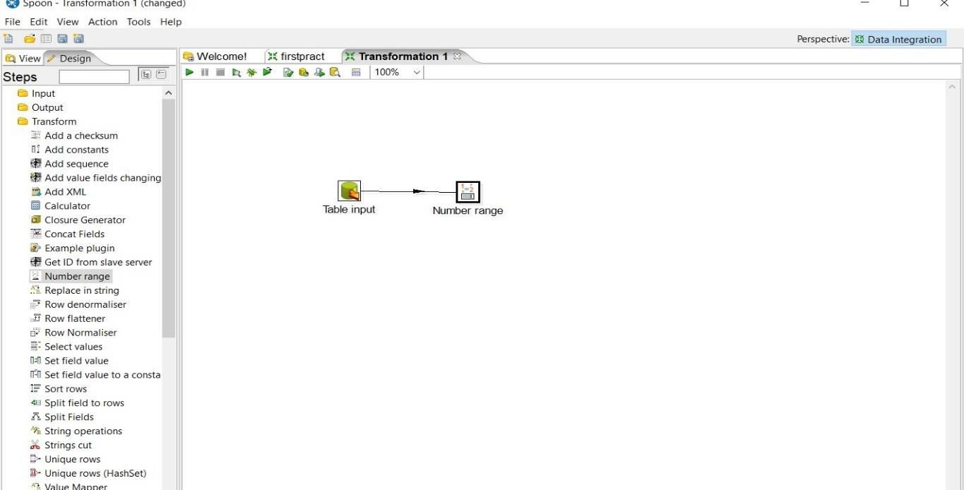

Step3: Set values for Input field, Output field, Lower bound, Upper bound and value according to the values specified in percentage column.

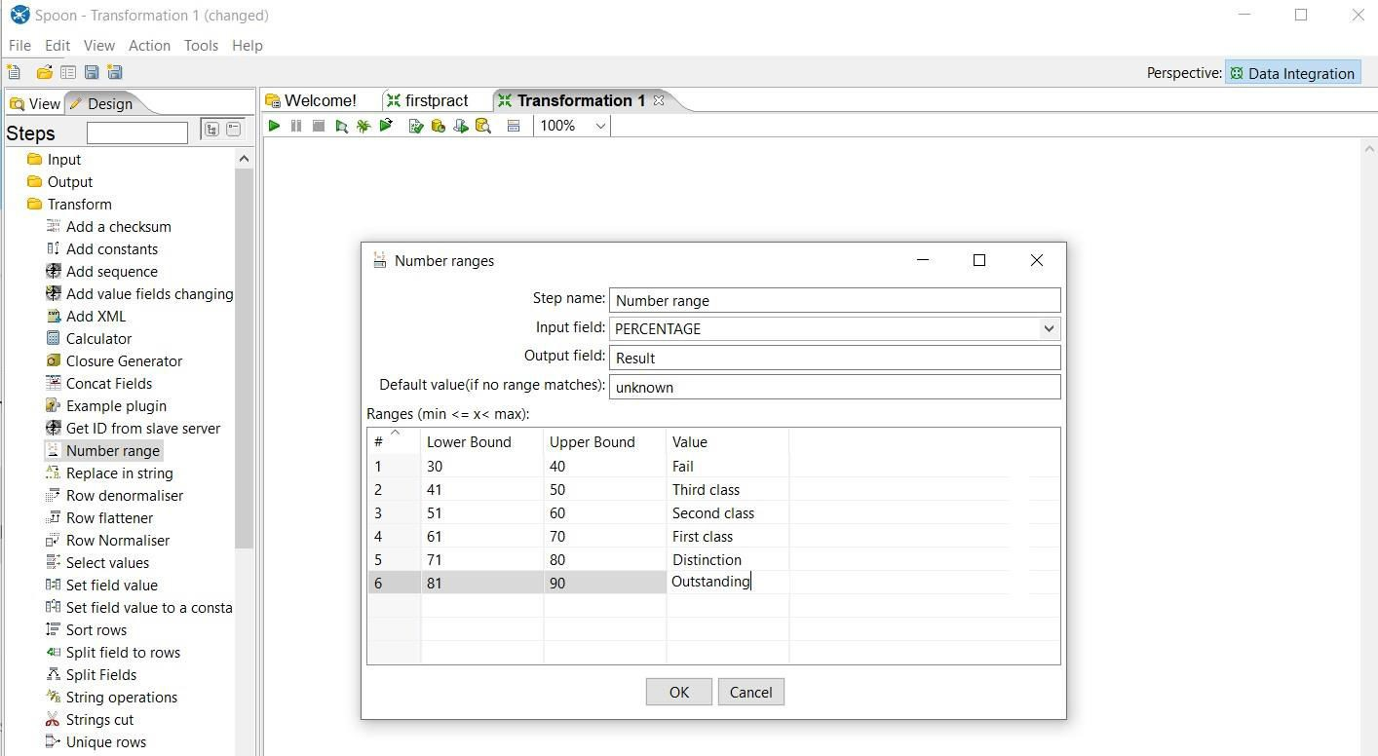

Step4: Click on Quick launch

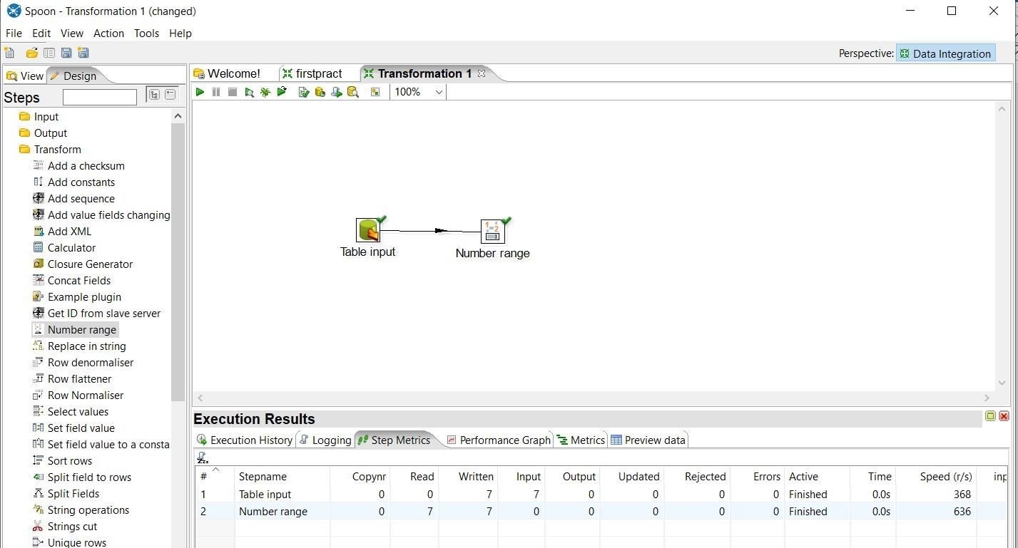

Step 5: Click on Preview data

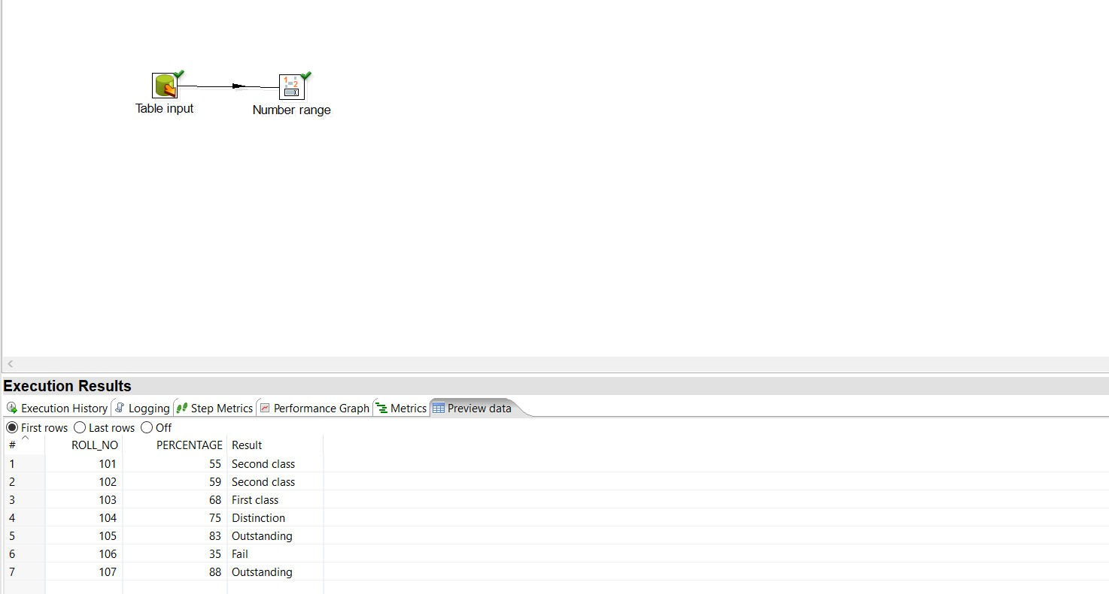

1. **String Operation:**

Required SQL table:

### SQL> select * from newemp;

EMPN ENAME DEPT JOB SALARY

E001 John D002 Manager 50000

|  |  |  |  |  |
| --- | --- | --- | --- | --- |
| E002 | Smit | D001 | Hr | 40000 |
| E003 | steven_king | D002 |  | 30000 |
| E004 | Lex Hean | D003 | Manager | 14000 |
| E005 | Bruce | D003 | Manager | 17000 |
| E006 | Kevin#Nash | D002 | Sales | 18000 |

6 rows selected.

Step 1: Perform first 6 steps same as practical 1.

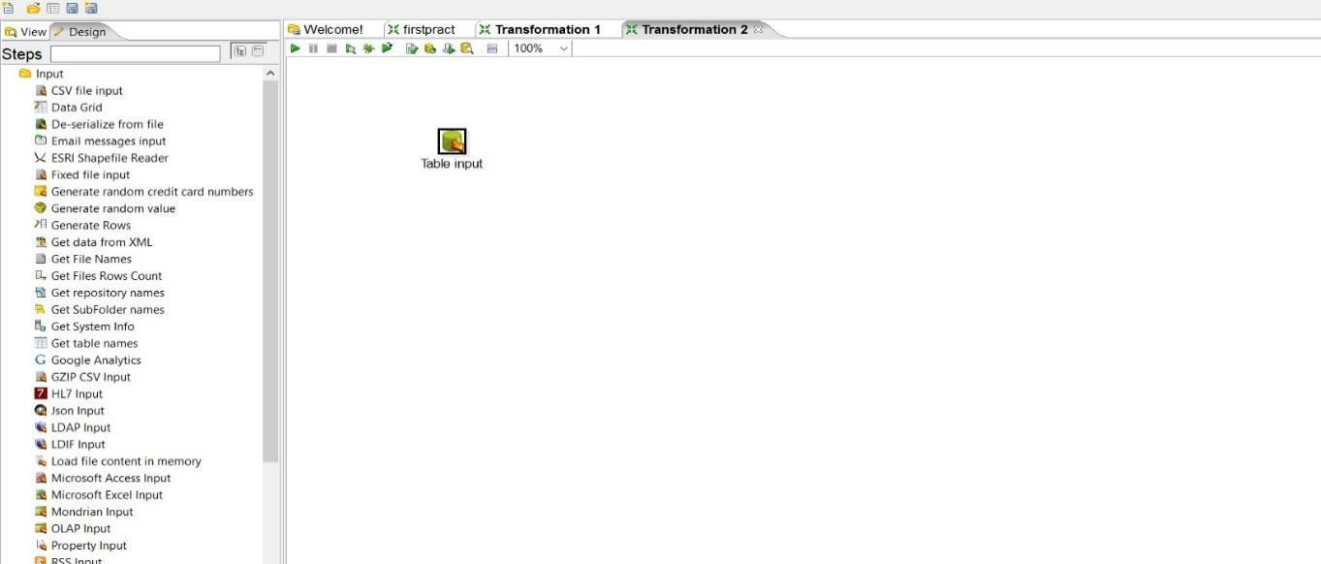

### Step 2: Drag and drop String operation transformation, make connection between table input and string operation and double click on it.

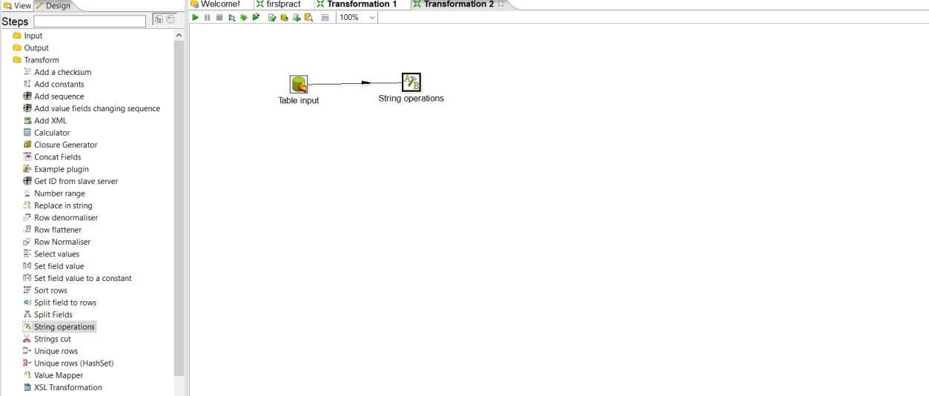

Step3: Set values for the parameters

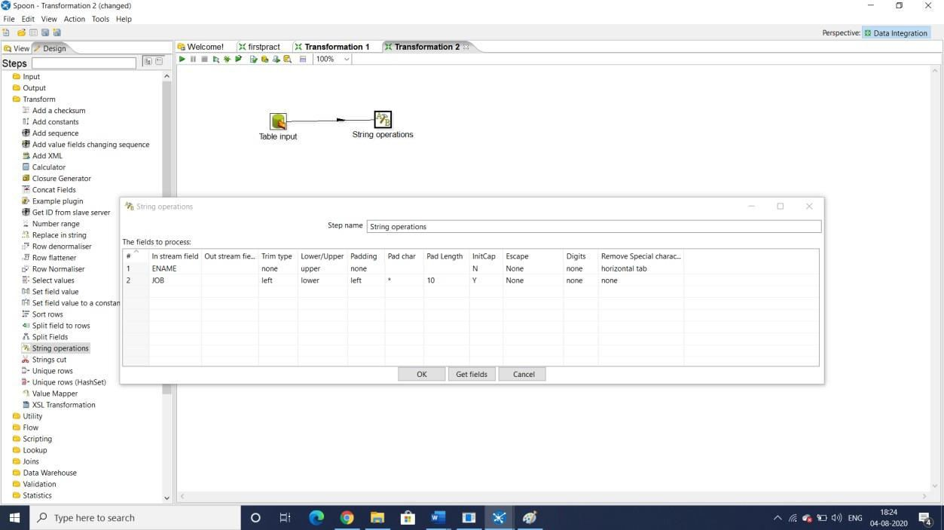

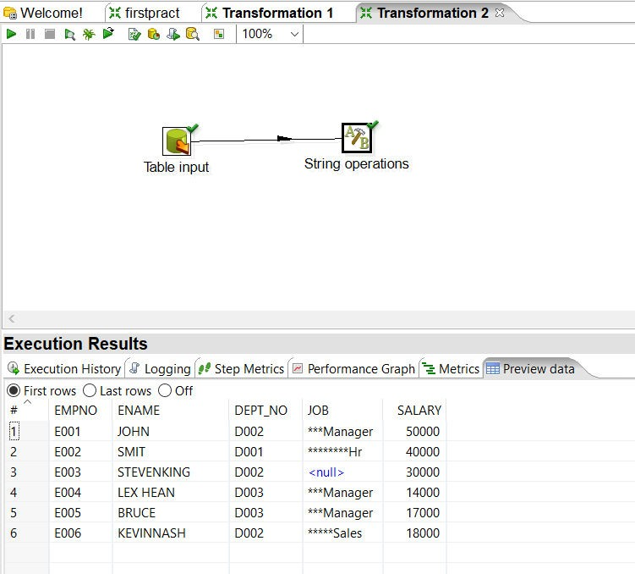Step 4: Launch the transformat

ion

Step 5: Drag and drop output table

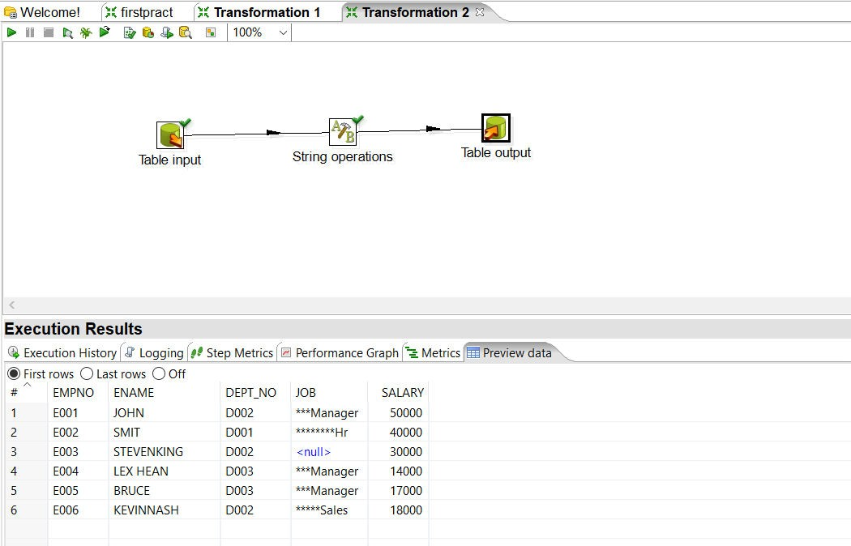

Step 6: Launch the transformation

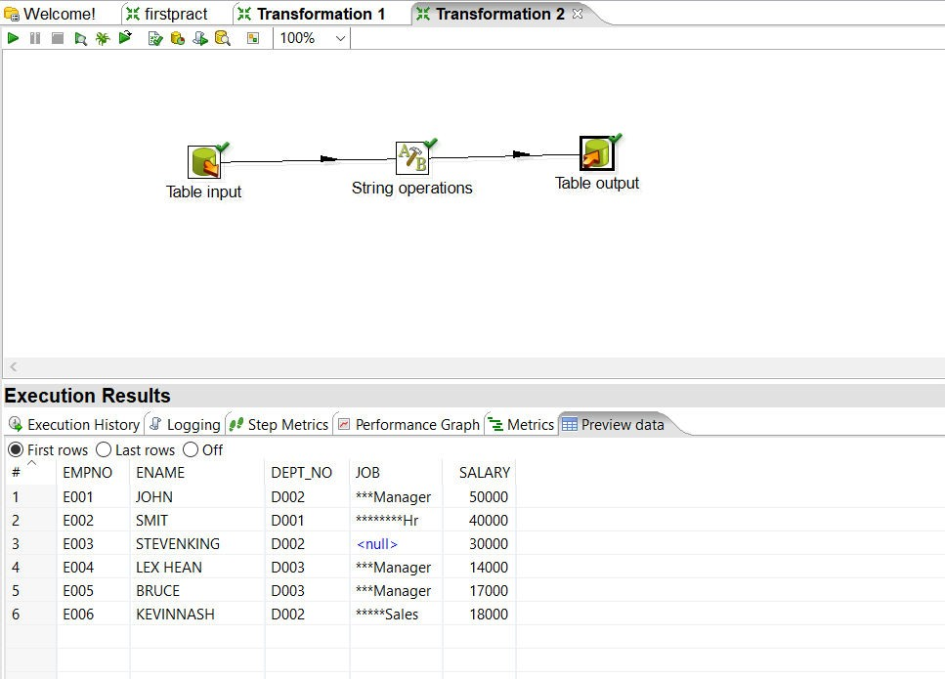

Step 7: In SQL output table SQL> select * from stringtable;

EMPN ENAME DEPT JOB SALARY

### E001 JOHN D002 ***Manager 50000

E002 SMIT D001 ********Hr 40000

E003 STEVENKI NG

D002 30000

E004 LEX HEAN D003 ***Manager 14000 E005 BRUCE D003 ***Manager 17000

E006 KEVINNA SH

D002 *****Sales 18000

6 rows selected.

##### Copy contents of.CSV file to the target table Step1:Drag and drop CSV file input on a panel

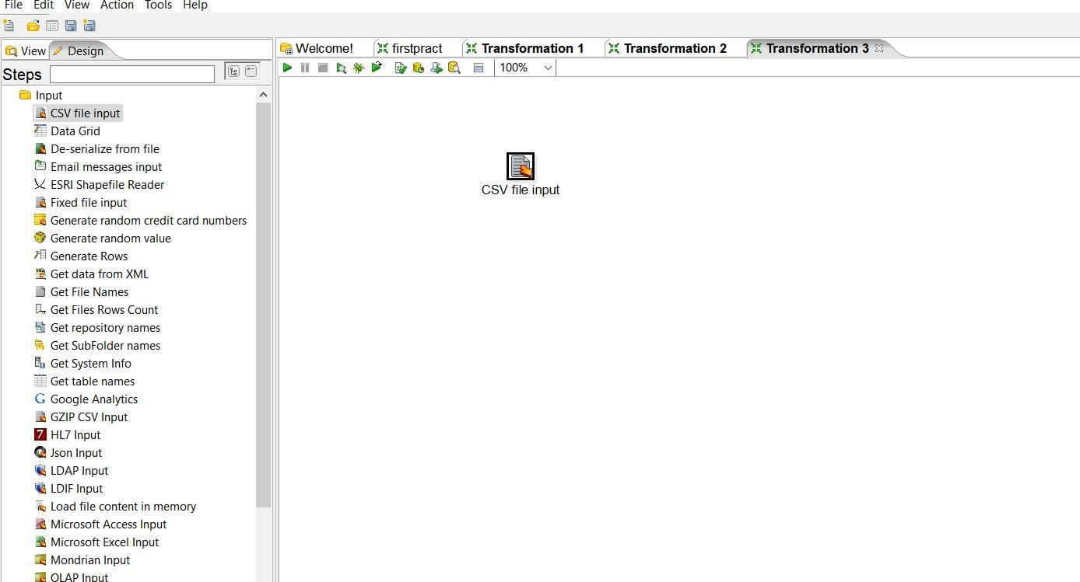

Step2: Double click on it and open respective CSV file, Lazy conversation and Header row present? Options should be checked, click on Getfield and then ok.

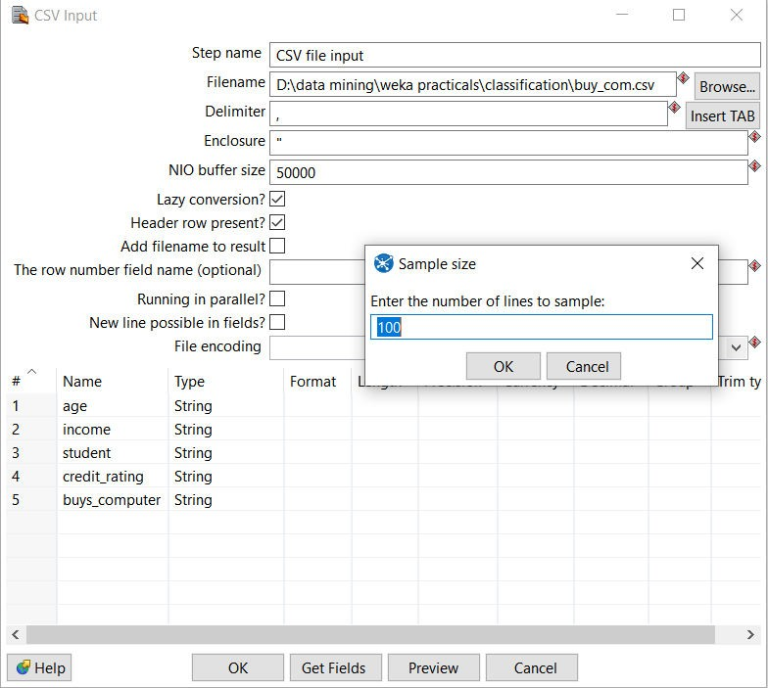

In this step we can change data type and format of CSV files after doing setting click on ok

53

Step3: Drag and drop Table output and connect it with CSV file.

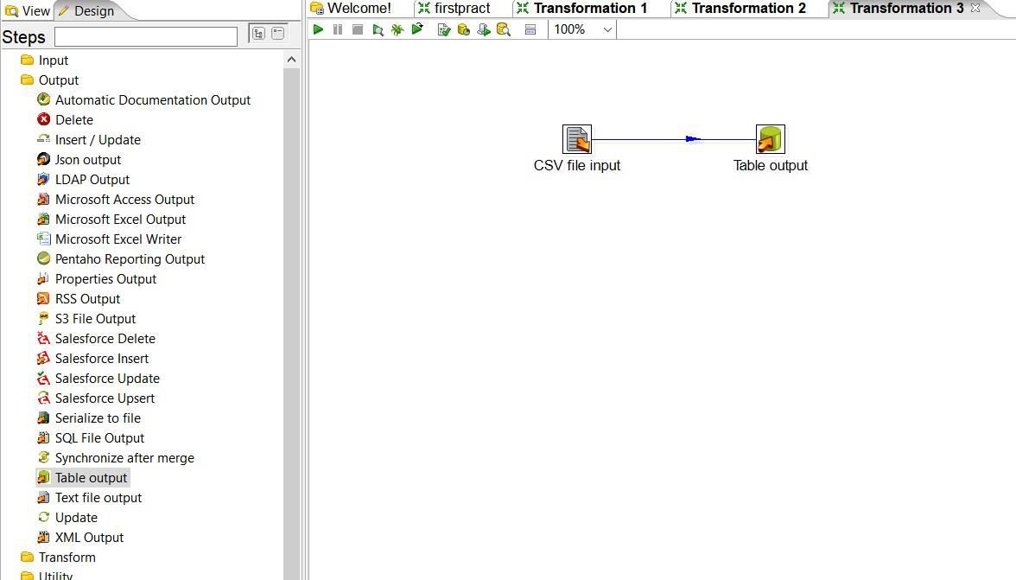

Step4: Double click on Table output and create new connection and follow same stapes like before and launch the transformation.

54

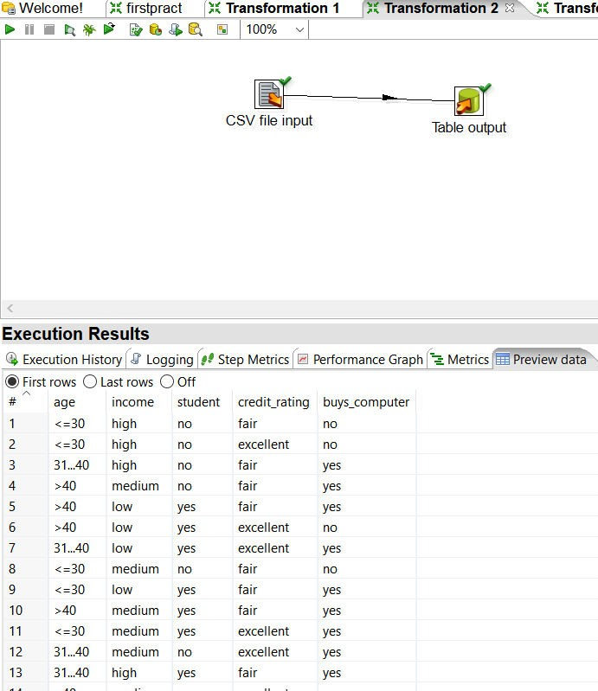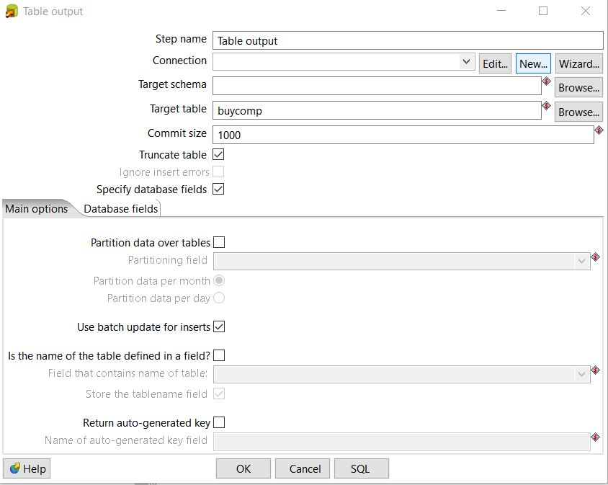

Step 5: Output table created in SQL SQL> select * from buycomp;

AGE INCOME STU CREDIT_RA BUY

### <=30 high no fair no

<=30 high no excellent no 31...40 high no fair yes

>40 medium no fair yes

>40 low yes fair yes

>40 low yes excellent no 31...40 low yes excellent yes

<=30 medium no fair no

<=30 low yes fair yes

>40 medium yes fair yes

<=30 medium yes excellent yes

AGE INCOME STU CREDIT_RA BUY

31...40 medium no excellent yes 31...40 high yes fair yes

>40 medium no excellent no

14 rows selected.

1. **Implement the merge join transformation on tables** Step1: Drag two Data grid on panel rename them with Employee and Department respectively.

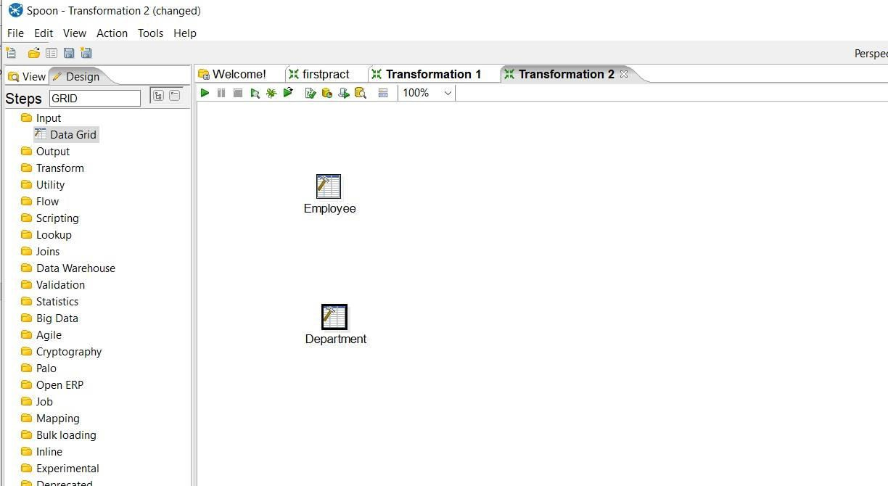

### Step2: Insert Records into respective grids.

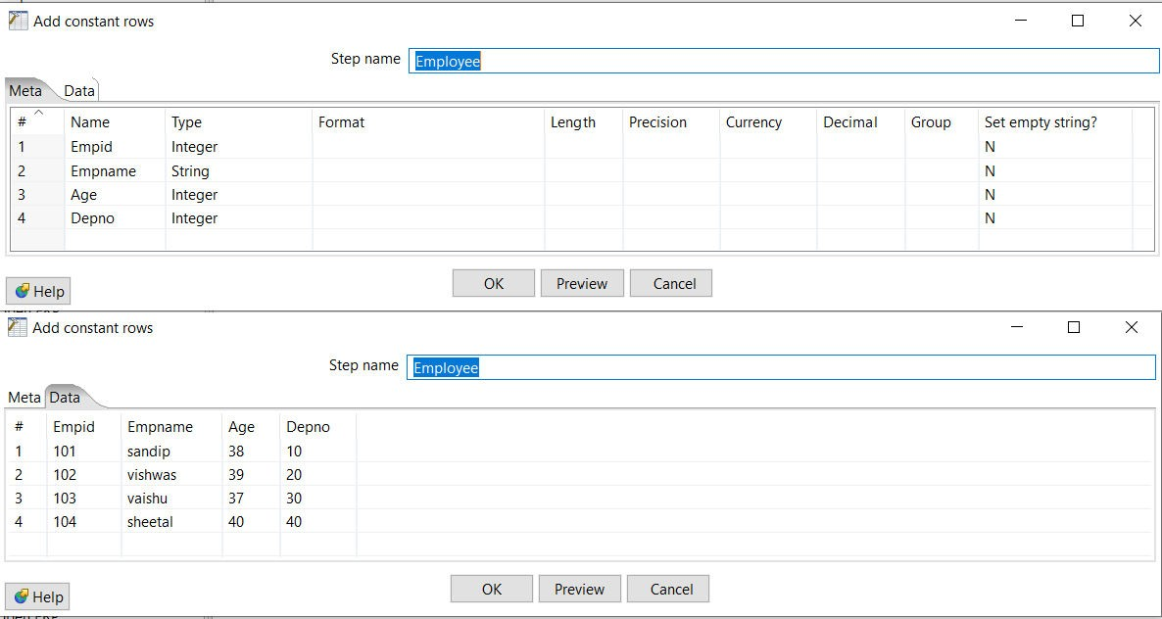

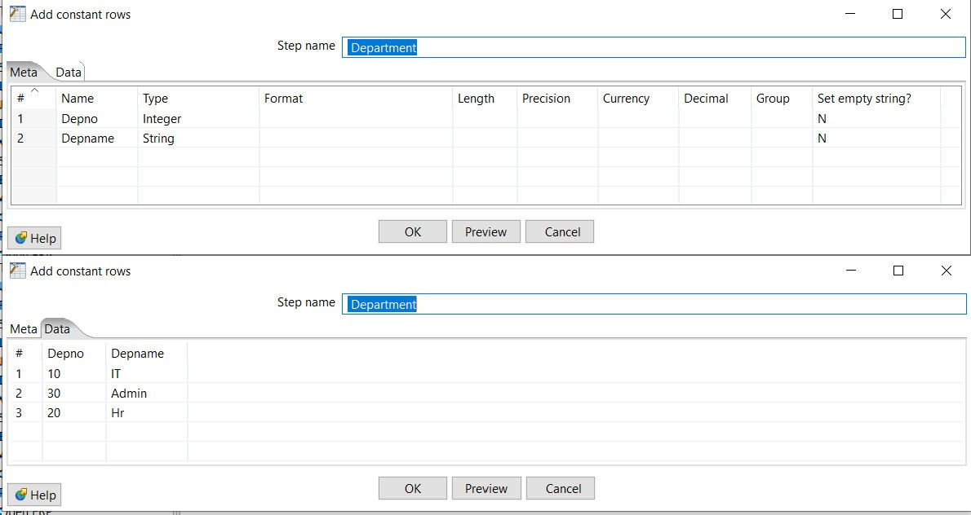

Step3: Insert sort rows transformation(on Empid) for both Employee and Department.

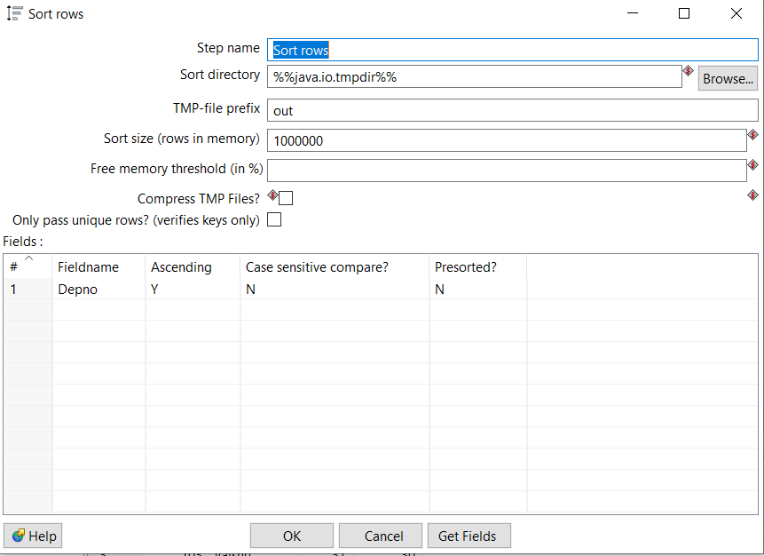

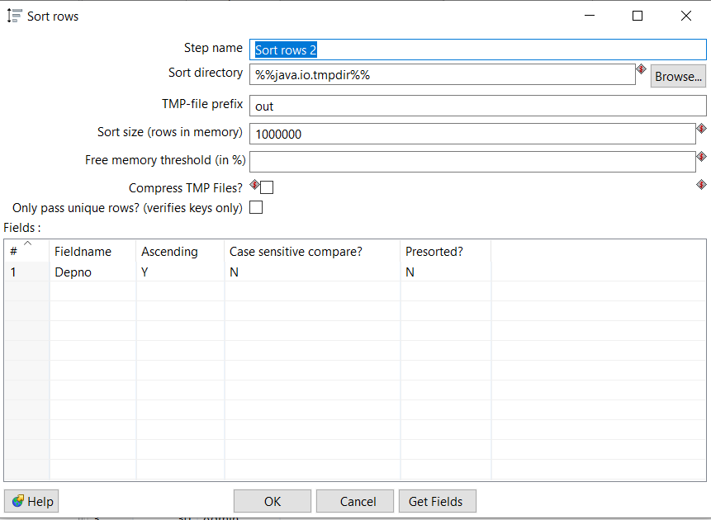

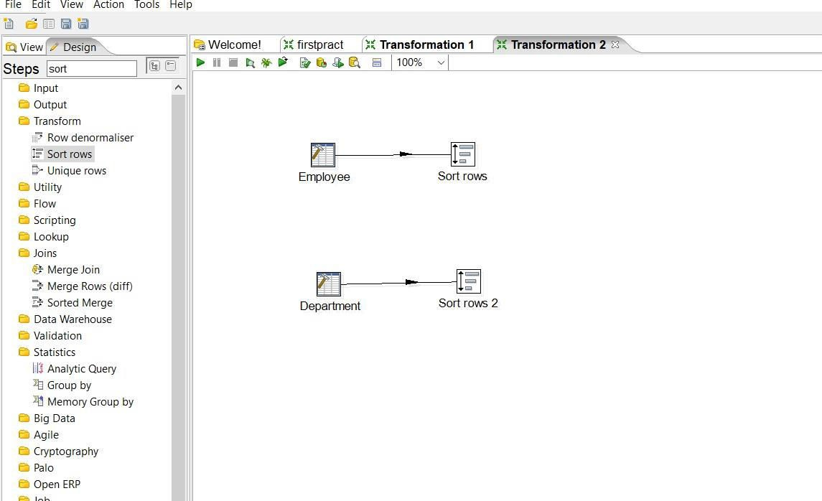

Step4: Add Merge join From Joins and connect it with sort rows.

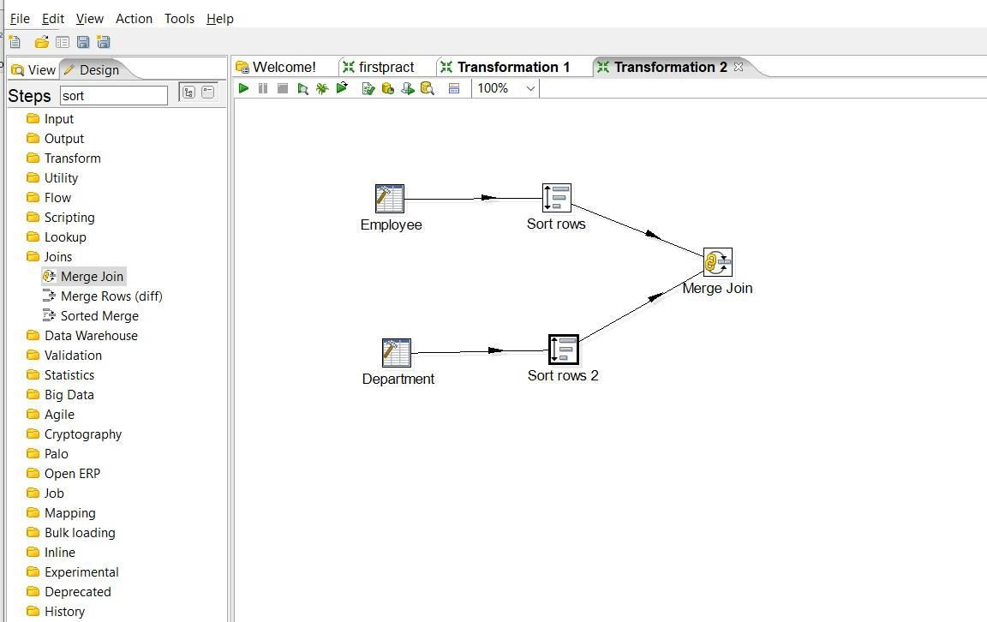

Step5: Double click on Merge join and made necessary settings First select First_step, then Second_step, select Join type INNER, and from get fields select Depno only, after that quick launch the transformation.

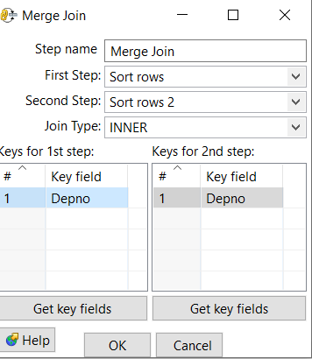

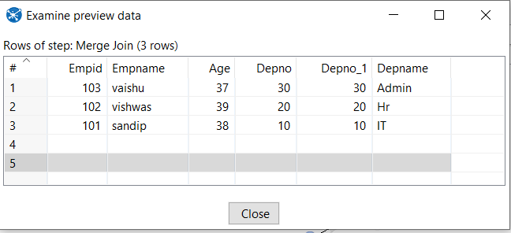

Step 6: Select Join Type Left Outer, then Right Outer and finally Full Outer join

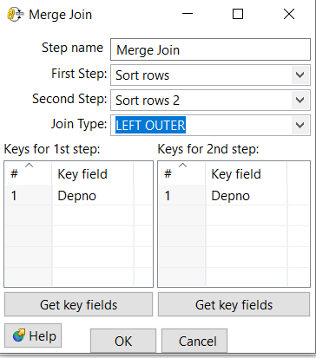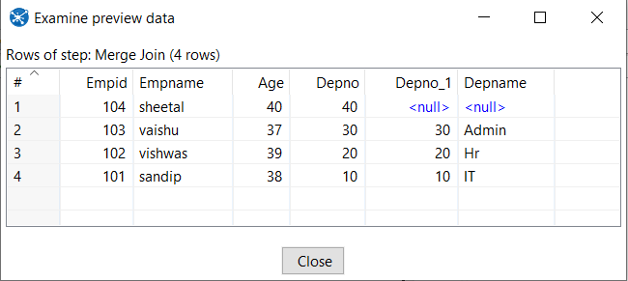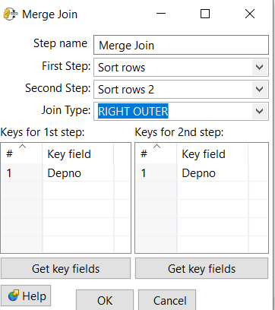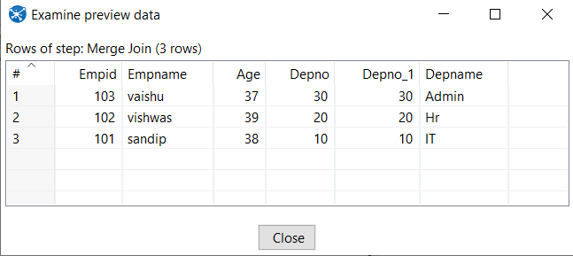

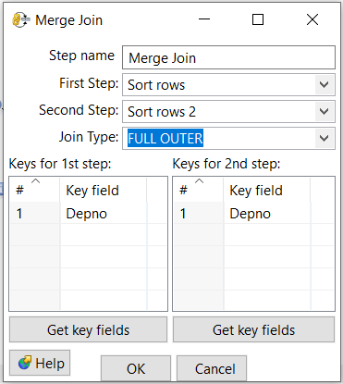

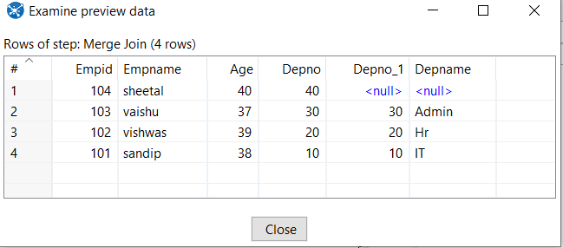

1. **Implement different data validations on table.**

Step1: Drag and drop Data grid on panel.

Step2: Double click on Data grid and create product table in Meta tab and enter records into it using Data tab.

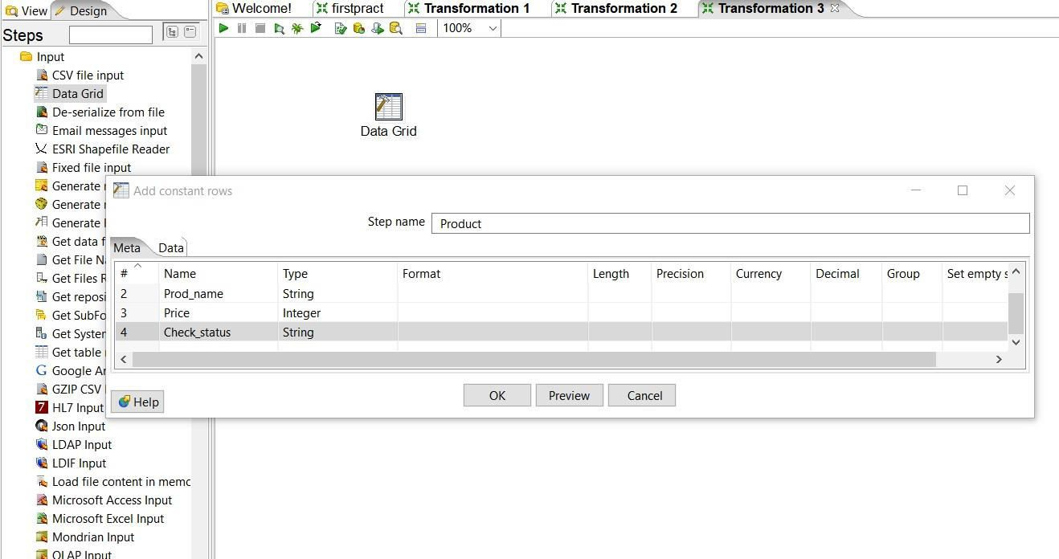

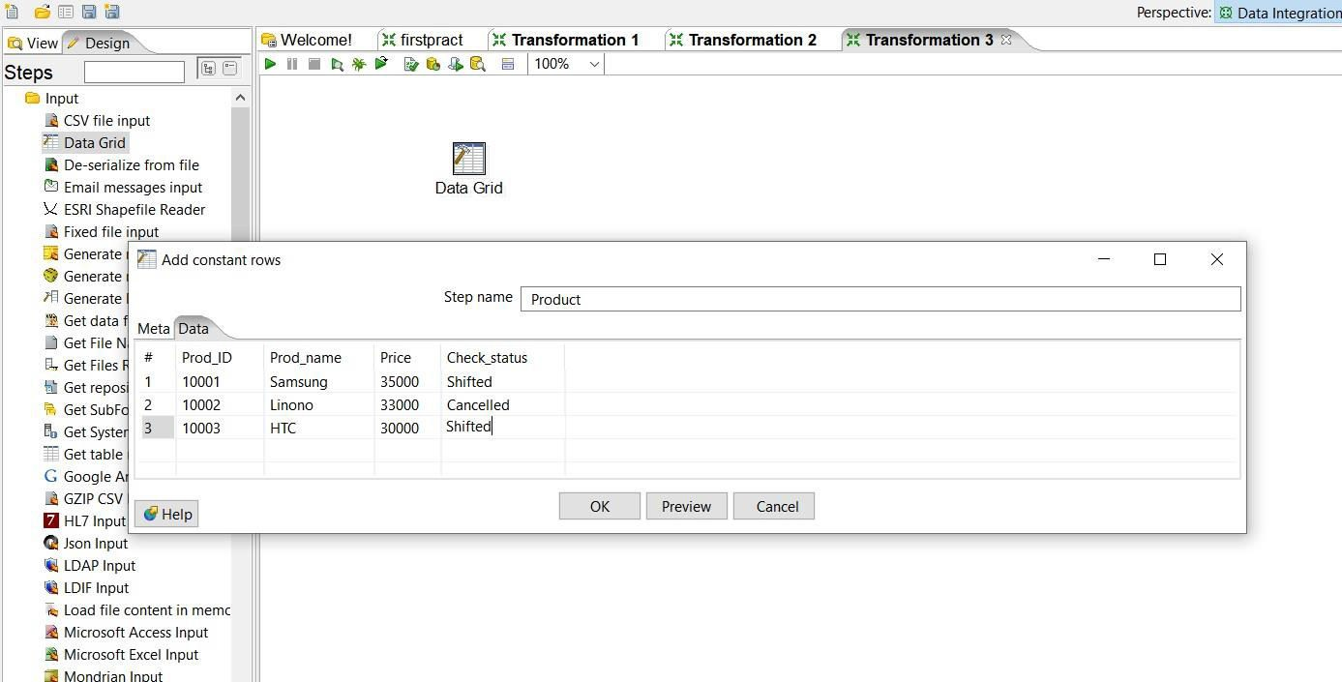

Step3: Go to Validation steps and select, Drag and Drop Data validator on panel and double click on it.

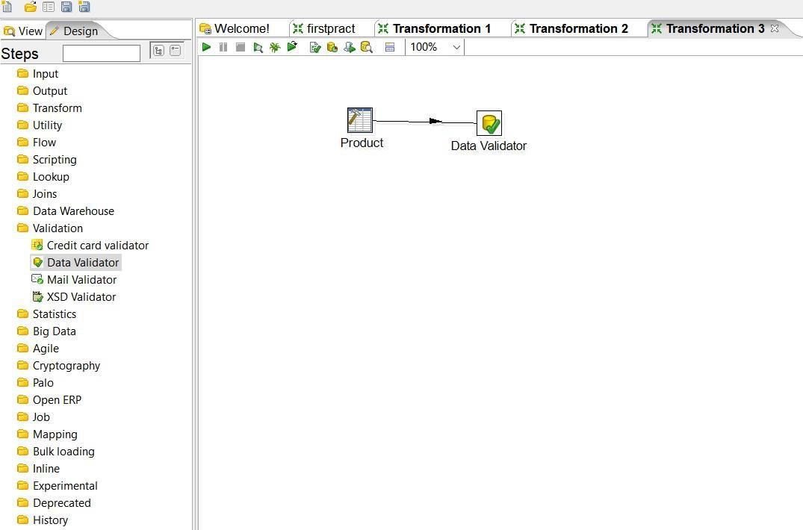

Step4: Click on new validation button and give new name to validation.

64

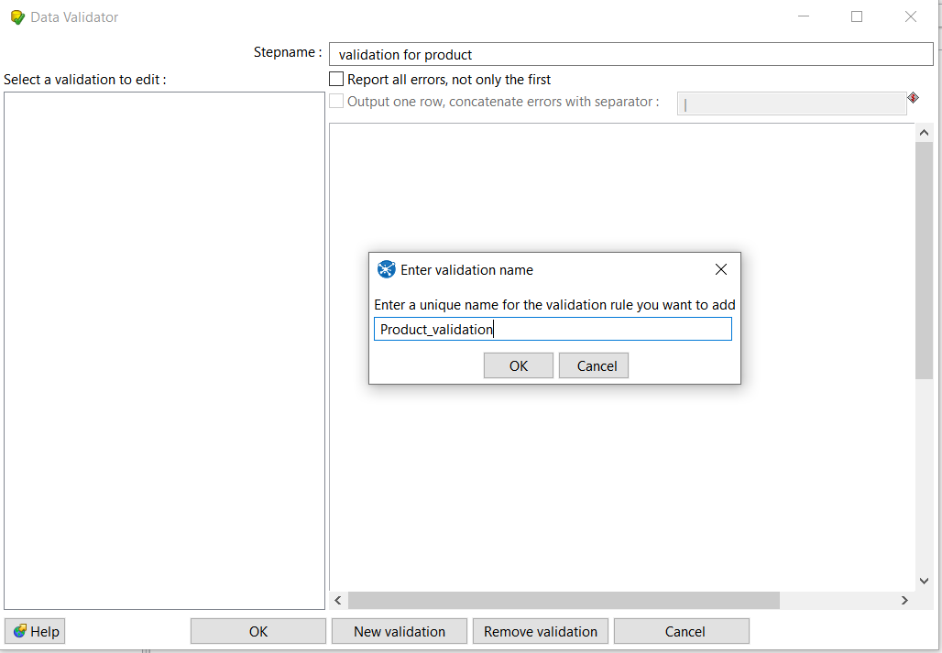

Once new validation is created it will appear on left panel, double click on it to set data validation

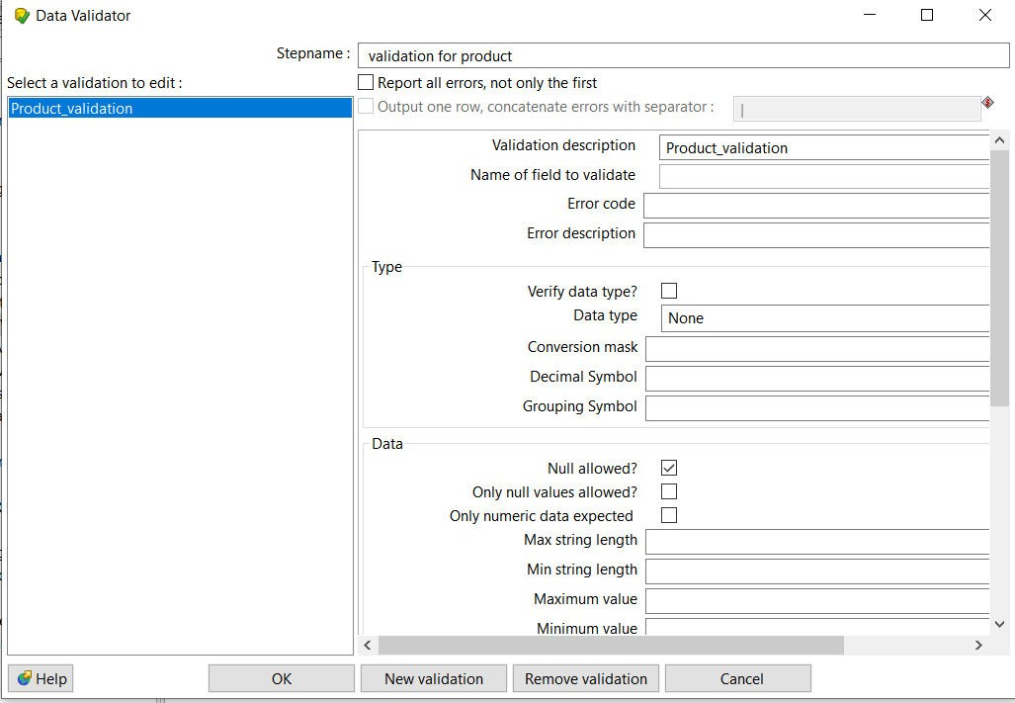

Step5: Set values for Name of field to validate=check status, and Data type

=string

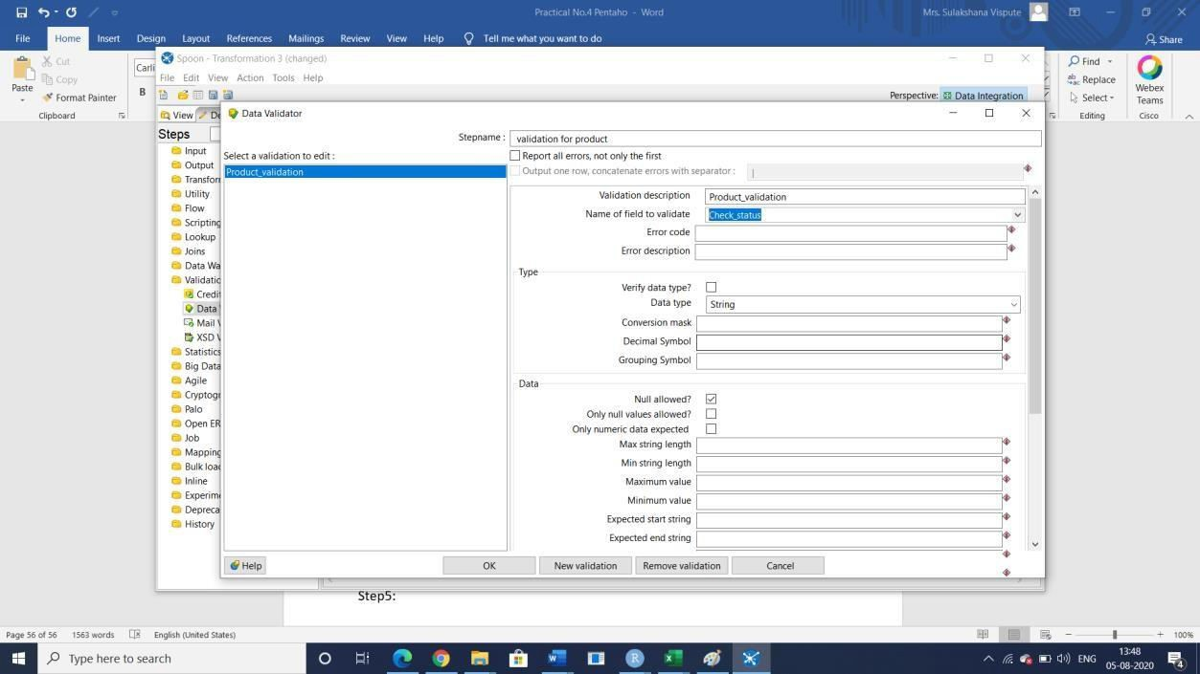

Step6: Click on add to set validation, set6i5tto Shifted and press Enter and click on ok.

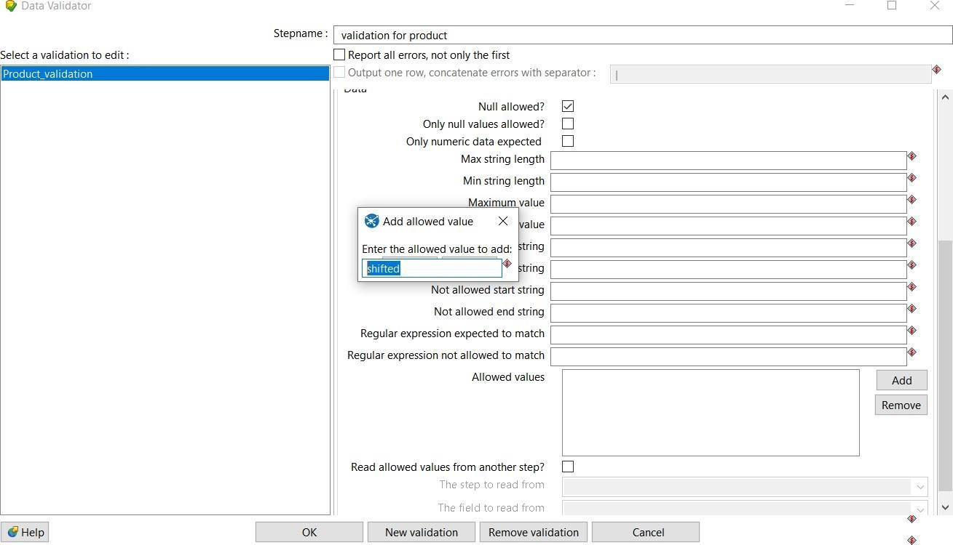

Step7: Select Dummy file from Flow to hold output and connect it with Data validation, while connecting select option *“* Main Output of step*”*

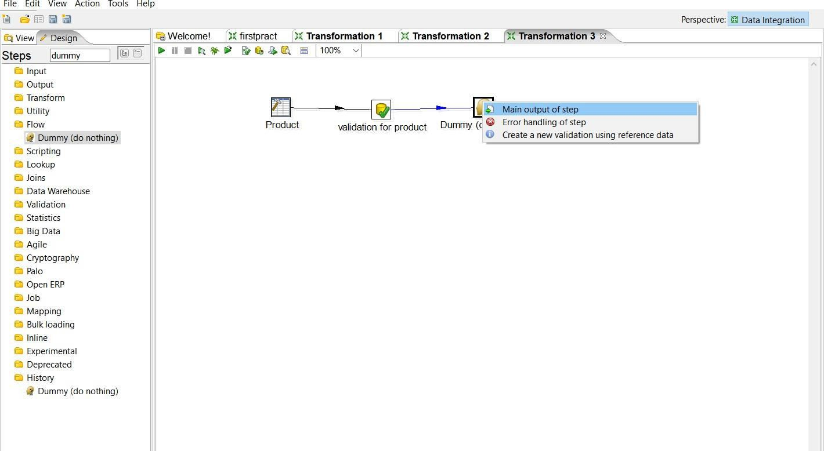

Step8: Select another dummy and connect it to *‘*Validation for product*’* and while selecting select *‘*Error handling of step and in next window click on copy

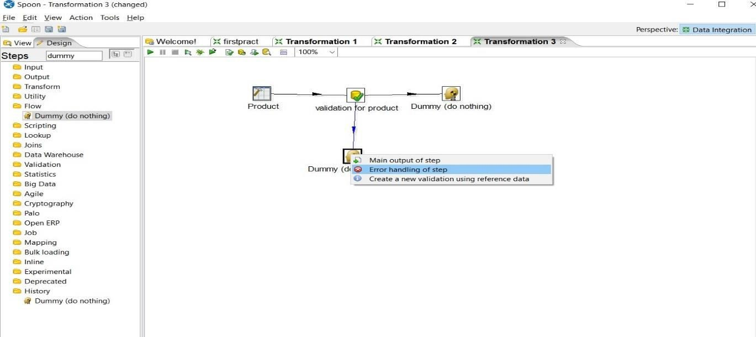

Step 9: launch transformation by selecting one dummy file each.

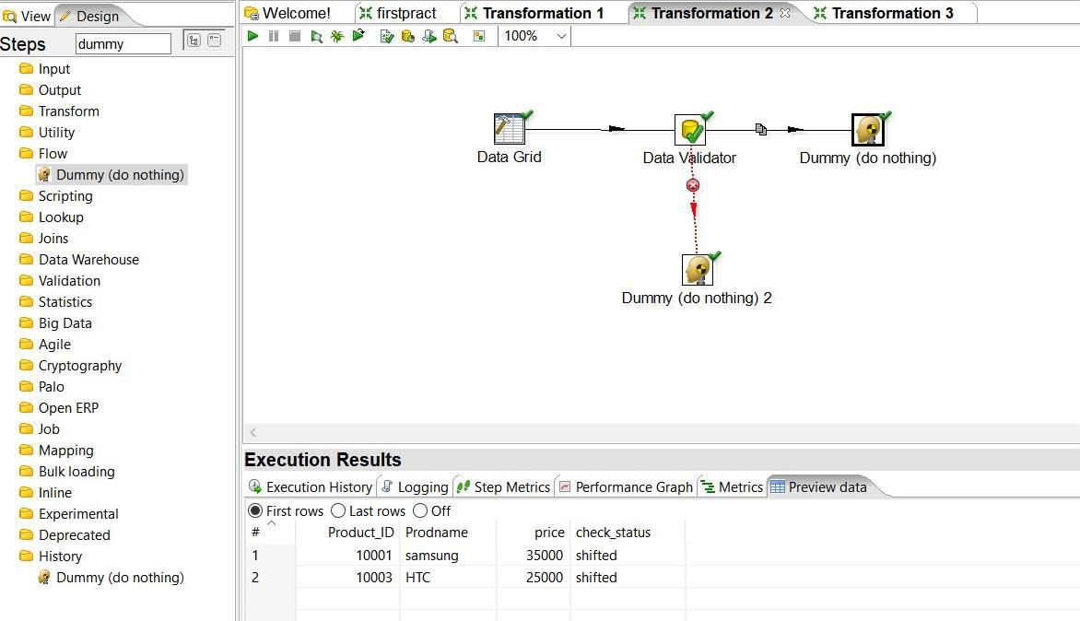

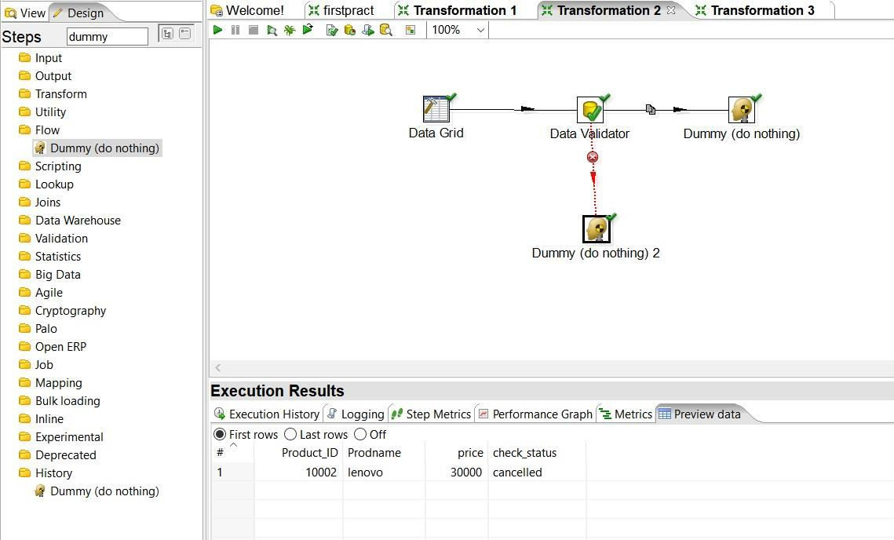

**Practical No.05**

**Introduction to R Programming and data acquisition.**

**Basics of R:**

myString <- "Hello, World!" print ( myString)

## [1] "Hello, World!"

#setwd() - sets working directory. setwd("E:/R Orientation")

##getwd() - gets current working directory. getwd()

## [1] "E:/R Orientation"

## dir() - lists the contents of current working directory. dir()

## [1] "CreditDefaulters.csv" "data.csv"

## [3] "Descriptive_DataSet.csv" "e2.xls"

## [5] "e2.xlsx" "employeeinfo.csv"

## [7] "employeeinfo.xlsx" "employeeinfoMissingData (1).csv"

## [9] "employeeinfonew.xls" "employment.csv"

## [11] "Experiment" "first.Rmd"

## [13] "first.tex" "groceries.csv"

## [15] "insuranceCharges.csv" "MU-data.html"

## [17] "MU-data.log" "MU-data.tex"

## [19] "MU-data2.html" "MU-data2new.aux"

## [21] "MU-data2new.html" "MU-data2new.log"

## [23] "MU-data2new.out" "MU-data2new.pdf"

## [25] "MU-data2new.Rmd" "MU-data2new.tex"

## [27] "MU data.Rmd" "MU data2.Rmd"

## [29] "MU data2new.Rmd" "mydata.csv"

## [31] "sample.txt" "secod.html"

## [33] "secod.Rmd" "secod.tex"

## [35] "trial.html" "trial.Rmd"

##ls() - lists names of objects in R environment ls()

## [1] "myString"

##help.start() - provides general help.

##help.start()

##data() - lists all example datasets in currently loaded packages.

##data()

## library() - lists all available packages.

##library()

#Creating and assigning to a variable:

#alternative: x=1 x<-1

## Checking the type of variable: class(x)

## [1] "numeric"

#Printing a variable:

#auto-printing x

## [1] 1

#explicit printing print(x)

## [1] 1

## is., as. functions: R has is.* and as.* family of functions that can be used to check whether a variable is of given type and convert the variable to a specific type.

x<-'c'

#check if character is.character(x)

## [1] TRUE

#check if integer is.integer(x)

## [1] FALSE y<-'2.14'

as.integer(y)

## [1] 2

###Creating Vector: contains objects of same class.

#using c() function x<-c(11.3,27.5,33.8)

#using vector() function

y<-vector("logical", length=10)

#length of vector x length(x)

## [1] 3

y

## [1] FALSE FALSE FALSE FALSE FALSE FALSE FALSE FALSE FALSE FALSE

#Vector operations: Various arithmetic operations can be performed member-wise. Like:

#- Multiplication by a scalar.

#- Addition of two vectors.

#- Multiplication of two vectors y<-c(4,5,6)

#multiplication by a scalar 5*x

## [1] 56.5 137.5 169.0

#addition of two vectors x+y

#multiplication of two vectors x*y

## [1] 45.2 137.5 202.8

#x to the power y x^y

## [1] 1.630474e+04 1.572764e+07 1.491077e+09

###Creating Matrix: Two-dimensional array having elements of same class.

#using matrix() function

m<-matrix(c(11,12,13,55,60,65,66,72,78),nrow=3,ncol=3)

m

## [,1] [,2] [,3]

## [1,] 11 55 66

## [2,] 12 60 72

## [3,] 13 65 78

#dimensions of matrix m dim(m)

## [1] 3 3

#attributes of matrix m attributes(m)

## $dim

## [1] 3 3

#By default, elements in matrix are filled by column. "byrow" attribute of matrix() can be used to fill elements by row. m<-matrix(c(11,12,13,55,60,65,66,72,78),nrow=3,ncol=3,byrow = TRUE)

m

## [,1] [,2] [,3]

## [1,] 11 12 13

## [2,] 55 60 65

## [3,] 66 72 78

#cbind-ing and rbind-ing:

#By using cbind() and rbind() functions x<-c(1,2,3)

y<-c(11,12,13)

cbind(x,y)

## x y

## [1,] 1 11

## [2,] 2 12

## [3,] 3 13

rbind(x,y)

## [,1] [,2] [,3]

## x 1 2 3

## y 11 12 13

##Matrix operations/functions:

#Multiplication by a scalar.

#Addition, subtraction and multiplication of two matrices.

#Transpose, determinant of a matrix. etc.

#multiplication by a scalar

p<-3*m p

## [,1] [,2] [,3]

## [1,] 33 36 39

## [2,] 165 180 195

## [3,] 198 216 234

n<-matrix(c(4,5,6,14,15,16,24,25,26),nrow=3,ncol=3)

#addition of two matrices q<-m+n

q

## [,1] [,2] [,3]

## [1,] 15 26 37

## [2,] 60 75 90

## [3,] 72 88 104

o<-matrix(c(4,5,6,14,15,16),nrow=3,ncol=2) o

## [,1] [,2]

## [1,] 4 14

## [2,] 5 15

## [3,] 6 16

#matrix multiplication by using %*% r<-m %*% o

r

## [,1] [,2]

## [1,] 182 542

## [2,] 910 2710

## [3,] 1092 3252

#transpose of matrix mdash<-t(m)

mdash

## [,1] [,2] [,3]

## [1,] 11 55 66

## [2,] 12 60 72

## [3,] 13 65 78

s<-matrix(c(4,5,6,14,15,16,24,25,26), nrow=3,ncol=3,byrow=TRUE)

#determinant of s s_det<-det(s) s_det

## [1] 1.110223e-14

###List: A special type of vector containing elements of different classes. ####Elements of list can be accessed by giving element index or name in [[]].

#using list() function

x<-list(1,"p",TRUE,2+4i)

x

## [[1]]

## [1] 1

##

## [[2]]

## [1] "p"

##

## [[3]]

## [1] TRUE

##

## [[4]]

## [1] 2+4i

###Factor: Represents categorical data. Can be ordered or unordered. status<-c("low","high","medium","high","low")

#using factor() function

x<-factor(status, ordered=TRUE,levels=c("low","medium","high")) x

## [1] low high medium high low

## Levels: low < medium < high

##levels' argument is used to set the order of levels.

#First level forms the baseline level.

# Without any order, levels are called nominal. Ex. - Type1, Type2, .

# With order, levels are called ordinal. Ex. - low, medium, .

###Data frame: Used to store tabular data. Can contain different classes. student_id<-c(1,2,3)

student_names<-c("Ram","Shyam","Laxman") position<-c("First","Second","Third")

#using data.frame() function

data<-data.frame(student_id,student_names,position) data

## student_id student_names position

## 1 1 Ram First

## 2 2 Shyam Second

## 3 3 Laxman Third

#accessing a particular column data$student_id

## [1] 1 2 3

#no. of rows in data nrow(data)

## [1] 3

#no. of columns in data ncol(data)

## [1] 3

#column names of data. for a dataframe, colnames() can also be used. names(data)

## [1] "student_id" "student_names" "position"

###Table command is used to create a 2dimensional table in R smoke <- matrix(c(51,43,22,92,28,21,68,22,9),ncol=3,byrow=TRUE) colnames(smoke) <- c("High","Low","Middle")

rownames(smoke) <- c("current","former","never") smoke <- as.table(smoke)

smoke

## High Low Middle

## current 51 43 22

## former 92 28 21

## never 68 22 9

###installing Package

#install.packages("XLConnect")

#library(XLConnect)

#install.packages("readxl")

#library(readxl)

#install.packages("writexl")

#library(writexl)

#uncomment this to read data from Excel Reading and writing data from csv

dataT <- read.table("mydata.csv", sep =",", header = T) dataT

|  |  |  |  |
| --- | --- | --- | --- |
| ## Name | Rollno | Class | Percent. Marks |
| ## 1 Sita | 23 | IV | 67% |
| ## 2 Rita | 28 | V | 98% |
| ## 3 Naresh | 69 | VII |  |
| ## 4 Mohit | 88 | V | 95% |
| # dimension |  |  |  |
| dim(dataT) |  |  |  |
| ## [1] 4 4 |  |  |  |

# Load just few lines at the top or bottom head(dataT, 2)

## Name Rollno Class Percent.Marks

## 1 Sita 23 IV 67%

## 2 Rita 28 V 98%

tail(dataT, 2)

## Name Rollno Class Percent.Marks

## 3 Naresh 69 VII

## 4 Mohit 88 V 95%

z <- data.frame(a = 5, b = 10, c = pi) write.csv(z,file="data.csv")

Reading and writing data from Excel using XLConnect

dataX <- XLConnect:: readWorksheetFromFile("employeeinfo.xlsx",sheet=1) dataX

|  |  |  |  |  |
| --- | --- | --- | --- | --- |
| ## id | Name | salary | start_date_of_the_employee_as_per_records | dept |
| ## 1 1 | Rick | 623.30 | 2012-01-01 | IT |
| ## 2 2 | Dan | 515.20 | 2013-09-23 | Operations |
| ## 3 3 | Michelle | 611.00 | 2014-11-15 | IT |
| ## 4 4 | Ryan | 729.00 | 2014-05-11 | HR |
| ## 5 NA | Gary | 843.25 | 2015-03-27 | Finance |
| ## 6 6 | Nina | 578.00 | 2013-05-21 | IT |
| ## 7 7 | Simon | 632.80 | 2013-07-30 | Operations |
| ## 8 8 | Guru | 722.50 | 2014-06-17 | Finance |
| ## 9 9 | John | 478.00 | 2012-05-21 | <NA> |
| ## 10 10 | Rock | 600.80 | 2013-07-30 | HR |
| ## 11 11 | Brad | 1032.80 | 2013-07-30 | Operations |
| ## 12 12 | Ryan | 729.00 | 2014-05-11 | HR |

# Following is called Subsetting - It will print rows from 1 to 2 and all columns dataY<- dataX[1:2,]

dataY

## id name salary start_date_of_the_employee_as_per_records dept

## 1 1 Rick 623.3 2012-01-01 IT

## 2 2 Dan 515.2 2013-09-23 Operations

Reading and writing data from Excel using readXL and writeXL

#uncomment Package install

#data2 <- read_excel("employeeinfonew.xls", sheet = "employeeinfo")

#data2

#data3<- data2[1:2,]

#write_xlsx(data3, "e2.xlsx")

# create an empty data frame

data <- data.frame(Name=character(), Age=numeric())

# load interface and assign edited values to data back - uncomment following

#data <- edit(data)

# print those values

#data

|  |  |
| --- | --- |
| *#my_data* |  |
| my_data1 <- my_data[1**:**6,1**:**5] my_data1 | |

# Practical No.06

**Implementation of Data Preprocessing techniques.**

## Data Preprocessing Techniques

Implementation of Data preprocessing techniques like,

* 1. Naming and Renaming variables, adding a new variable.
  2. Dealing with missing data.
  3. Dealing with categorical data.
  4. Data reduction using subsetting setwd(“E:/R Orientation”) getwd()

|  |  |
| --- | --- |
| my_data<-mtcars |  |
| **head**(my_data,5) |

|  |  |  |  |  |  |  |  |  |  |  |  |
| --- | --- | --- | --- | --- | --- | --- | --- | --- | --- | --- | --- |
| ## | mpg | cyl | disp | hp | drat | wt | qsec | vs | am | gear | carb |
| ## Mazda RX4 | 21.0 | 6 | 160 | 110 | 3.90 | 2.620 | 16.46 | 0 | 1 | 4 | 4 |
| ## Mazda RX4 Wag | 21.0 | 6 | 160 | 110 | 3.90 | 2.875 | 17.02 | 0 | 1 | 4 | 4 |
| ## Datsun 710 | 22.8 | 4 | 108 | 93 | 3.85 | 2.320 | 18.61 | 1 | 1 | 4 | 1 |
| ## Hornet 4 Drive | 21.4 | 6 | 258 | 110 | 3.08 | 3.215 | 19.44 | 1 | 0 | 3 | 1 |
| ## Hornet Sportabout | 18.7 | 8 | 360 | 175 | 3.15 | 3.440 | 17.02 | 0 | 0 | 3 | 2 |

|  |  |  |  |  |  |  |
| --- | --- | --- | --- | --- | --- | --- |
| ##  ## | Mazda RX4 | mpg 21.0 | cyl 6 | disp 160 | hp 110 | drat 3.90 |
| ## | Mazda RX4 Wag | 21.0 | 6 | 160 | 110 | 3.90 |
| ## | Datsun 710 | 22.8 | 4 | 108 | 93 | 3.85 |
| ## | Hornet 4 Drive | 21.4 | 6 | 258 | 110 | 3.08 |
| ## | Hornet Sportabout | 18.7 | 8 | 360 | 175 | 3.15 |
| ## | Valiant | 18.1 | 6 | 225 | 105 | 2.76 |

*## Renaming columns with dplyr::rename()*

**require**(dplyr)

my_data1 = **rename**(my_data1, horse_power = hp) my_data1

## mpg cyl disp horse_power drat

|  |  |  |  |  |  |  |
| --- | --- | --- | --- | --- | --- | --- |
| ## | Mazda RX4 | 21.0 | 6 | 160 | 110 | 3.90 |
| ## | Mazda RX4 Wag | 21.0 | 6 | 160 | 110 | 3.90 |
| ## | Datsun 710 | 22.8 | 4 | 108 | 93 | 3.85 |
| ## | Hornet 4 Drive | 21.4 | 6 | 258 | 110 | 3.08 |
| ## | Hornet Sportabout | 18.7 | 8 | 360 | 175 | 3.15 |
| ## | Valiant | 18.1 | 6 | 225 | 105 | 2.76 |

## [1] "mpg" "cyl" "disp" "horse_power" "drat"

*## Adding new variable*

my_data1**$**new_hp1 <- my_data1**$**horse_power **\*** 0.5

**colnames**(my_data1)

## [6] "new_hp1" my_data1

## mpg cyl disp horse_power drat new_hp1

|  |  |
| --- | --- |
| *#naming variable* |  |
| *#Reading with read.table() assumes no headers by default. First few lines :* data2 = **read.table**(file="E:/R Orientation/missing_col1.csv", sep = ",") data2 | |

|  |  |  |  |  |  |
| --- | --- | --- | --- | --- | --- |
| ## Mazda RX4 | 21.0 | 6 | 160 | 110 3.90 | 55.0 |
| ## Mazda RX4 Wag | 21.0 | 6 | 160 | 110 3.90 | 55.0 |
| ## Datsun 710 | 22.8 | 4 | 108 | 93 3.85 | 46.5 |
| ## Hornet 4 Drive | 21.4 | 6 | 258 | 110 3.08 | 55.0 |
| ## Hornet Sportabout | 18.7 | 8 | 360 | 175 3.15 | 87.5 |
| ## Valiant | 18.1 | 6 | 225 | 105 2.76 | 52.5 |

|  |  |  |  |  |  |  |
| --- | --- | --- | --- | --- | --- | --- |
| ##  ## | 1 | V1 1 | V2  Rick | V3 623.30 | V4 01/01/2012 | V5 IT |
| ## | 2 | 2 | Dan | 515.20 | 23/09/2013 | Operations |
| ## | 3 | 3 | Michelle | 611.00 | 15/11/2014 | IT |
| ## | 4 | 4 | Ryan | 729.00 | 11/05/2014 | HR |
| ## | 5 | NA | Gary | 843.25 | 27/03/2015 | Finance |
| ## | 6 | 6 | Nina | NA | 21/05/2013 | IT |
| ## | 7 | 7 | Simon | 632.80 | 30/07/2013 | Operations |

*#V1, V2, V3.. are given as default names (titles) by R*

data2 = **read.csv**(file="E:/R Orientation/missing_col1.csv", col.names=**c**("Sno","NAME","SALARY","DateOfJoin”,”Department”) data2

## Sno NAME SALARY DateOfJoin Department

|  |  |  |  |  |  |  |
| --- | --- | --- | --- | --- | --- | --- |
| ## | 1 | 2 | Dan | 515.20 | 23/09/2013 | Operations |
| ## | 2 | 3 | Michelle | 611.00 | 15/11/2014 | IT |
| ## | 3 | 4 | Ryan | 729.00 | 11/05/2014 | HR |
| ## | 4 | NA | Gary | 843.25 | 27/03/2015 | Finance |
| ## | 5 | 6 | Nina | NA | 21/05/2013 | IT |
| ## | 6 | 7 | Simon | 632.80 | 30/07/2013 | Operations |
| ## | 7 | 8 | Guru | 722.50 | 17/06/2014 | Finance |
| ## | 8 | 9 | John | NA | 21/05/2012 |  |
| ## | 9 | 10 | Rock | 600.80 | 30/07/2013 | HR |
| ## | 10 | 11 | Brad | 1032.80 | 30/07/2013 | Operations |
| ## | 11 | 12 | Ryan | 729.00 | 11/05/2014 | HR |

## Error Detection and Correction

NA : Not Available - Known as missing values

Works as a place holder for something that is ‘missing’

Most basic operations(addition, subtraction, multiplication, etc.) in R deal with it without crashing and return NA if one of the inputs is NA

is.na(VALUE) is used to check if the input value is NA or not. Returns a TRUE/FALSE vector Whereas in case of Excel like utilities for numeric computations it’s assumed to be 0

*# Subset only the rows without NA* dataCompleteCases <- dataC[**complete.cases**(dataC),] dataCompleteCases

*# Operation with NA*

## [1] NA

*# Create a vector V with 1 NA value*

V <- **c**(1,2,NA,3)

*# Median with and without NA (remove NA)*

## [1] NA

*# On removing NAs*

**median**(V, na.rm = T)

## [1] 2

*# Apply is.na() to vector*

## [1] FALSE FALSE TRUE FALSE

*# Removing the NA values by using logical indexing*

naVals <- **is.na**(V)

*# Get values that are not NA*

## [1] 1 2 3

*# Subsetting with complete cases - values that are not NA*

## [1] 1 2 3

*# Subsetting a data frame with complete cases # Complete Data of Prime Ministers. Notice NAs*

dataC <- **read.csv**(file ="E:/R Orientation/na_data.csv", na.strings = "") dataC

|  |  |  |  |  |  |
| --- | --- | --- | --- | --- | --- |
| ##  ## | 1 | X1  2 | Rick  Dan | X623.3 X01.01.2012  515.20 23/09/2013 | IT  Operations |
| ## | 2 | 3 | Michelle | 611.00 15/11/2014 | IT |
| ## | 3 | 4 | Ryan | 729.00 11/05/2014 | HR |
| ## | 4 | NA | Gary | 843.25 27/03/2015 | Finance |
| ## | 5 | 6 | Nina | NA 21/05/2013 | IT |
| ## | 6 | 7 | Simon | 632.80 30/07/2013 | Operations |
| ## | 7 | 8 | Guru | 722.50 17/06/2014 | Finance |
| ## | 8 | 9 | John | NA 21/05/2012 | <NA> |
| ## | 9 | 10 | Rock | 600.80 30/07/2013 | HR |
| ## | 10 | 11 | Brad | 1032.80 30/07/2013 | Operations |
| ## | 11 | 12 | Ryan | 729.00 11/05/2014 | HR |

|  |  |  |  |
| --- | --- | --- | --- |
| ## | X1 | Rick X623.3 X01.01.2012 | IT |
| ## 1 | 2 | Dan 515.2 23/09/2013 | Operations |
| ## 2 | 3 | Michelle 611.0 15/11/2014 | IT |
| ## 3 | 4 | Ryan 729.0 11/05/2014 | HR |

|  |  |  |  |  |  |
| --- | --- | --- | --- | --- | --- |
| ## 6 | 7 | Simon | 632.8 | 30/07/2013 | Operations |
| ## 7 | 8 | Guru | 722.5 | 17/06/2014 | Finance |
| ## 9 | 10 | Rock | 600.8 | 30/07/2013 | HR |
| ## 10 | 11 | Brad | 1032.8 | 30/07/2013 | Operations |

## 11 12 Ryan 729.0 11/05/2014 HR

**Imputation**

The process of estimating or deriving missing values There are various methods for imputation

* Imputation of the mean
* Imputation of the median
* Imputation using linear regression models
* Package Hmisc implments many imputation methods, few examples :

**library**(Hmisc)

*## create a vector*

x = **c**(1,2,3,NA,4,4,NA)

*# mean imputation - from package, mention name of function to be used*

## 1 2 3 4 5 6 7

## 1.0 2.0 3.0 2.8* 4.0 4.0 2.8*

*#median imputation*

x <- **impute**(x, fun = median) x

|  |  |  |  |  |  |
| --- | --- | --- | --- | --- | --- |
| ## | 1 | 2 | 3 4 | 5 | 6 7 |
| ## | 1.0 | 2.0 | 3.0 2.8* | 4.0 | 4.0 2.8* |
| *##*  *##* | *1 2 3 4*  *1.0 2.0* | *5 6 7*  *3.0 2.8* | *\* 4.0* | *4.0* | *2.8\** |

** Categorical Data **

## Factors are variables in R which take on a limited number of different values; such variables are often referred to as categorical variables.

*#Convert Character into Factor(categorical data) # Create gender vector*

gender_vector <- **c**("Male", "Female", "Female", "Male", "Male")

**class**(gender_vector)

## [1] "character"

*# Convert gender_vector to a factor* factor_gender_vector

<-**factor**(gender_vector) **class**(factor_gender_vector)

## [1] "factor"

*# Create Ordinal categorical vector*

day_vector <- **c**('evening', 'morning', 'afternoon', 'midday', 'midnight', 'evening')

*# Convert `day_vector` to a factor with ordered level*

factor_day <- **factor**(day_vector, order = TRUE, levels =**c**('morning', 'midday','afternoon', 'evening',

*# Print the new variable*

## [1] evening morning afternoon midday midnight evening

'

## Levels: morning < midday < afternoon < evening < midnight

*# Convert Numeric to Factor #*

*Creating vectors*

age <- **c**(40, 49, 48, 40, 67, 52, 53)

salary <- **c**(103200, 106200, 150200, 10606, 10390, 14070, 10220)

gender <- **c**("male", "male", "transgender",

"female", "male", "female", "transgender")

*# Creating data frame named employee* employee<-

**data.frame**(age, salary, gender) employee

|  |  |  |  |
| --- | --- | --- | --- |
| ##  ## 1 | age salary 40 103200 | | gender  male |
| ## 2 | 49 106200 | | Male |
| ## 3 48 150200 transgender | | | |
| ## 4 | 40 | 10606 | Female |
| ## 5 | 67 | 10390 | Male |
| ## 6 | 52 | 14070 | Female |

## 7 53 10220 transgender

*# Creating a factor corresponding to age with labels*

wfact = **cut**(employee**$**age, 3, labels=**c**('Young', 'Medium', 'Aged'))

## wfact

## Young Medium

Aged ## 4 2 1

# Practical No.07

**Implementation and analysis of Linear regression through graphical methods including Plots**

## Regression Analysis

setwd(“E:/R Orientation”)

**library**(ggplot2) my_data <-mtcars **names**(my_data)

|  |  |  |  |  |  |  |
| --- | --- | --- | --- | --- | --- | --- |
| ## [1] "mpg" | "cyl" | "disp" "hp" | "drat" "wt" | "qsec" "vs" | "am" | "gear" |
| ## [11] "carb" |  |  |  |  |  |  |
| **dim**(my_data) |  |  |  |  |  |  |
| ## [1] 32 11 |  |  |  |  |  |  |

*#randomize*

my_data <- my_data[**sample**(**nrow**(my_data), ), ]

## mpg cyl disp hp drat

wt qsec vs am gear carb

|  |  |  |  |  |  |  |  |  |  |  |  |
| --- | --- | --- | --- | --- | --- | --- | --- | --- | --- | --- | --- |
| ## | Mazda RX4 Wag | 21.0 | 6 | 160.0 | 110 | 3.90 | 2.875 | 17.02 | 0 | 1 | 4 |
| ## | Duster 360 | 14.3 | 8 | 360.0 | 245 | 3.21 | 3.570 | 15.84 | 0 | 0 | 3 |
| ## | Ford Pantera L | 15.8 | 8 | 351.0 | 264 | 4.22 | 3.170 | 14.50 | 0 | 1 | 5 |
| ## | Mazda RX4 | 21.0 | 6 | 160.0 | 110 | 3.90 | 2.620 | 16.46 | 0 | 1 | 4 |
| ## | Porsche 914-2 | 26.0 | 4 | 120.3 | 91 | 4.43 | 2.140 | 16.70 | 0 | 1 | 5 |
| ## | Cadillac Fleetwood | 10.4 | 8 | 472.0 | 205 | 2.93 | 5.250 | 17.98 | 0 | 0 | 3 |

TrainData <- my_data[1**:**20,] TestData <- my_data[21**:**32,]

*## Linear Model*

fit = **lm**(mpg **~** hp, data=mtcars)

**summary**(fit)

##

## Call:

## lm(formula = mpg ~ hp, data = mtcars) ##

## Residuals:

## Min 1Q Median 3Q Max

## -5.7121 -2.1122 -0.8854 1.5819 8.2360

##

## Coefficients:

## Estimate Std. Error t value Pr(>|t|)

## (Intercept) 30.09886 1.63392 18.421 < 2e-16 ***

## hp -0.06823 0.01012 -6.742 1.79e-07 ***

## ---

## Signif. codes: 0 '***' 0.001 '**' 0.01 '*' 0.05 '.' 0.1 ' ' 1

##

## Residual standard error: 3.863 on 30 degrees of freedom ## Multiple R- squared: 0.6024, Adjusted R-squared: 0.5892

## F-statistic: 45.46 on 1 and 30 DF, p-value: 1.788e-07

preds <- **predict**(fit, newdata = TestData) df1 <-

**data.frame**(preds,TestData**$**mpg) **head**(df1)

|  |  |  |
| --- | --- | --- |
| ## | preds | TestData.mpg |
| ## Hornet 4 Drive | 22.59375 | 21.4 |
| ## Chrysler Imperial | 14.40636 | 14.7 |
| ## Merc 230 | 23.61717 | 22.8 |
| ## Volvo 142E | 22.66198 | 21.4 |
| ## Datsun 710 | 23.75363 | 22.8 |
| ## Camaro Z28 | 13.38293 | 13.3 |

## [1] 0.7858354

*#correlation*

**cor**(preds,TestData**$**mpg)

**plot**(mtcars**$**hp, mtcars**$**mpg)

mtcars$mpg

30



50 100 150 200 250 300

10

15

2250

mtcars$hp

**ggplot**(fit, **aes**(hp, mpg)) **+ geom_point**() **+ stat_smooth**(method = lm, se = FALSE) **+**

**geom_segment**(**aes**(xend = hp, yend = .fitted), color = "red", size = 0.3)

35

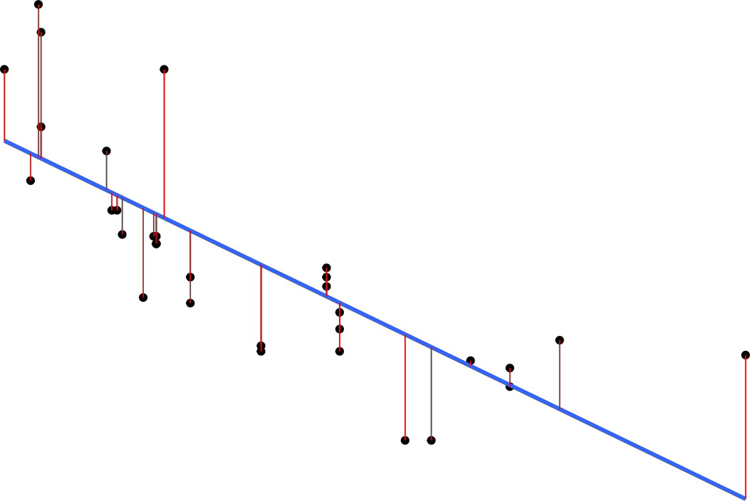

30

25

20

mpg

15

10

100 200 300

##### hp

*# BetterModel ?*

lmmodel1 <- **lm**(mpg **~** hp**+**cyl**+**gear**+**wt, data = TrainData)

**summary**(lmmodel1)

##

## Call:

## lm(formula = mpg ~ hp + cyl + gear + wt, data = TrainData) ##

## Residuals:

## Min 1Q Median 3Q Max ## -3.9265 - 1.5118 -0.6719 1.2700 5.3709 ##

## Coefficients:

## Estimate Std. Error t value Pr(>|t|)

## (Intercept) 39.28913 7.48216 5.251 9.77e-05 ***

|  |  |  |  |  |
| --- | --- | --- | --- | --- |
| ## hp | -0.02878 | 0.02567 | -1.122 | 0.2797 |
| ## cyl | -0.70088 | 1.05380 | -0.665 | 0.5161 |
| ## gear | 0.03884 | 1.22367 | 0.032 | 0.9751 |
| ## wt  ## --- | -3.40102 | 1.26458 | -2.689 | 0.0168 * |

## Signif. codes: 0 '***' 0.001 '**' 0.01 '*' 0.05 '.' 0.1 ' ' 1 ##

## Residual standard error: 2.784 on 15 degrees of freedom ## Multiple R- squared: 0.8446, Adjusted R-squared: 0.8031

## F-statistic: 20.38 on 4 and 15 DF, p-value: 6.332e-06

preds_new <- **predict**(lmmodel1, newdata = TestData) df2 <-

**data.frame**(preds_new,TestData**$**mpg) **head**(df2)

|  |  |  |
| --- | --- | --- |
| ## | preds_new | TestData.mpg |
| ## Hornet 4 Drive | 21.099790 | 21.4 |
| ## Chrysler Imperial | 8.999695 | 14.7 |
| ## Merc 230 | 23.193219 | 22.8 |
| ## Volvo 142E | 24.048611 | 21.4 |
| ## Datsun 710 | 26.073636 | 22.8 |
| ## Camaro Z28 | 13.686462 | 13.3 |

## [1] 0.9266731

**cor**(preds_new,TestData**$**mpg)

**plot**(mtcars**$**hp**+**mtcars**$**cyl**+**mtcars**$**gear**+**mtcars**$**wt, mtcars**$**mpg)

mtcars$mpg

30



100 150 200 250 300 350

10

15

2520

mtcars$hp + mtcars$cyl + mtcars$gear + mtcars$wt

**ggplot**(fit, **aes**(mtcars**$**hp**+**mtcars**$**cyl**+**mtcars**$**gear**+**mtcars**$**wt, mpg)) **+ geom_point**() **+ stat_smooth**(method = lm, se = FALSE) **+**

**geom_segment**(**aes**(xend = hp, yend = .fitted), color = "red", size = 0.3)

35

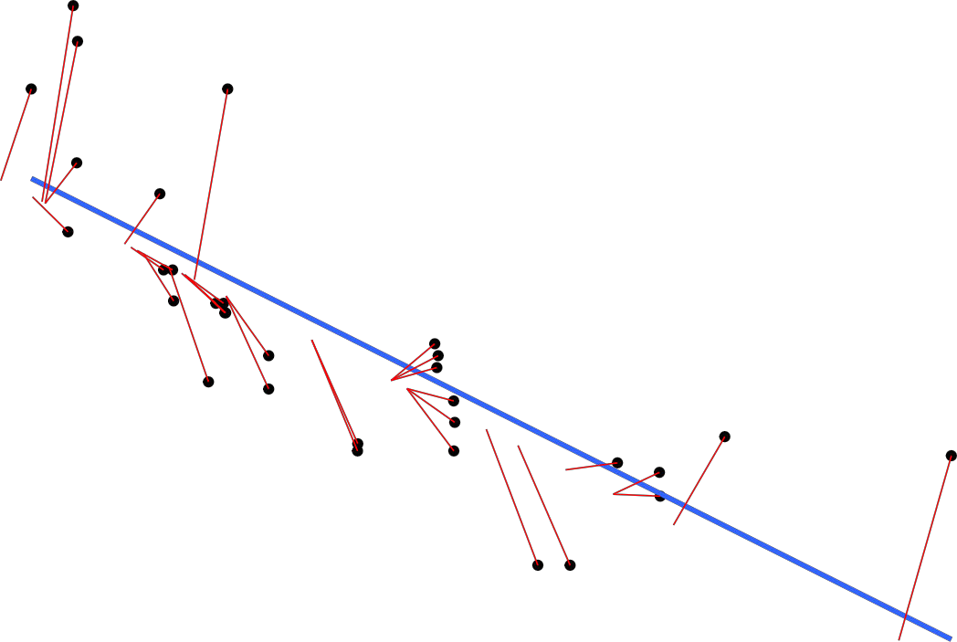

30

25

20

mpg

15

10

100 200 300

##### mtcars$hp + mtcars$cyl + mtcars$gear + mtcars$wt

**Practical No.08**

**Implementation and analysis of Classification and algorithms.**

**Classification**

Implementation and analysis of Classification algorithms like

* + 1. Naive Bayesian, 2.K-Nearest Neighbor 3.ID3

4.C4.5

**Naive Bayes** • Based on the Bayes theorem

* Predicts based on probabilities from training data P(B|A) = P(A|B) P(B)/P(A)

Gives posterior probability of ‘B’ given ‘A’ using prior probability of ‘B’

prior probability of‘A’

and conditional probability of ‘A’ given ‘B’

* Takes two step approach
* Calculates the posterior probability of the Class given the input - for every class
* Assigns the class with higher posterior probability
* More suited when dimensionality of input is high the - widely used for documentclassification
* Also good for the multiclass classifications
* Works well with less datasets also, but the assumption that predictor variables are independent should hold ##Naive Bayes setwd(“E:/R Orientation”)

*# loading library e1071*

**library**(e1071) **library**("klaR")

## Loading required package: MASS

**library**("caret")

## Loading required package: lattice ## Loading required package: ggplot2

## Sepal.Length Sepal.Width Petal.Length Petal.Width Species

**library**(ggplot2) *# iris dataset* **data**(iris) **head**(iris)

|  |  |  |  |  |  |
| --- | --- | --- | --- | --- | --- |
| ## 1 | 5.1 | 3.5 | 1.4 | 0.2 | setosa |
| ## 2 | 4.9 | 3.0 | 1.4 | 0.2 | setosa |
| ## 3 | 4.7 | 3.2 | 1.3 | 0.2 | setosa |
| ## 4 | 4.6 | 3.1 | 1.5 | 0.2 | setosa |

|  |  |  |  |  |
| --- | --- | --- | --- | --- |
| ## 5 5.0 | 3.6 | 1.4 | 0.2 | setosa |
| ## 6 5.4 | 3.9 | 1.7 | 0.4 | setosa |
| **unique**(iris**$**Species) |  |  |  |  |
| ## [1] setosa | versicolor virginica ## |  |  |  |

Levels: setosa versicolorvirginica

*#Plot graph*

**pairs**(iris[1**:**4],main="Iris Data (red=setosa,green=versicolor,blue=virginica)", pch=21,bg=

**c**("red","green3","blue")[**unclass**(iris**$**Species)])

## Iris Data (red=setosa,green=versicolor,blue=virginica)

4.0

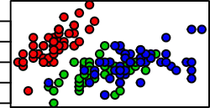

Sepal.Length

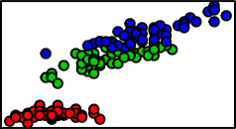

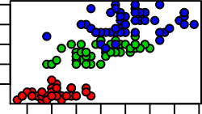

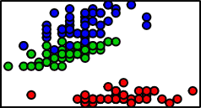4.5 5.5 6.5 7.5

4.5 6.0 7.5

2.0 3.0 4.0

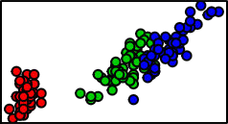

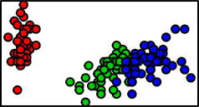

Petal.Length

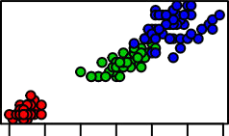

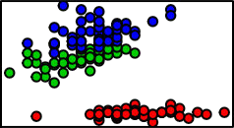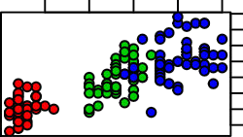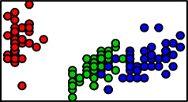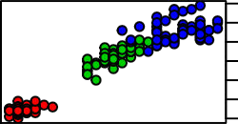1 2 3 4 5 6 7

0.5

1.5

2.5

1 3 5 7

0.5 1.5 2.5

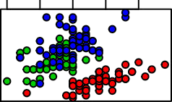

Sepal.Width

Petal.Width

**Practical No.09**

**Implementation and analysis of Apriori Algorithm using Market Basket Analysis.**

setwd(“E:/R Orientation”)

**setwd**("E:/R Orientation")

*# we are creating a data frame by importing csv file*

mba_data<-**read.csv**("data_apriori.csv")

*# you can check top 6 observation using head() function*

## $`1`

## [1] "bread" "butter" "eggs" "milk" ##

## $`2`

## [1] "beer" "bread" "cheese" "chips" "mayo" "soda" ##

## $`3`

|  |  |  |  |  |  |
| --- | --- | --- | --- | --- | --- |
| ## [1] "bread" "butter" "eggs" "milk" ##  ## $`4`  ## [1] "bread" "butter" "eggs" "milk" ##  ## $`5`  ## [1] "buns" "chips" "beer" "mustard" | | | | "oranges"  "soda"  "pickels" | "soda" |
| ## ## ## | $`6`  [1] "bread" | "butter" | "chocolate" | "eggs" | "milk" |
| *# loading arules library*  **library**(arules) | | | | | |

## Loading required package: Matrix ## ## Attaching package: 'arules'

## The following objects are masked from 'package:base':

##

## abbreviate, write

rules = **apriori**(trans, parameter=**list**(support=0.5,confidence=0.9,maxlen=3,minlen=2)) ## Warning in asMethod(object): removing duplicated items in transactions ## Apriori

##

## Parameter specification:

## confidence minval smax arem aval originalSupport maxtime support minlen

## 0.9 0.1 1 none FALSE TRUE 5 0.5 2

## maxlen target ext ## 3 rules TRUE ##

## Algorithmic control:

## filter tree heap memopt load sort verbose ##

0.1 TRUE TRUE FALSE TRUE 2 TRUE ## ## Absolute minimum support count:

7 ##

## set item appearances [0 item(s)] done [0.00s].

## set transactions [15 item(s), 15 transaction(s)] done [0.00s]. ## sorting and

recoding items [4 item(s)] done [0.00s].

## creating transaction tree done [0.00s]. ##

checking subsets of size 1 2 3

## Warning in apriori(trans, parameter = list(support = 0.5, confidence = 0.9, : ## Mining stopped (maxlen reached). Only patterns up to a length of 3 returned!

## done [0.00s].

## writing [11 rule(s)] done[0.00s]. ##

creating S4 object done

*# to get the rules*

**inspect**(rules)

[0.00s].

## lhs rhs support confidence coverage lift count

|  |  |  |  |  |  |  |  |  |  |
| --- | --- | --- | --- | --- | --- | --- | --- | --- | --- |
| ## | [1] | {eggs} | => | {milk} | 0.6000000 | 1 | 0.6000000 | 1.666667 | 9 |
| ## | [2] | {milk} | => | {eggs} | 0.6000000 | 1 | 0.6000000 | 1.666667 | 9 |
| ## | [3] | {butter} | => | {bread} | 0.6000000 | 1 | 0.6000000 | 1.250000 | 9 |
| ## | [4] | {butter,eggs} | => | {milk} | 0.5333333 | 1 | 0.5333333 | 1.666667 | 8 |
| ## | [5] | {butter,milk} | => | {eggs} | 0.5333333 | 1 | 0.5333333 | 1.666667 | 8 |
| ## | [6] | {bread,eggs} | => | {milk} | 0.5333333 | 1 | 0.5333333 | 1.666667 | 8 |
| ## | [7] | {bread,milk} | => | {eggs} | 0.5333333 | 1 | 0.5333333 | 1.666667 | 8 |
| ## | [8] | {butter,eggs} | => | {bread} | 0.5333333 | 1 | 0.5333333 | 1.250000 | 8 |
| ## | [9] | {bread,eggs} | => | {butter} | 0.5333333 | 1 | 0.5333333 | 1.666667 | 8 |
| ## | [10] | {butter,milk} | => | {bread} | 0.5333333 | 1 | 0.5333333 | 1.250000 | 8 |
| ## | [11] | {bread,milk} | => | {butter} | 0.5333333 | 1 | 0.5333333 | 1.666667 | 8 |

**Practical No.10**

**Implementation and analysis of clustering and algorithm.**

**K-Means**

